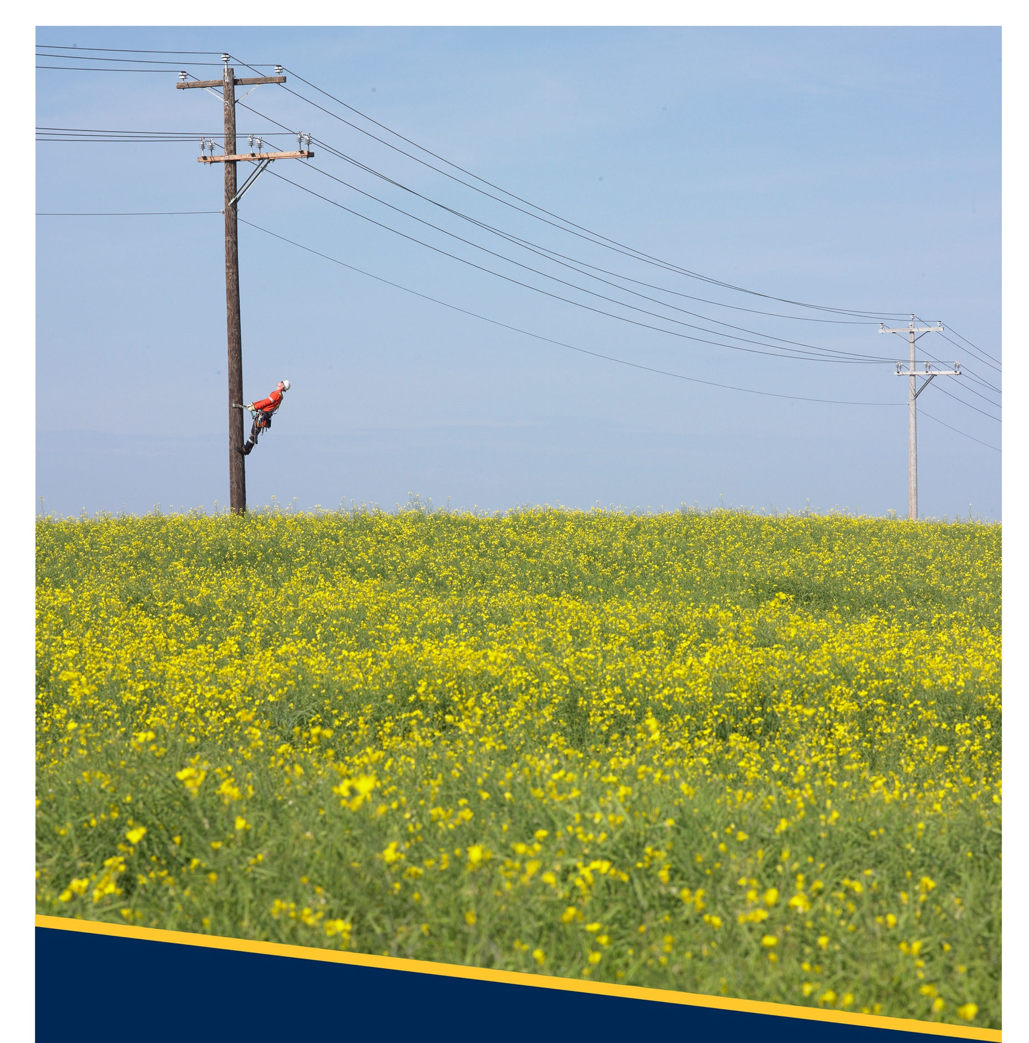
.
Licensed Occupant Guide:
Wireline Attachments
D08-08.1
Revision No: 1.1

Copyright © 2024 FortisAlberta. All rights reserved. This document is the proprietary and confidential property of FortisAlberta Inc.
No modifications, reproduction, or further distribution of this document is permitted, in whole or in part, without written consent of FortisAlberta.
FortisAlberta accepts no liability for unauthorized use of this document. Printed on Sep. 10, 2024 at 11:22 AM.
The current revision is on FortisAlberta Standards Database.

YYYY / MM / DD: 2024 / 09 / 10
Prepared |  | Approved | Ownership | Authentication | Responsible Member Validation
Chris Mateo, P. Eng.  Standards and Projects Engineer |  | Kevin van Popta, P.Eng.  Principal Engineer, Standards & Operations | Licensed Occupancy Steering Committee and  Standards & Projects Engineering |   Authenticated and validated original filed with the Engineering Department | Responsible Member Validation
 |  |  |  |  | APEGA PERMIT NUMBER: P07387
 |  |  |  |  | 
Additional Reviewers and/or Contributors | Scott Sorestad, Manager Licensed Occupancy  Marvin Henderson, Supervisor Licensed Occupancy  Joshua Krebs, Power Line Technician  Monty Walker, Worksite Quality Inspector

Table of Contents
1. Scope 3
2. Purpose 3
3. Normative References 3
4. Glossary 3
5. Legislation 4
6. General Requirements 8
7. Application for Licensed Occupancy Wireline Attachments on a Pole 11
8. Telecommunications New and Additional Attachments on Poles 12
9. Restricted Poles, Changes, and Required Work on the Pole 12
10. Analysis and Gathering of Pole Information 14
11. Structure Loading 14
12. Supply and Installation of New Pole for Licensed Occupant Attachment 15
13. Clearances and Vertical Separations on Poles 16
14. Telecommunication Splices and Devices on Poles 19
15. Climbing Space, Working Space, and Minimum Approach Distance 20
16. Types and Methods of Telecommunications Attachment on Poles 20
17. Placement of Above Ground Equipment in Proximity to Poles 25
18. Telecommunication Vertical Clearances to Ground 26
19. Land Rights and/or Rights of Ways 26
20. Gathering of Pole Information 26
21. Grounding and Bonding Requirement 32
22. Mapping of FortisAlberta’s Electrical Facilities 34
Annex A Alberta Electrical Utility Code (AEUC), 6th Edition (Normative) 35
Annex B Climbing space, Working Space, and Minimum Approach Distance (Informative) 36
Annex C 1342, Pole Riser for Single or Multi-Duct Entrance (Informative) 37
Annex D 2624 Secondary Stand-Off Bracket (Informative) 40
Annex E Streetlights on Wood Poles (Informative) 44
Annex F FortisAlberta Facilities Web Map (Informative) 45
Annex G Counting of Wireline Attachments (Normative) 47
Annex H Bibliography (Informative) 48
The previously published revision was Rev # 1.0, December 13, 2023. Significant content changes shown in purple for convenience.

Scope

This document provides the guidelines and technical requirements of telecommunication wireline attachments on poles.

The requirements and instructions in managing and approving municipal attachments on FortisAlberta poles are provided in D08-08.2 Licensed Occupant Guide: Municipal Attachments.

The requirements and instructions in managing and approving attachment and servicing of small connected devices on FortisAlberta poles are provided in D08-08.3 Licensed Occupant Guide: Small Connected Devices.

The requirements and instructions in managing and approving attachment and servicing of distributed energy resources on FortisAlberta poles are provided in D08-08.4 Licensed Occupant Guide: Distributed Energy Resources.

The process for licensed occupancy applications is provided in the Joint Use Process (external) document.

Purpose

To provide details and requirements for the safe installation and operation of telecommunication wireline attachments on FortisAlberta poles and to meet applicable codes and regulations.

Normative References

Workers shall be competent in FortisAlberta standards:
- D08-08.2 – Licensed Occupant Guide: Municipal Attachments [B1]
- D08-08.3 – Licensed Occupant Guide: Small Connected Devices [B2]
- D08-08.4 – Licensed Occupant Guide: Distributed Energy Resources [B3]
- FortisAlberta Joint Use Process (external) [B4]
- Ground Clearances for Aerial Lines (External for Joint Use Communications)

Glossary
Licensed Occupant: the party that has entered into an agreement with FortisAlberta that allows it to attach its facilities on FortisAlberta poles. The licensed occupant is referred to as the Licensee within the Licensed Occupancy Agreement.
Make Ready Work: the work required by FortisAlberta in preparing the pole to be ready and fit (compliant to applicable safety code, engineering standards, and by-law) for the required licensed occupant attachment or alterations.
Pole(s): Certain electric distribution poles owned by FortisAlberta which are located in the area within which FortisAlberta operates its electric distribution system as prescribed by the Alberta Utilities Commission under the Hydro and Electric Energy Act (Alberta), as amended.
Primary Underground Risers: are primary supply facilities, installed in ducts on the pole, transitioning from overhead to underground installations or vice versa. Small Connected Devices and Telecommunication risers are not allowed on poles with primary underground risers.
Secondary Underground Risers: are secondary supply facilities, installed in ducts on the pole, transitioning from overhead to underground installations or vice versa. Small Connected Devices and Telecommunication risers may be attached on poles with existing secondary underground risers.
Telecommunication Risers: commonly referred to as “laterals”, are telecommunication facilities, installed in ducts on the pole, transitioning from overhead to underground installations or vice versa.
“Where practical”: the use of term “where practical” is not intended to provide an opportunity for not meeting the minimum requirements specified of this document. When an alternative is not specified, the engineering solution that most close approximates the preferred method is to be used.

Legislation

Alberta Electrical Utility Code (AEUC) (See Annex A)
The Alberta Electrical Utility Code (AEUC) [B6], provides the minimum safe limits of approach for persons and equipment performing activities near overhead power lines and definitions of utility worker and qualified utility worker.

A person must notify FortisAlberta, by calling 310-WIRE (9473), before activities are undertaken or equipment is operated within 7.0 meters of FortisAlberta’s electric distribution system, to:
- Determine the voltage of the powerline; and
- Establish the safe limit of Approach distance as listed in Section 2-014 and Table 1.

Section 2-014 and Table 1, safe limits of approach
- 0 – 750 V insulated, or polyethylene covered conductors 0.3 m
- 0 – 750 V bare, uninsulated 1.0 m
- Above 750 V insulated conductors ² 1.0 m
- 0.75 kV – 40 kV 3.0 m

Section 2-014 (8) If an activity is being carried out near the safe limits of approach distances specified in Table 1, the person completing the activity shall assign a competent person to act as an observer whose only responsibility is to ensure that the safe limit of approach distances will be maintained.

Province of Alberta, Occupational Health and Safety Code
Alberta Occupational Health and Safety Code 2023 [B4] and Explanation Guide provides further guidance on the safe limit of approach distances as specified in the AEUC.

Section 225 (2), An employer must notify the operator of an energized overhead power line before work is done or equipment is operated in the vicinity of the powerline at distances less than the safe limits of approach as specified below and obtain the operator’s assistance in protecting workers involved.
- 0 – 750V insulated or polyethylene covered conductors ² 0.3 m
- 0 – 750V bare, uninsulated 1.0 m
- Above 750V insulated conductors ² ³ 1.0 m
- 0.75V – 40kV 3.0 m

CSA C22.3 No. 1-20, Overhead Systems

Table 23, Minimum vertical separation at a joint use structure
This section specifies the Minimum Vertical Separations at a Joint Use structure and working space to allow workers to have access to equipment and conductors and to allow for the installation of the equipment on the structure. FortisAlberta’s interpretation is that these separations do not include the minimum approach distance required by AEUC.
- 0 – 750V supply conductors and Communication line plant 1.0m
  - On lateral communication drop wire plant 0.6m
- > 0.75kV up to and less than 22kV supply conductors 1.2m
- Luminaires span wires or brackets and communication line plant
- Not effectively grounded 1.0m
- Effectively grounded 0.1m

Section 4.2.4.2 Mechanical protection of supply cables on joint use poles
Supply riser cables that have a grounded metal sheath or concentric neutral on poles jointly used with communication systems shall have a protective covering extending at least 1 meter above the communication plant.
NOTE: Supply riser cables include primary and secondary electric supply cables.
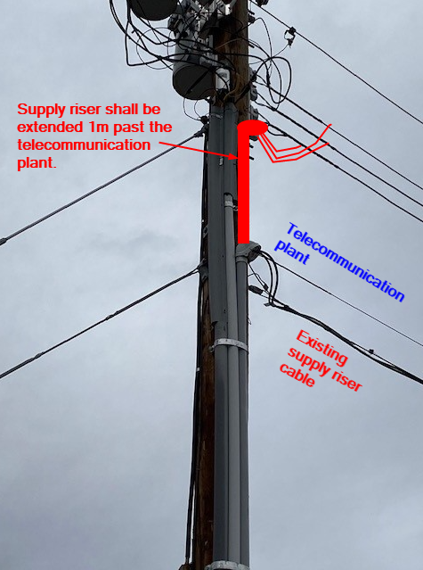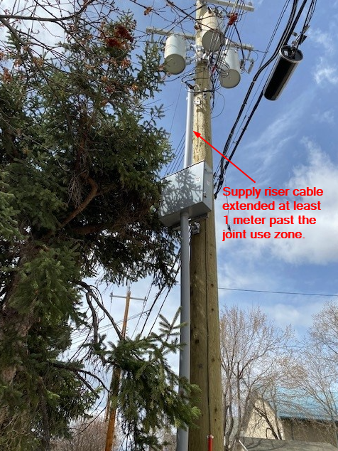

Figure 1: Supply riser cables configurations on poles with telecommunication plant

Part 20: Radiation Exposure, Section 291, Prevention and Protection
“If a worker may be exposed to ionizing radiation at a work site, an employer must.
- Develop and implement safe work practices and procedures to be used when the worker works with or approaches the radiation source,
- If practicable, involve affected workers in the development and implementation of the safe work practices and procedures, and
- Inform affected workers of the potential hazards, including reproductive hazards, of ionizing radiation and the radiation source and the precautions to be taken to protect the workers and other persons from those hazards.”

Section 5.10.1.2 Luminaires and associated brackets on joint use poles
Supply cables and wires associated with the luminaire shall be insulated and protected by a covering that provides suitable mechanical protection unless they are located more than 1 meter above the communication plant.
In addition, FortisAlberta standard is to bond luminaires and connect the ground wire and the neutral wire to the system neutral. See Annex E.

Section 5.10.1.3 Switch handles and communication plant
Switch handles shall be separated by at least 100 mm from the communication plant. The metal frames and operating rods in the vicinity of the joint use space shall be effectively grounded or shall be insulated above the communication working space.

APEGA

Professional Practice Standard (January 2022): Authenticating Professional Work Products
A professional work product (PWP) is any output of professional services with technical information relied upon by others to make a decision or to take action. A professional work product requires authentication and validation.

Professional Practice Bulletin (February 2023): Authentication Requirements for As-Built, Record, and As-Acquired Drawings
“As-built drawings”, also referred to as “redline drawings, reflect the installed condition of a professional work product and have been marked up by someone other than the licensed professional who prepared the PWP. The mark ups are intended to incorporate on-site conditions not represented in the original PWP. The changes to the PWP may have been initiated by the constructor or field reviewer to accommodate site conditions.
If the changes affect the intended purpose of the original PWP or deviate from its specifications, these material changes must be discussed with the licensed professional responsible for the PWP.
When possible, material changes in the field should be handled through change orders, change directives, and site instructions, and authenticated accordingly.

CAN/ULC-S801-14-REV1 – Standards on Electric Utility Workplace Electrical Safety for Generation, Transmission, and Distribution

Section 9, Radio Frequency Hazards
- When work is performed in proximity to communication antennas in the range of 3 kHz to 300 GHz, workers shall not be exposed to radiation levels that exceed Health Canada – Safety Code 6 requirements.
- Employer shall ensure safe work methods are in place to manage exposure limits; RF minimum approach distances; lockout and/or tagging procedures; RF protective clothing; fall protection; climbing plans; rescue training and emergency response; and third-party agreements.

Safety Code 6: Health Canada’s Radiofrequency Exposure Guidelines

Safety Code 6 [B9] provides technical information for guiding individuals or groups in their understanding of Health Canada’s radiofrequency (RF) exposure guidelines.

Uncontrolled and controlled environments
Controlled environments are defined as those that meets the following conditions:
- The RF field intensities were characterized by means of measurements, calculations, or modelling,
- The person exposed is aware of the potential for RF exposure and are cognizant of the intensities of the RF field in their environment, and
- The person exposed is aware of the potential health risks associated with RF field exposures and can control their risk using mitigation strategies.
Situations that do not meet the above conditions are considered uncontrolled environments.

Safety signs for RF protection
- Areas
Signs should be used to label areas where RF exposure levels may exceed exposure limits for controlled and uncontrolled areas.
- Devices
A Caution sign may be used to identify RF energy emitting devices that can produce exposures that can lead to injury from misuse.
A Danger sign may be applied to any device, if it produces exposure levels that pose a risk of immediate and severe injury.

General Requirements

The safety of workers and public, accessibility, maintainability, security, and reliability of FortisAlberta electric infrastructure are to be paramount.

Code and Regulations

Licensed occupant proposing to attach on FortisAlberta poles are responsible to comply with the latest edition of the Alberta Electric Utility Code - ground clearance requirements.

FortisAlberta’s interpretation of the AEUC ground clearance requirement is provided in S35- 06, Ground Clearances for Aerial Lines document [B10]. The S35-06 presents all other factors that needed to be considered when designing, building, and maintaining ground clearances. As such, the licensed occupant is required to meet the specified ground clearances in embedded S35-06 external communication document when attaching on FortisAlberta poles.

Licensed Occupancy Agreement [B7]

Licensed occupancy agreement is an agreement between FortisAlberta and the Licensed Occupant, where the latter wishes to install telecommunication equipment on poles, and FortisAlberta is agreeable upon the terms and conditions contained in this agreement.

Licensed occupant proposing to attach on FortisAlberta’s electric distribution poles shall complete and maintain a licensed occupancy agreement with FortisAlberta, prior to any work or attachment is made on FortisAlberta poles.

To obtain more information, please contact FortisAlberta’s Licensed Occupancy Team (e-mail: licensedoccupancy@fortisalberta.com).

Municipal Approval

FortisAlberta maintains an Electric Distribution System Franchise Agreements [B8] with certain municipalities in its service area.

FortisAlberta is required to direct the licensed occupant, proposing to attach on FortisAlberta poles located within the local municipal service area or right of way, to obtain the local municipal approval.

The licensed occupant proposing to attach on FortisAlberta’s electric distribution poles shall obtain the local municipality approval and to provide a copy of the municipal approval to FortisAlberta representative.

Issued For Review (IFR) Prints

Licensed occupant proposing to attach wireline attachment on poles shall submit Issued for Review (IFR) prints for review by FortisAlberta design representative. IFR prints must be stamped “Issued for Review” and signed by an Engineer.
NOTE: IFR documents should be reviewed and signed by an Engineer to help ensure completeness and compliance of submission and to avoid delays due to multiple submissions and reviews.

Issued For Construction (IFC) Prints

The Issued for Construction (IFC) print shall be Authenticated. IFC print submissions include design calculations, plans, technical information, survey information, and related documents including a completed FortisAlberta survey sheet which are used as reference by FortisAlberta in approving licensed occupant’s proposed attachment on poles. As such, IFC prints are considered professional work product and shall be signed and sealed by a competent Professional Engineer.

The IFC prints must include and show the plan view and Joint Use Survey Sheet of proposed wireline attachments.

Upon acceptance of IFR prints, the licensed occupant shall submit Issued for Construction (IFC) prints to FortisAlberta representative, for final review and acceptance. IFC print submissions shall be Authenticated.
NOTE: FortisAlberta will not accept responsibility for any engineering errors and omissions shown on, or relating to, the plans and drawings, or in any way reduce or relieve the customer and its representative’s responsibility to meet the standards and requirements provided in this document, and to comply with all applicable Municipal, Provincial or Federal statutes, laws, ordinances, codes, and regulations governing the performance of the proposed Work.

The FortisAlberta accepted IFC prints are deemed “final” and frozen. All construction by the licensed occupant must be carried out in accordance with the FortisAlberta accepted IFC prints.

The inspections and verification of licensed occupant attachments on poles, by FortisAlberta representatives, shall be based on the FortisAlberta accepted IFC prints.

Powerline Orientation and Start-up Construction Meeting

Before any activities are undertaken or equipment operated to install telecommunication wireline attachments on FortisAlberta poles, the licensed occupant shall call 310-WIRE (9473) and arrange for a powerline orientation and start-up construction meeting with a FortisAlberta representative.

FortisAlberta accepted IFC prints shall be available to all parties on site, which includes, but is not limited to, the licensed occupant construction crews and FortisAlberta representative, before an orientation and start up meeting begins.
NOTE: Orientation and start-up meeting will not begin without a FortisAlberta accepted IFC prints copies available on site. IFR prints or preliminary IFC prints shall not be used as reference for licensed occupant installations nor for FortisAlberta inspections.

Powerline and Telecommunication Wireline Construction

The licensed occupant must not attach any facilities on the poles until after the required FortisAlberta Make Ready Work is complete.

During construction, it is important that FortisAlberta and the licensed occupant:
- Accurately place conductors and messengers on the pole in accordance with the FortisAlberta Make Ready Work prints and Accepted IFC prints.
- Accurately sag conductors and messengers as per accepted design and based on their respective standard stringing sag criteria.

Shutdown procedures for work with and affecting small connected devices on poles (see FortisAlberta D08-08.3 for additional requirements and information):
- Prior to performing work on the pole, check and look for any field labeling of the small connected device on the pole. Call the telephone number indicated in the field label and provide details of the work that needs to be done.
- After an arrangement has been made with the licensed occupant representative, locate the load center (disconnect switch) on the pole and switch it to the “OFF” position. NOTE: This is intended (for safety of workers) to avoid exposure from non-ionizing frequencies in case the device is emitting these hazardous frequencies.
- After work is completed, switch the load center to the “ON” position and call back the licensed occupant representative and notify them that the device has been put back into service.

Structure integrity critical changes that will require FortisAlberta field and design review and approval.
The integrity of a structure is affected by (but not limited to) changing the following:
- Height, class, setting depth, location, and deflection of pole.
- Lead distances of anchors.
- Height of attachment of the structure framing.
- Structure framing.
- Material change.
- Conductor size, sag, and tension.
- Alignment of new facilities.

Notification of Construction Complete and submission of As-Built Drawings

The licensed occupant shall notify the FortisAlberta representative by sending a request for inspection and acceptance of its installations to licensedoccupancy@fortisalberta.com upon completion of installation of telecommunication facilities. Note: This will trigger inspection and field acceptance of the telecommunication wireline installations.

As-built drawings shall be Authenticated and completed as per APEGA’s “Authentication Requirements for As-Built Record, and As-Acquired Drawings” Professional Practice Bulletin. As such, the licensed professional must conduct a thorough review of the revisions or markups, confirm the site conditions are accurately represented in the as-built drawings, and to verify the site conditions reflected by the changes in the as-built drawings are suitable and aligned with the intended purpose of the original professional work product.

The licensed occupant shall submit an as-built drawing within 60 days of the completed installation of telecommunication facilities on FortisAlberta poles. Note: The as-built drawings will be used to update FortisAlberta mapping records of licensee wireline attachments.

Application for Licensed Occupancy Wireline Attachments on a Pole

All telecommunication wireline applications for licensed occupancy on FortisAlberta poles shall follow the Licensed Occupancy Wireline Attachment Process (external) [B4] document.

Application for licensed occupancy wireline attachments shall be on a first permit submission – first served basis. FortisAlberta will not grant the attacher exclusive use, vested rights, or franchise licensed occupancy of its facilities to third party attachers. The attacher is required to share the pole with the Power Utility or other third party attachers.
NOTE: As per the License Occupancy agreement, the approved application will be valid for 6 months. If after 6 months no work has been completed the approval will be rescinded. The licensee may, within the first six (6) month period, request an extension by email of up to six (6) additional months to complete its install.

An application is required for the following wireline attachment requests:
- All wireline attachments include tangents, taps, deadend, and angle deflections. Wireline attachments refer to the addition of telecommunication cables lashed on messenger wires on the pole.
- All required changes in height of attachments of existing supply/communication facilities on pole.
- Underground risers on pole.
- Addition of splices, devices, and equipment on pole.
- Installations of service drops not meeting Section 7.4.

An application is not required for the following cases meeting all the requirements below:
- Installations of service drops originating from a pole (approved for wireline attachments) or in-spans (between approved poles for wireline attachments) to customer property.
NOTES:
- A service drop must be no more than 30 m; no strands/supporting cable (is not lashed on messenger wires); and no more than 1400 N of maximum tension.
- The vertical clearances of a service drop to ground shall meet the clearances specified in S35-06, Ground Clearances document.

Telecommunications New and Additional Attachments on Poles

All new and additional telecommunication attachment on poles shall comply with the requirements specified in this document and process, accordingly.

All poles proposed for telecommunication attachments shall meet and/or be brought to current standards. This includes, but are not limited to:
- Structure loading capacity.

All telecommunication attachment on poles, proposed for new and additional attachments, shall meet and/or be brought to current standards. This includes, but are not limited to:
- Telecommunication risers. See Section 16.2.
If existing telecommunication risers are mounted directly at the pole, then such telecommunication risers shall be placed on stand-off brackets.
- Guys and anchors. See Section 16.3.
If existing telecommunication guys are attached to FortisAlberta anchors, such telecommunication guy wires shall be installed on its own anchor and separate from FortisAlberta anchors.

Drilling of New Holes in the Pole
When drilling new holes in the pole of which are intended for licensed occupant framing, the minimum vertical separation of holes at the pole shall be 100 mm (4 inches).

All vertical separations at the pole, inter-circuit clearances, and vertical clearances to ground shall meet and/or be brought to current standards. This includes, but are not limited to:
- Vertical separations at the pole. See Section 5.3.1.
- Inter-circuit clearances in-span. See Section 13.
- Vertical clearances to ground. See Section 6.1.2 and S35-06, Ground clearances.

The licensed occupant shall be responsible for all work and costs needed to meet and/or bring the proposed poles for attachment to current standards.

Restricted Poles, Changes, and Required Work on the Pole

The following presents restrictions for new (or altered) telecommunication wireline attachments on poles:
- New telecom risers proposed on poles with existing primary underground risers are not allowed.
- New telecom risers proposed on poles with equipment or switching devices (e.g., cutouts, hot-line clamps, air brakes, regulator banks, MVIs, capacitor banks) should be avoided, where practical. Use tangent poles without equipment where available.
- All proposed telecommunication attachments on poles located on private property, without pre-approval from FortisAlberta and approval from property owner, are restricted.
NOTE: The full restriction listed in a) for primary riser structures is made due to a higher level of risk associated with these structure types, coupled with relatively lower prevalence. The restrictions listed in b) also are made due to higher risk associated with these structure types, however due to their higher prevalence of these structure types, alternative simpler poles are not always present within a practical distance. Refer to H&S 7.5 Section 7 and the figure below.
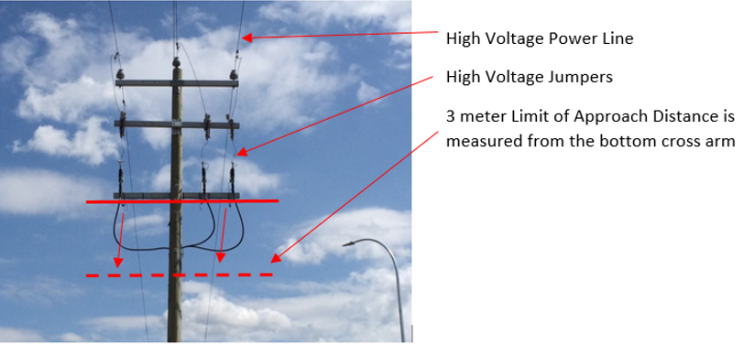
Figure 2: Limits of approach on poles with primary underground risers.

Where the licensee would perform work on poles with third-party (including FortisAlberta) attachments, the licensee and FortisAlberta shall discuss an acceptable solution (during the overhead orientation) to maintain or improve the current placement of facilities on poles.

Changes, removal, replacement or relocation of licensed occupant structures and attachments on the pole shall be completed as specified in the licensed occupancy agreement.

If removal of license occupancy attachments results in decreased structural loading on the pole and doesn’t make any spacing or clearance distances any worse, then the detailed pole measurement requirements normally required for pole line analysis (PLA) may not be necessary. Indicate this in the application.

In situations where a licensed occupant proposes changes to another licensed occupant attachment on the pole (i.e., lowering or increasing height of attachments), refer to the licensed occupancy agreement (Articles 8 and 10).

Not-in-use (NIU) or obsolete licensed occupant wireline attachments must be salvaged, removed, or consolidated.

Beyond the licensed occupant initial installation, the licensed occupant has an on-going duty to maintain their attachments, its impacts on others, and shall resolve any issues caused by their attachments in a timely manner and in accordance with the licensed occupancy agreement.

Analysis and Gathering of Pole Information

The licensed occupant shall be responsible for gathering pole information proposed for the telecommunication wireline attachments. The licensed occupant is responsible for the design and installation of its attachments on poles. The list of information needed for analysis is listed in Section 20.

FortisAlberta will perform the structural analysis of the poles proposed for telecommunication wireline attachments based on the project scope and information provided by the licensed occupant. The pole class and height must be selected to meet the requirements of all parties including FortisAlberta and all licensed occupants on the pole.

Structure Loading

Weather Loading Conditions

Condition A: CSA C22.3 No.1-20 [B9] heavy loading condition of 12.5 mm of radial ice on the conductors with 400 Pa of wind at -20°C.

Condition B: FortisAlberta loading condition of 850-1900 Pa (location dependent) at 4°C.

Weather Loading Specification

The weather loading map dictates the weather loading condition to be used for each region. The boundaries outlined on the loading map are not definite. Discretion will have to be used as to what loading condition is used in areas close to these boundaries.
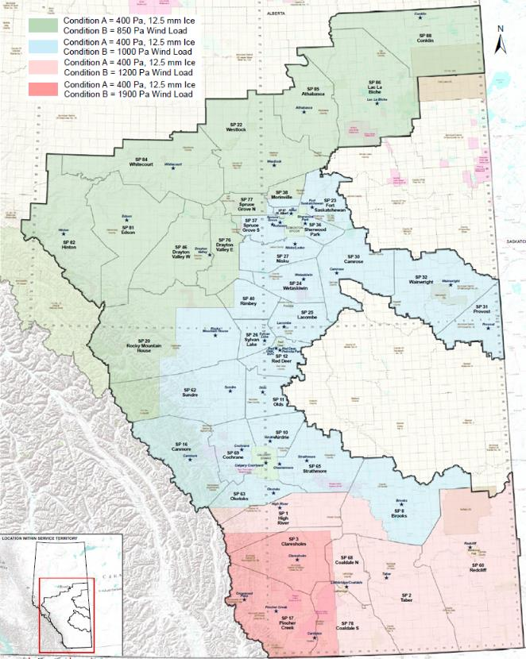

Figure 3: – Weather loading map

Supply and Installation of New Pole for Licensed Occupant Attachment

If the licensed occupant requires a new or additional pole to attach its telecommunication facilities, a request can be made to have FortisAlberta supply and install the pole.

The licensed occupant shall be responsible to pay for the associated costs for the supply and installation of the new pole.

This installation is subject to applicable laws, approvals, land rights and engineering requirements.

Locations are generally restricted to acceptable locations within government road allowances and utility right of ways as determined by FortisAlberta. FortisAlberta will not supply a pole on private property; in a location that requires regular land access costs; or one that has accessibility concerns.

The addition of a pole may affect the adjacent structures, such as with uplift issues or additional loading. As such, the licensed occupant shall pay the required changes in the system in accommodating this new pole.

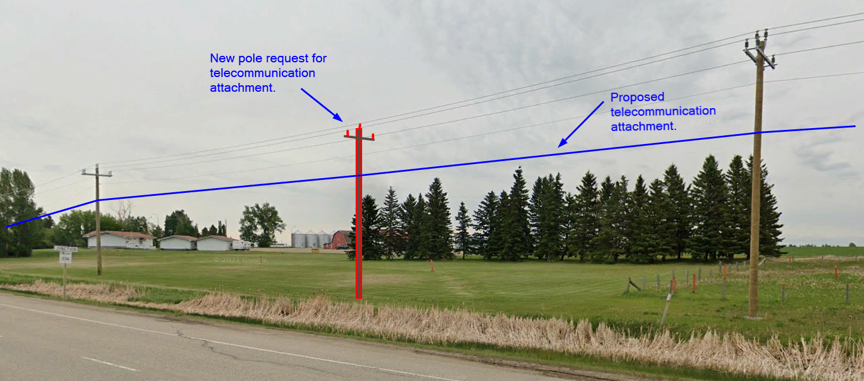

Figure 4: An example of pole addition request for telecommunication attachments

Clearances and Vertical Separations on Poles
FortisAlberta requires the following clearances and minimum vertical separations at the pole and in-span circuit clearances.
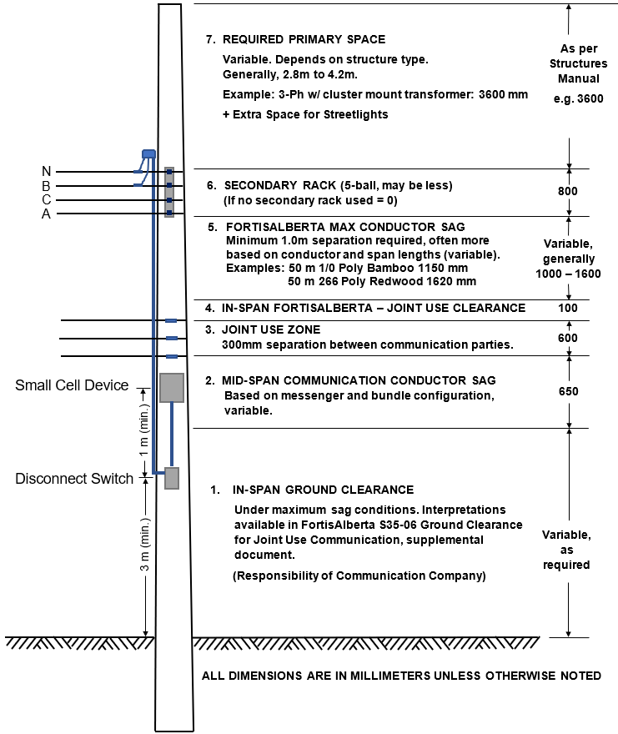

Figure 5 – Typical Space Allocation for Services on FortisAlberta Wood Structures

Licensed Occupant Zone (on wood pole)

By default, licensed occupant zone does not exist on the pole since FortisAlberta will not normally account for licensed occupant attachment on poles when providing electric services to its customers.

The licensed occupant zone on the pole will only exist where the licensed occupant requests and is approved to attach on the pole. The licensed occupant shall pay for the needed changes on the pole to allow for its attachment to the pole.

Each licensed occupant on the pole is provided with a 300 mm zone.

The maximum number of licensed occupants attaching wireline attachments on the pole is 3. As such, the total available licensed occupant zone on a wood pole is 600 mm.

Separations between wireline attachments within the licensed occupant zone.
- The vertical separations of telecommunication wireline attachments within the licensed occupant zone shall be 300 mm.
- On an existing pole where the 300 mm separation requirement cannot be met, the telecommunication wireline attachment may be attached with a minimum vertical separation of 100 mm from another telecommunication wireline attachment within the licensed occupant zone.

The Alberta Government Telecommunications (AGT) historically owned the telecommunication facilities on FortisAlberta poles and were typically placed at the lowest position within the licensed occupant zone. Since TELUS communications bought out the AGT telecommunication facilities, telecommunication facilities (copper, lashing of additional fibre) continue to be placed at the lowest position (600 mm) in the licensed occupant zone. Likewise, cable TV (e.g., SHAW) wireline attachments are placed and located in the middle (300 mm) of the licensed occupant zone. New telecommunication wireline licensed occupants will normally take the upper and last position (0 mm) in the licensed occupant zone. As such and in keeping licensed occupant facilities placed consistently on existing poles and to avoid crisscrossing between facilities, the placement of telecommunication wireline attachments shall be maintained as follows:
  - New licensed occupant – upper position (0 mm)
  - SHAW licensed occupant – middle position (300 mm)
  - TELUS licensed occupant – lower position (600 mm)
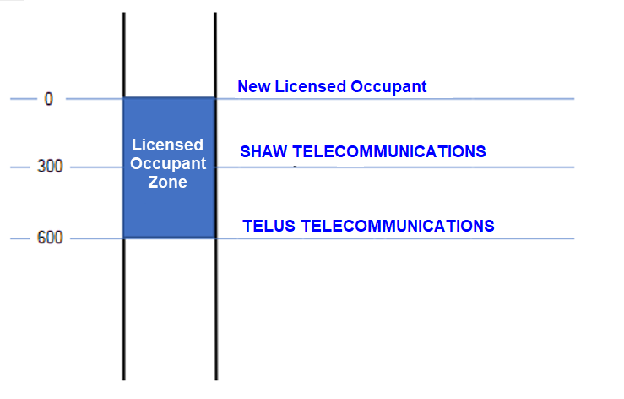

Figure 6 – Placement of wireline facilities within the licensed occupant use zone.

Telecommunication facilities shall be installed within the established licensed occupant zone and not to be installed apart or at different parts or sections of the pole.

The standard placement of wireline attachments will also place the heavier telecommunication facilities at the lower position and the lighter telecommunication facilities placed at the higher position within the licensed occupant zone. This will allow for the proper sag between telecommunication facilities and order (i.e., no crisscrossing of telecommunication lines and guys) in installation. This will also allow for efficient use of the pole with the heavier and bigger diameter telecommunication facilities attached lower in the pole (i.e., lesser loading and bending moments).

Telecommunication equipment and small connected devices shall be attached below the licensed occupant use zone.

Telecommunication wireline attachments such as copper lines, coaxial cables, and fibre optic cables, intended for main and service lines, are to be attached on wood pole structures.

Telecommunication wireline attachment on streetlight poles is not allowed.
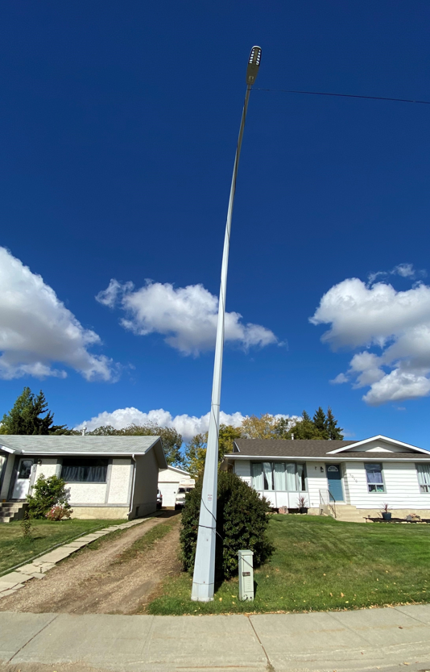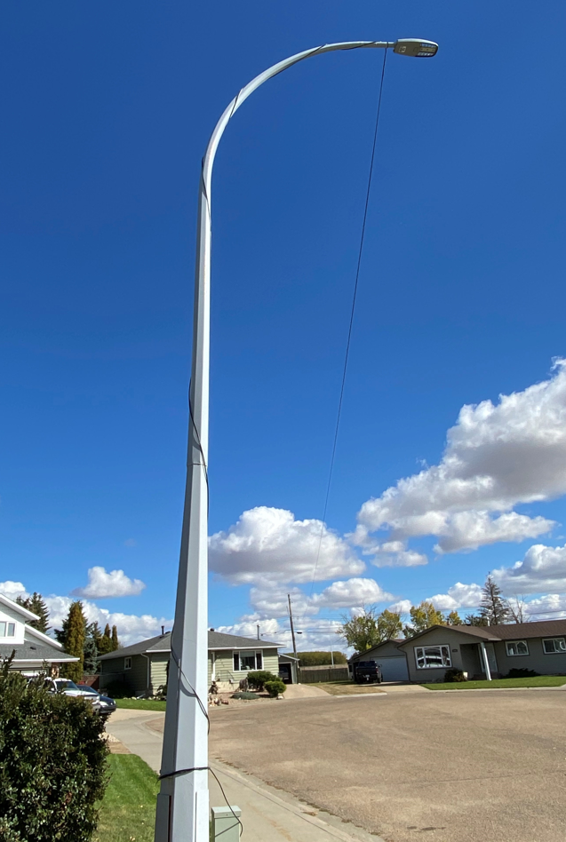

Figure 7: (NOT ALLOWED) Telecommunication wireline attachments on Streetlight poles

Telecommunication Splices and Devices on Poles

Telecommunication splices, amplifiers, nodes, and wireline devices attached on the messenger shall be made within 1 to 2 metres from the pole.

Fibre storage loops (snowshoe) additions shall be identified where required. As such, additional weight, and tensions due to these additions should be presented at time of application.
NOTE: This would be presented as distributed load equivalent (kg/m or N/m) and overwrite the bundle weight (add distributed load) while preserving cable bundle size.
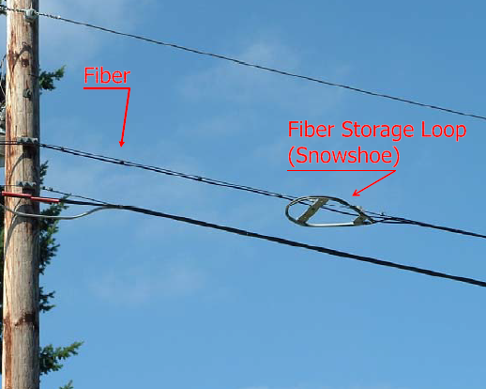

Figure 8: Fiber storage loop (Snowshoe)

Climbing Space, Working Space, and Minimum Approach Distance

The climbing space, working space, and minimum approach distance to supply facilities are detailed in Annex B. Climbing Space, Working Space, and Minimum Approach Distance.

Types and Methods of Telecommunications Attachment on Poles

Wireline Attachments

Telecommunication wireline attachments include copper, coaxial, and fiber optic cables. Telecommunication cables are typically lashed on a messenger wire. Messenger wires are attached on poles which holds and supports the telecommunication cables.

Telecommunication wirelines – Pole to pole attachments
- For tangent (straight line) attachments – the use of a 3-bolt attachments (single through bolt and 2x bolts holding a clamp).
- For deadend attachments – the use of deadend eyebolts.
NOTE: Other types of material attachments may be considered and must be referred to the Standards Department for approval prior to the use and installation.

Telecommunication service drops – Pole/mid-span to residential service
- Telecommunication service drop must be no more than 30 m; no strand/supporting cable (is not lashed on its own stand-alone messenger wires); and no more than 1400 N of maximum tension (e.g., under CSA C22.3 No.1 heavy ice loading conditions).
- The pole shall have an unimpeded climbing space for workers to climb up the pole and to be able to perform work. As such, telecommunication service drops shall not block or impede the climbing space on the pole.
- Use eyenut when servicing houses on the side of the pole where the telecommunication messenger/cables are attached. See Figure below.
- When servicing houses behind where the telecommunication messenger/cables are attached, the telecommunication service drop shall be placed a minimum of one (1) meter away from the pole and lashed on to the messenger wire. This is to avoid service drops impeding on the climbing space at the pole. See Figure below.
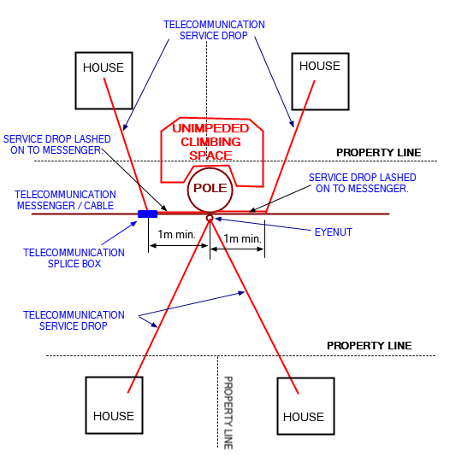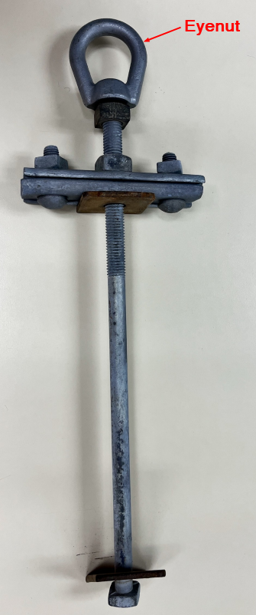

Figure 9: (Left) Diagram of service drops on the pole and along the span; (Right) Eyenut attached.
- A service drop is not allowed to run from pole to pole (See Figure 10). If service drops are required at mid-span, then the service drop shall be lashed onto the existing messenger wire/cables.
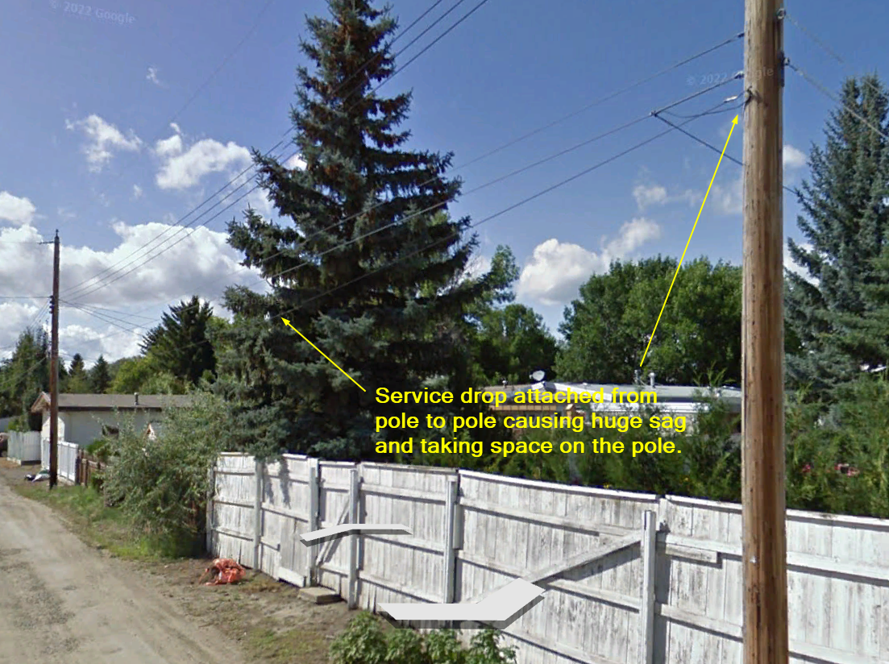

Figure 10: NOT ALLOWED: A service drop running from pole to pole causing excessive sag and taking space on pole.

Telecommunication risers

Telecommunication risers and underground risers refer to the installation of telecommunication and cable wireline facilities transitioning from overhead to underground, or vice versa.

Telecommunication risers and underground risers on wood poles must be attached on stand-off brackets. All materials needed for the installation of telecommunication risers and underground risers shall be supplied and installed by the licensed occupant.
NOTE: The installation of telecommunication risers on stand-off brackets will keep the duct away from the pole to allow workers to climb up the pole.

Standard structures 1342 (Annex C) and 2624 (Annex D) provide guidelines in allowing telecommunication risers on poles with existing primary and secondary underground risers.

The licensed occupant shall use non-metallic conduit equivalent or better than schedule 40 rigid PVC conduit.

In case where telecommunication risers are attached directly on pole and where there is a request for a rebuild or application for additional telecommunication risers on these poles, the existing telecommunication risers and underground risers shall be brought to current standards and shall have all telecommunication risers installed on stand-off brackets.
NOTE: The coordination and determination of who pays for the costs of rebuilding shall be consistent with the licensed occupant agreement.
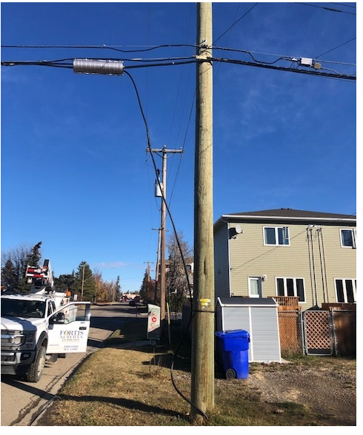

Figure 11: (NOT ALLOWED) Telecommunication risers not installed in stand-off conduits.

Telecommunication Guys and Anchors

Telecommunication guys and anchors are to be designed separate from FortisAlberta facilities and to support the intended telecommunication attachments on the pole. The licensed occupant shall be responsible to assess and evaluate the strength of their own guys and anchors to have appropriate capacity to support the tensions of their facilities on the pole.

The size of telecommunication guy wires and its corresponding lead distances shall be specified by the licensed occupant in their drawings and submissions. NOTE: The Licensed Occupant Survey Sheet (also called existing poles DSA) embedded in this document allows the licensed occupant to choose the size of guy wire and specify lead distance of their anchors.

Telecommunication guys and anchors shall maintain a minimum horizontal separation of 2 meters from FortisAlberta helix anchors and 3 meters from FortisAlberta plate anchors.
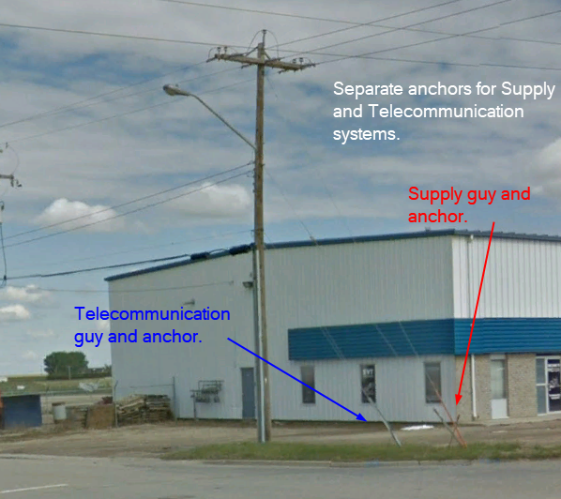

Figure 12: Guys and anchors separately supporting supply and telecommunication systems.

Placement of Above Ground Equipment in Proximity to Poles

Telecommunication above ground facilities such as pedestals and equipment should be placed at least 3 meters away from poles. This is to avoid obstructions (see figure below) and to allow workers access and ability to climb up the pole. It will also offer flexibility and avoid damage to the telecommunication facility when replacing the pole.
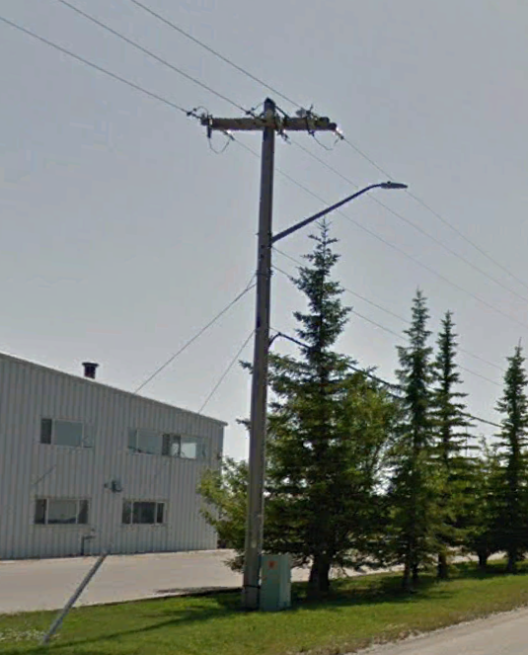

Figure 13: Avoid installation of telecommunication above ground facility within 3 m from pole.

Telecommunication Vertical Clearances to Ground

The following document outlines the ground clearance requirements for telecommunication wireline attachments on poles.

For the purposes of maximum sag, these are defined in the CSA C22.3 No.1-20 code as the worst of two conditions:
- Thermal sag, at 50°C for communication
- Vertical sag at -20°C with a vertical load that is equivalent in magnitude to the total resultant loading calculated from the ice (12.5mm radial) and wind (400 Pascals) conditions specified.
For the vertical ice loaded sag condition above, an alternative vertical sag condition below (sometimes referred to as warm ice) is considered acceptable for ground clearance checks.
Acceptable alternative to b) Vertical sag at 0°C with 12.5 mm radial ice and no wind. NOTE –This alternative condition is proposed in the upcoming CSA C22.3 No.1-2025 code.

Land Rights and/or Rights of Ways

The licensed occupant shall secure needed land rights and or rights of way for their proposed facilities on the pole. This includes but is not limited to the installation of anchors and overhanging of facilities on private property.

Where FortisAlberta has an existing land right for its facilities may not mean that additional licensed occupant attachments on the pole will be covered and included in the agreement. Due diligence is required to confirm scope and content of the rights of ways agreement before approving and attaching on poles.

Gathering of Pole Information

Prior to making an application for wireline attachments, the applicant shall gather and provide the following information for each pole proposed for attachment. This information will be used by FortisAlberta in assessing poles to determine if poles are fit for attachments, requires alterations, or replacement.
- Pole Stamp
The pictures below show a pole stamp and metal tag – located approximately 6 feet from the ground level at the pole. Pole lengths are in 5-foot increments, typically from 35’ to 55’. Pole classes range from class 6 (skinny) to class 1 (thick) or occasionally H1 (thicker) to H6 (thickest).
In cases where pole stamps are not readable or available, the diameter of the pole at the ground line and height of pole above ground shall be provided instead.
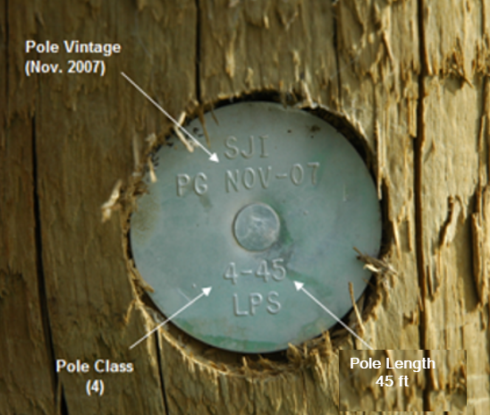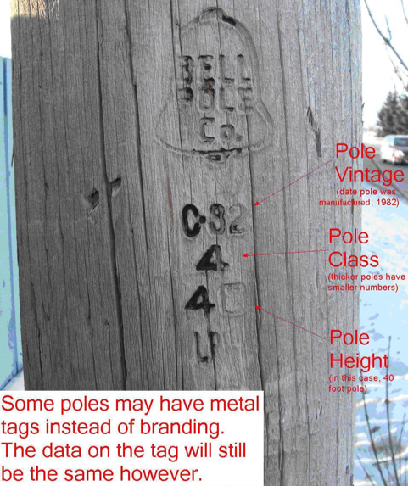

Figure 14: Pole vintage on metal tags (left), pole stamp on pole (right)
- Technical Cable Data (existing & proposed)
  - Cable name/description
  - Bundled cable diameter and mass
  - Fibre storage loop (Snowshoe)
  - Tension Type (Slack / Tight)
  - Cable bundle diameter of licensed occupant cables existing at the structure
  - Maximum tension of bundle(s)
- If not known for tight spans, they will be conservatively approximated.
- Slack spans are required due to variability in tensions and stress on the poles.
  - The following additional data may be provided but is not required
- Ultimate Tensile Strength (UTS) or Rated Tensile Strength (RTS) of messenger wire.
- Stringing table indicating temperature, loading tensions and sags for all proposed bundles.
- Profile view showing vertical clearances of communication or cable facilities crossing roads, alleys, driveways, railways, highways, etc.
  - Attached below are the Communication Technical Data sheet that can be filled out by the licensed occupant.
- Photos
Provide photos of each pole proposed for wireline attachment. Photos should be taken in a consistent fashion, facing the same direction (preferably at 45° from mainline) and approximately the same distance from pole.
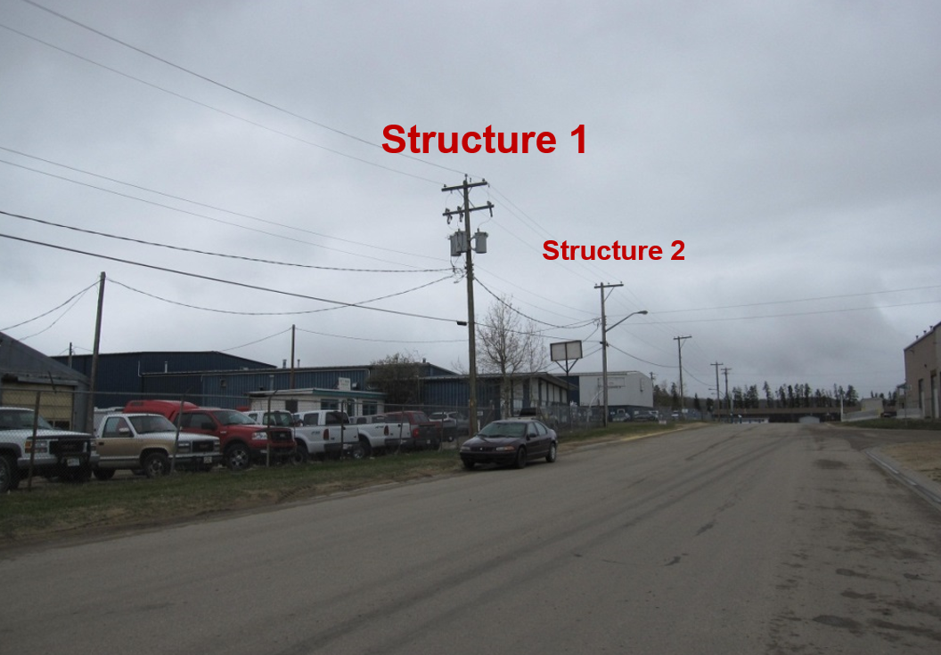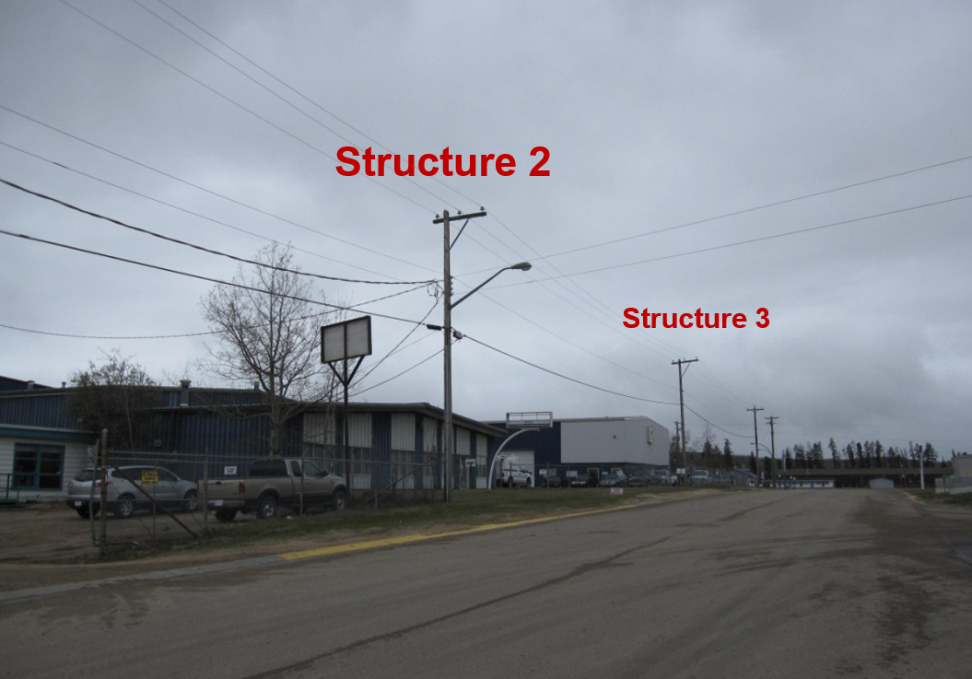

Figure 15: Photos taken 45° from mainline and structures identified as per plan view.

- Profile and Plan View information
The licensed occupant shall provide a plan and profile view of their proposed telecommunication facilities on poles.
An example of a profile and plan view plans are provided in Figure 16 and Figure 17, respectively. The profile and plan view plans shall show the following information in all spans and poles proposed for wireline attachments.
- Starting and ending point of proposed change
- Span lengths
- Dead-end structures for each affected span
- Guy locations
- Tap (include power and telecommunication main line and service drops) locations, distance, and angle deflections
- Conductor changes on double dead-end structures
- Tabulated list of existing and proposed changes
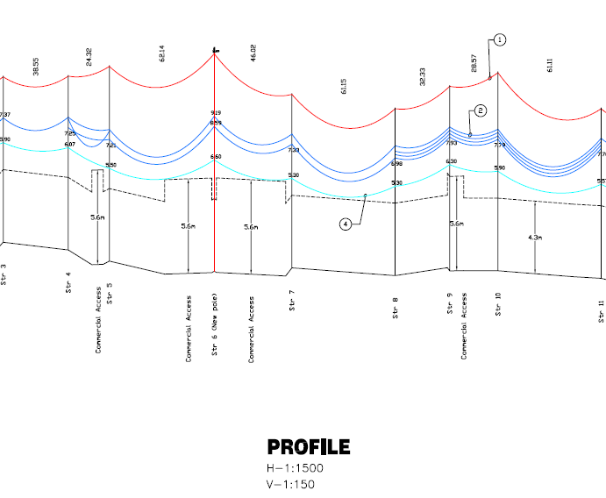
Figure 16: Profile View (to scale)

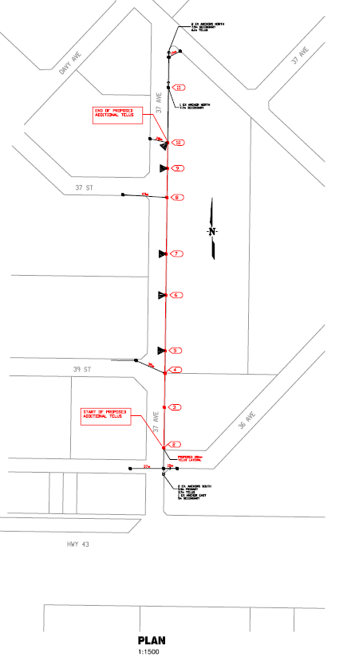
Figure 17: Plan View (to scale)
- Completed and filled out Survey Sheet (Existing Poles DSA)
The embedded Excel spreadsheet is required to be filled out for each pole that is being analyzed for structural strength. The sheet can handle multiple poles (1 pole per column). Use the “Generate Columns” button to insert more pole columns to fill in (limit max poles to keep file sizes low, dependent on pictures, discuss with FortisAlberta staff if over 50 poles). All relevant information about a pole can be entered into the interface, including pole info, heights of attachment, guy wires, tap angles, communication bundle information, tensions, equipment details, overhead guys (with stub poles) and more. This interface can accommodate virtually any type of single-pole structure encountered in the service territory.
Instructions are included on a separate tab. Each section is given a brief description of the details of what needs to be entered. Additionally, there are comments for the user in the Excel cells. Many cells use dropdowns, so the surveyor is encouraged to enter the data while on site to ensure accuracy. The interface utilizes conditional formatting to assist with entering valid information into the spreadsheet. Also, once the data is entered the ‘Analysis’ button can be run. This will load the details on the column into the background and produce two sketches: a plan view and an isometric sketch. These are available to help assist the user in ensuring the data is entered correctly. If an error is encountered when the analysis is run, this will indicate that erroneous data has been entered. Note that the structural analysis portion will not run, this is left for internal FortisAlberta use.
Note: This spreadsheet has macros. You will need to save a copy to your computer and re-open it with macros enabled to use the sheet. In August 2024 an additional tab was added “D08-08.1 Sag Charts” to further assist with telecom inter-circuit spacing calculations.
To assist with the use of this sheet, in addition to the ‘Instructions’ tab, the sheet below contains 3 examples of pole data entered into the sheet. The user can see the digital pictures, heights of attachment, guy wires and plan views at the bottom of the sheet and then see how they are filled out in the Survey Sheet. This should help give reference to how the sheets are to be filled out. Your FortisAlberta contact can be reached for further clarification if there are still unanswered questions.
The Survey Sheet must be saved and submitted in an Excel spreadsheet format (PDF or scanned copy not acceptable).
A properly completed sheet must contain the following required information:
          - Height of attachments for all facilities (primary, neutral, and service drops for secondary and communication lines including transformers and taps)
          - Deflection angles of lines and taps
          - Guy lengths with indicated guyed circuit and direction (primary, secondary, communication)
          - Span lengths, including one span length before the first attachment and one span length after the last attachment
          - Proposed height of attachments for all new communication or cable facilities
          - Bundled communication cable diameters
          - Pole length and class
          - Pole circumference at ground level, if unreadable
          - Measured pole height (setting depth will be determined from this by FortisAlberta)
          - Mid-span heights for the lowest supply conductor in any one span of each independent section of line with proposed modifications (Note the temperature and weather condition (Cloudy or Sunny) at which the measurements are taken. Include in comments where applicable.
- Proposed and existing underground riser attachments on pole
Provide details of all proposed and existing underground risers attached on poles within the licensed occupant project scope.
Provide the following details relating to the underground riser attachments on poles:
- Owner (if known) or type of attachment (for example, power, telephone, cable).
- Size and quantity of ducts for each party on pole.
- Specify if underground riser attachments (cables in ducts) are attached directly on the pole or attached on stand-of brackets.
- Provide licensed occupant field representative and contact information.
- Licensed Occupant Checklist
The Licensed Occupant Checklist is provided below as a quick reference of the information required by FortisAlberta on poles proposed for wireline attachment.

Grounding and Bonding Requirement

Multi-Grounded Neutral (MGN) Requirements

A multi-grounded neutral is required on poles proposed for telecommunication wireline attachments.

A multi-grounded neutral shall be installed in isolated multi-grounded systems that are bridged by telecommunication circuits.

Telecommunication wireline attachments are not allowed on earth-return-neutral and ungrounded primary systems.

Where both primary and secondary exist on the same structure, the secondary open wire neutral (i.e., top poly-covered circuit of the secondary rack) is acceptable to be used as the multi-grounded neutral.

The size of a neutral conductor shall meet the minimum size as per Table 1.
Table #1 – Accepted neutral sizes (primary and secondary circuits)
Primary | Secondary | Neutral Minimum Size
#2 ACSR Haddock  to #266 ACSR | #2 Ebony to #1/0 Bamboo | #2 Haddock or #2 Ebony
#2 ACSR Haddock  to #266 ACSR | #3/0 Mahogany | #2 Haddock or #1/0 Bamboo
#2 ACSR Haddock  to #266 ACSR | #266 Redwood | #3/0 Pigeon or #3/0 Mahogany
#397 ACSR to #477 ACSR | #2 Ebony to #266 Redwood | #3/0 Pigeon or #3/0 Mahogany

The messenger conductor on plex cables (duplex, triplex, quadplex) is not to be used as a multi-grounded neutral where both primary and secondary circuits exist on the same structure. A separate multi-grounded neutral conductor shall be installed before a telecommunication wireline attachment can be strung on the pole.

Telecommunication wireline attachments can be strung on secondary poles (no primary) with existing plex (duplex, triplex, quadplex) cables. The messenger conductor on plex cables maybe used as a multi-grounded neutral on secondary poles (where no primary circuit is present).

Bonding of telecommunication messenger to supply multigrounded neutral system

The telecommunication messenger (i.e., support strands) shall be bonded to the multigrounded neutral system of the supply system at a maximum of 300m intervals, and at common crossing structures, using a minimum conductor size of No. 6 AWG copper or equivalent.
NOTE: The bonding between telecommunication and supply system should be completed on poles with existing grounding electrode (i.e., ground rod and downlead).

Where grounding and bonding of telecommunication messenger is required on the pole, FortisAlberta will install and maintain the grounding electrode (i.e., ground rod and downlead) on the pole.

The licensed occupant shall bond and ground the telecommunication wireline attachment to the grounding downlead on the pole (as provided by FortisAlberta). The connection shall be made by a qualified utility worker. This is typically coordinated between FortisAlberta and the licensed occupant representative, where FortisAlberta personnel may perform that actual work if the licensed occupant representative is not qualified, and it is agreed upon.

Mapping of FortisAlberta’s Electrical Facilities

FortisAlberta electrical facilities mapping information may be obtained as follows:
- Through Altalis.com website. Annex F provides information in obtaining mapping information of FortisAlberta electrical facilities through Altalis.com.
- Through FortisAlberta. Please send a request to FortisAlberta Licensed Occupancy Team (licensedoccupancy@fortisalberta.com).

Alberta Electrical Utility Code (AEUC), 6th Edition (Normative)
This annex contains some applicable code clauses. Refer to the full AEUC for more details.
2-012 Interference with Systems
(1) No person shall interfere with, tamper with, or willfully damage electrical utility systems covered by this Code.
(2) Electrical utility system poles and structures shall be kept free of all materials and equipment not required for the system, unless permitted by the operator of the utility system.
(3) No person shall make attachments to electrical utility system poles and structures unless authorization has been received from the operator of the utility system.
(4) No person shall climb electrical utility system poles or structures or make connections or disconnections to electrical utility system equipment unless the person has been authorized to do so by the operator of the utility system.
(5) No person shall enter an electrical utility system generating station, substation, subsurface chamber, equipment room, or similar location unless that person is authorized to enter by the operator of the utility system.
2-014 Activities near Overhead Power Lines (See Appendix B.)
(1) This Rule applies to activities near overhead powerlines and not the movement of persons, equipment, buildings, vehicles, or objects under overhead powerlines.
(2) A person must contact the operator of the utility system before activities other than those in Subrule (1) are undertaken or equipment is operated within 7.0 meters of an energized overhead line to:
(a) determine the voltage of the power line; and
(b) establish the appropriate safe limit of approach distance listed in Table 1.
(3) Except as provided for in Subrule (4), a person must ensure that the safe limit of approach distance, as established in Subrule (2), is maintained and that no activities are undertaken, and no equipment is operated at distances less than the established safe limit of approach distance.
(4) A person must notify the operator of the utility system before activities are undertaken or equipment is operated in the vicinity of the power line at distances less than the safe limit of approach distances listed in Table 1 and obtain the operator’s assistance in protecting persons involved.
(5) Notwithstanding Subrules (1) through (4), Table 1 does not apply to utility workers falling under the OH&S Code, Part 40 Utility Workers – Electrical.
(6) A person must ensure that earth or other materials are not placed under or beside an overhead power line if doing so reduces the safe clearance to less than the Minimum Vertical Design Clearances above Ground or Rails as defined in Table 5 of this Code and the safe limit of approach distances listed in Table 1.
(7) A person must follow the direction of the operator of the utility system in maintaining the appropriate safe clearance when conducting activities near an overhead power line.
(8) If an activity is being carried out near the safe limits of approach distances specified in Table 1, the person completing the activity shall assign a competent person to act as an observer whose only responsibility is to ensure that the safe limit of approach distances will be maintained.
(9) A person shall not excavate or perform similar operations in the vicinity of an overhead or underground power line if it reduces the electrical and structural integrity of the power line including associated grounding equipment.

Climbing space, Working Space, and Minimum Approach Distance (Informative)
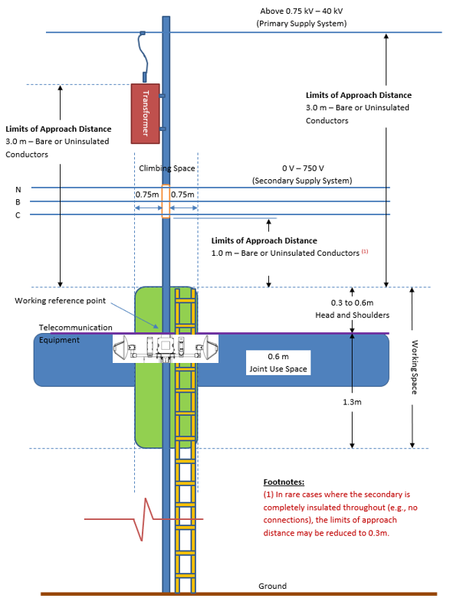

Figure B1: Diagram showing minimum approach distance

1342, Pole Riser for Single or Multi-Duct Entrance (Informative)
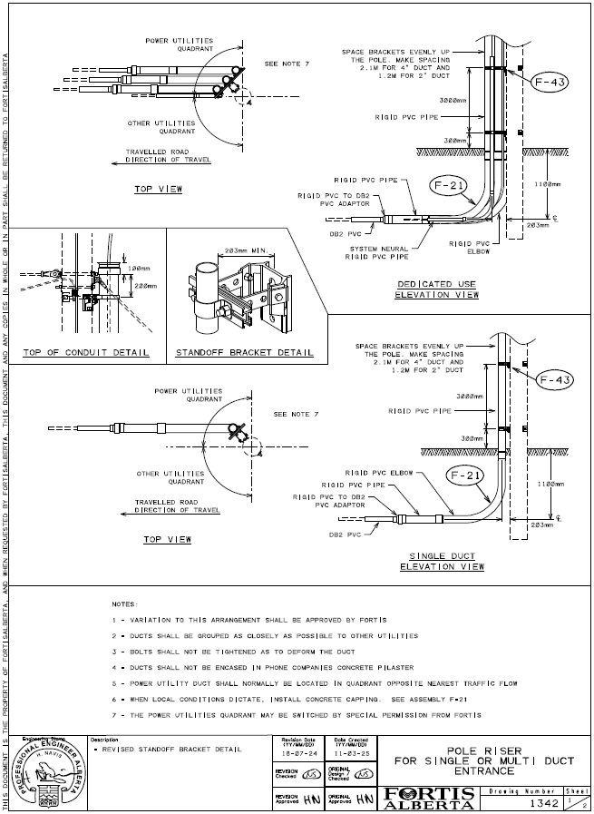

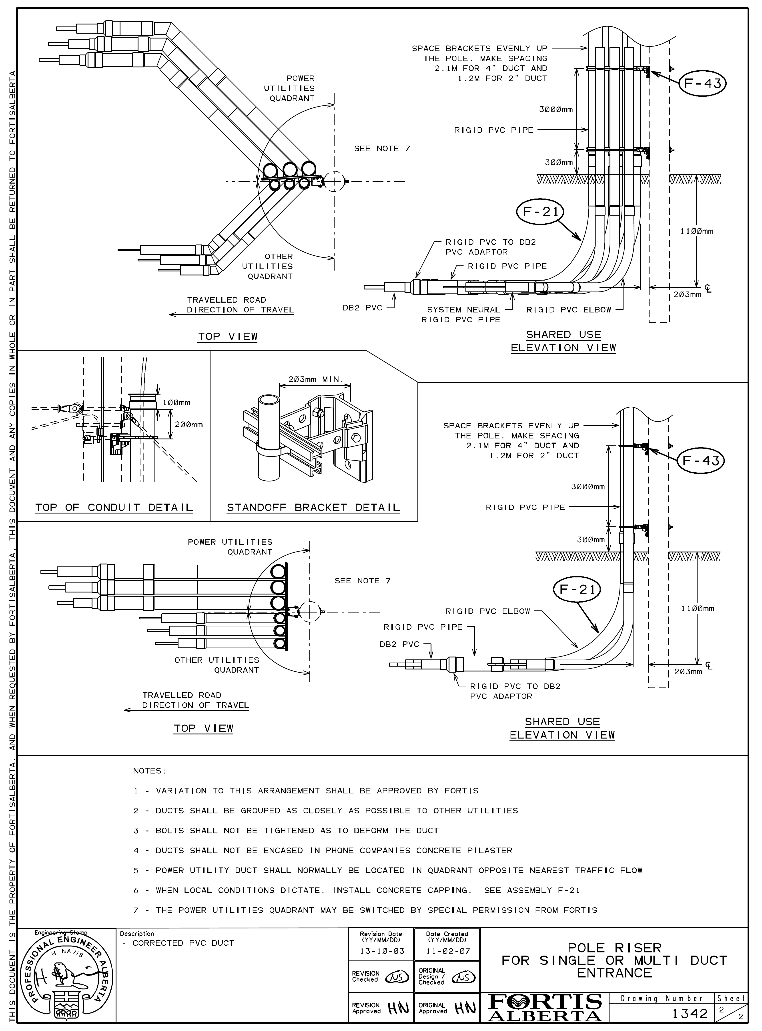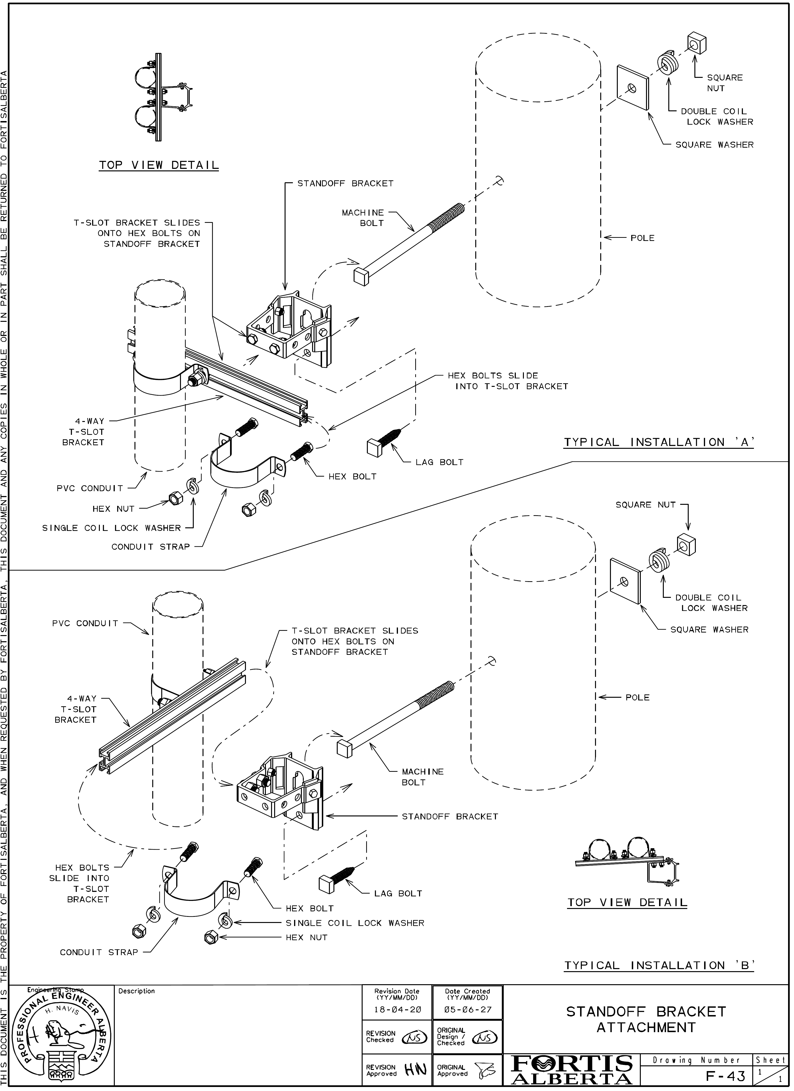

2624 Secondary Stand-Off Bracket (Informative)

2624, Secondary Conduit Stand-Off Bracket
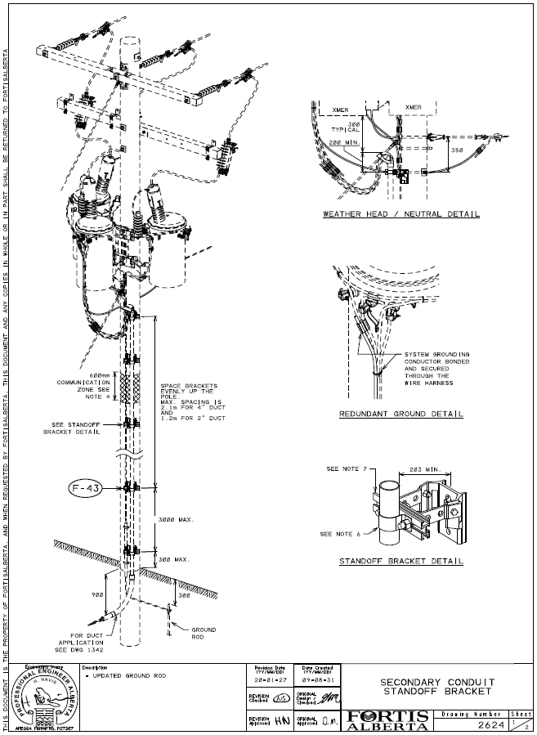
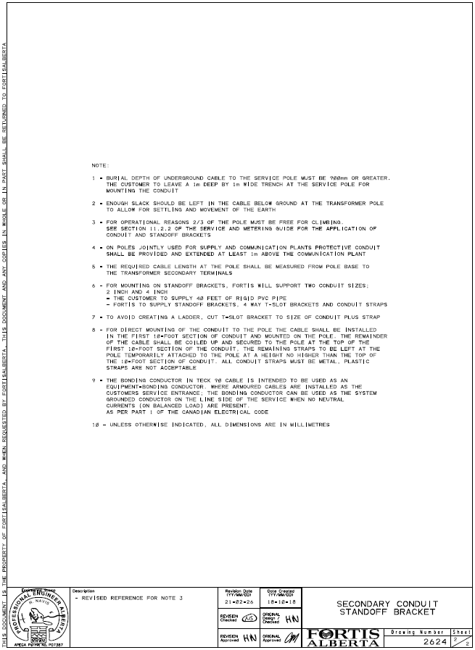

Standoff Bracket Standard Materials

FortisAlberta has specified the following stand-off bracket materials to be used on FortisAlberta poles:
  - FortisAlberta Item No. 5132616
BOLT, machine, 3/4-inch x 16 inches long with a minimum length of 6 inches of 10 uncut or rolled threads, square or hex heads, half cone point ends, made from steel rod and hot dipped galvanized finish. minimum breaking load in tension of 20,050 pounds. The machine bolt shall be supplied and assembled with one regular hex or square nut that is free running to the full length of threads.
Manufacturer: HUBBELL (PS8916CW), MACLEAN (J8916), HYDEL (1634M), SLACAN (9916), STEEL CITY (SC8916BG), ALUMAFORM (AF8916), ORBIS (BM3416)
  - FortisAlberta Item No. 5132618
BOLT, machine, 3/4-inch x 18 inches long with a minimum length of 6 inches of 10 uncut or rolled threads, square or hex heads, half cone point ends, made from steel rod and hot dipped galvanized finish. minimum breaking load in tension of 20,050 pounds. The machine bolt shall be supplied and assembled with one regular hex or square nut that is free running to the full length of threads.
Manufacturer: HUBBELL (PS8918CW), MACLEAN (J8918), HYDEL (1834M), SLACAN (9918), STEEL CITY (SC8918BG), ALUMAFORM (AF8918), ORBIS (BM3418)
  - FortisAlberta Item No. 5132620
BOLT, machine, 3/4-inch x 20 inches long with a minimum length of 6 inches of 10 uncut or rolled threads, square or hex heads, half cone point ends, made from steel rod and hot dipped galvanized finish. minimum breaking load in tension of 20,050 pounds. The machine bolt shall be supplied and assembled with one regular hex or square nut that is free running to the full length of threads.
Manufacturer: HUBBELL (PS8920CW), MACLEAN (J8920), HYDEL (2034M), SLACAN (9920), STEEL CITY (SC8920BG), ALUMAFORM (AF8920).
  - FortisAlberta Item No. 5138401
BOLT, lag / screw, 1/2-inch diameter x 4 inches long, with a hex or square head, fetter drive with a drive / pilot point. if the threads are rolled, then the shaft of the bolt directly beneath the head, (upset shoulder), shall have the same diameter as that of the treads so as to provide a snug fit in hardware mounting holes.
Manufacturer: ALUMAFORM (AF8754P), POLTECH IND (P-944LF), MACLEAN (J8754P)
  - FortisAlberta Item No. 5890450
BRACKET, multipurpose, all aluminum standoff-unit, used with any length T-slot brackets, item 5890458.
Manufacturer: ALUMA-FORM (6B-CSO-P13/16)
  - FortisAlberta Item No. 5890455
BRACKET, 4-way, "T-slot" shaped, extruded aluminum bracket, 12 inches long. Used with item number 5890450 and strap kits to mount 1 inch through 6" conduit on a power pole.
Manufacturer: ALUMAFORM (4WT-12), HUBBELL (C4WT-12), MACLEAN (M4WT-12)
  - FortisAlberta Item No. 6311108
STRAP, kit for use with the four-way T-slot bars that is part of the conduit standoff bracket system. Each strap kit comes with an aluminum strap that is suitable for supporting one 2-inch conduit, two 1/2-inch hex head bolt with a maximum length of 1-1/2 inches, two 1/2-inch hex nuts and two 1/2-inch single coil lock washers. The bolts, nuts and washers are to be made from galvanized steel and assembled onto the strap.
Manufacturer: ALUMAFORM (CSTK2), HUBBELL (MSTK-2), MACLEAN (STK-2)
  - FortisAlberta Item No. 6311110
STRAP, kit for use with the four-way T-slot bars that is part of the conduit standoff bracket system. Each strap kit comes with an aluminum strap that is suitable for supporting one 4-inch conduit, two 1/2-inch hex head bolt with a maximum length of 1-1/2 inches, two 1/2-inch hex nuts and two 1/2-inch single coil lock washers. The bolts, nuts and washers are to be made from galvanized steel and assembled onto the strap.
Manufacturer: ALUMAFORM (CSTK4), HUBBELL (MSTK-4), MACLEAN (STK-4)

Streetlights on Wood Poles (Informative)

1440, Steel Bracket for wood poles
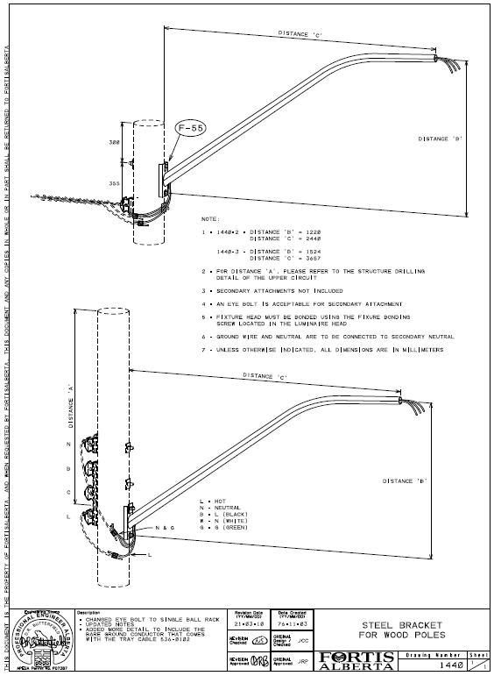

FortisAlberta Facilities Web Map (Informative)
The following steps will guide the licensed occupant in gathering FortisAlberta electrical facilities mapping information:
        - Click on the link www.altalis.com
        - Click “Infrastructure”

        - Click on “Electrical”
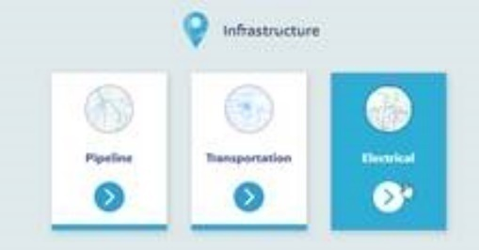
        - Click on “Fortis Facility Data”
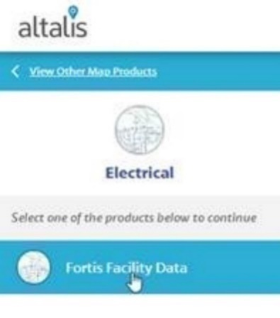
        - Select the area of interest by clicking on “Select” and “Rectangle” or “Polygon”
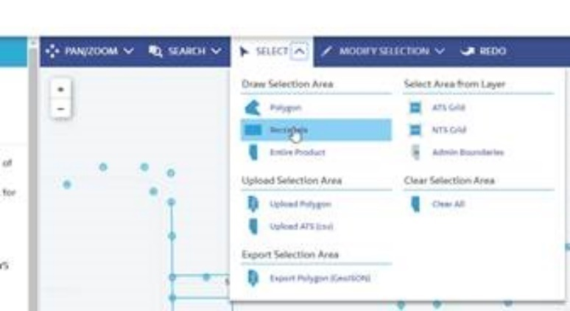
        - Click and drag the cursor to identify the area of interest.
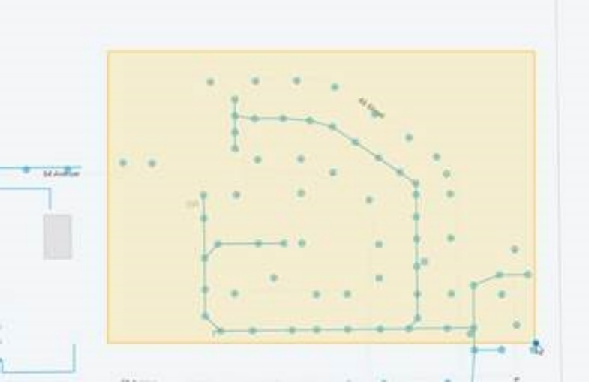
        - Click “Add to Cart” located at the bottom right corner of the screen.


Counting of Wireline Attachments (Normative)

General

Telecommunication wireline attachments on FortisAlberta poles are billed per zone, and in accordance with the Agreement for Licensed Occupancy.

Adherence to the “Joint Use” Process is needed to ensure proper installation and counting of licensed occupant attachments on poles.

Telecommunication Wireline Attachment

The following attachments qualify to be counted as one attachment on the pole as long as they occupy within the licensed occupant zone.
- Tangent attachment – 3-bolt attachments (single through bolt and 2x bolts holding a clamp).
- Deadend/tap attachment – deadend eyebolts or bolt eye
NOTE: A double dead-end; a tap from an existing tangent attachment; a corner run attachment; are all considered as one attachment as they occupy the same licensed occupant zone.
NOTE: Multiple attachments from the same licensed occupant that are at different heights but support lines that are in the same direction (i.e., one line on top of another line in-span) shall each be counted separately as they occupy different licensed occupant zones.
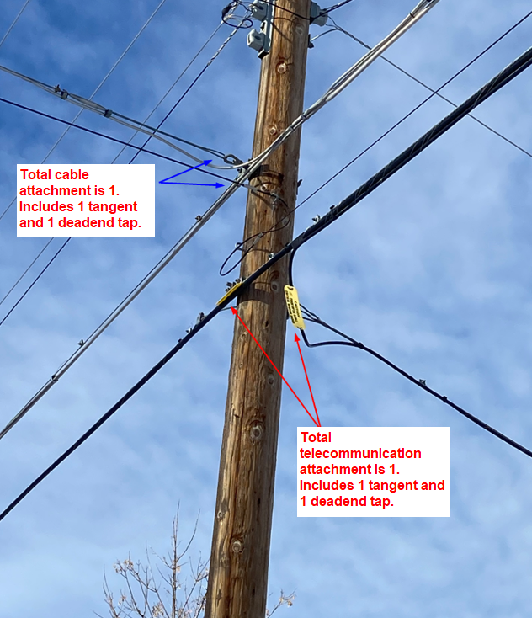
Figure F1: Showing quantity of attachments on pole from Telecommunication and Cable companies.

Bibliography (Informative)
[B1] D08-08.2, Joint Use, Municipal Attachments
[B2] D08-08.3, Joint Use, Small Connected Devices
[B3] D08-08.4, Joint Use, Distributed Energy Resources
[B4] Licensed Occupancy Wireline Attachment Process. Available on the FortisAlberta external website.
[B5] Occupational Health and Safety Code – Alberta Regulation 191/2021
[B6] Alberta Electrical Utility Code (AEUC), 6th Edition, August 2022
[B7] Licensed Occupancy Agreement
[B8] Electric Distribution System Franchise Agreements
[B9] Canadian Standards Association (CSA) C22.3 No.1-20, Overhead Systems
[B10] FortisAlberta S35-06, Ground Clearances – External Version for License Occupancy Guide embedded within this D08-08.1 document.

Revision Tracking Table
Rev | Date | Summary of Changes
0 | January 19, 2023 | Creation of D08-08.1 Licensed Occupant Guide: Wireline Attachments
1.0 | December 12, 2023 | Section 5.4: APEGA requirements.  Section 6.2.3: Change of contact information to licensedoccupancy@fortisalberta.com  Section 7: Provided clarity where application for licensed occupancy on poles are required.  Section 8: Telecommunications New and Additional attachments on poles requirements (New!)  Section 9: Third-party attachments on poles (New!)  Section 16.2: Telecommunication risers and underground risers.  Section 20.E. Survey Sheet spreadsheet updated.  Section 24: Mapping of FortisAlberta Electrical Facilities (New!)
1.1 | September 10, 2024 | Section 4, Glossary, added primary, secondary, and telecommunication risers. Updated “laterals” in the document to “risers”.  Section 5.3.3 CSA C22.3 No. 1, Part 20 Radiation Exposure requirement added.  Section 5.5 CAN/ULC S801, Section 9, Radio Frequency Hazards requirement added.  Section 5.6 Safety Code 6, Radiofrequency Exposure guidelines added.  Section 6.1 Added section.  Section 6.6.1 IFC print shall be authenticated. Added clarification and in compliance to APEGA requirements.  Section 6.8.3 Shutdown procedures for work on the pole with small connected devices.  Section 6.10 Notifications and As-built drawings shall be authenticated as per APEGA requirements.  Section 7.2 Applications on a first permit submission – first serve basis.  Section 7.4 Length of service drop updated from 25m to 30m.  Section 8.4 Minimum vertical separation of holes on pole is 100 mm (4”).  Section 9 Added restricted poles, general attachment changes, and housekeeping of telecommunication on poles.  Section 13.4, installations within licensed occupant zone.  Section 16.1.3 and Figure 9, Added requirements and details on telecommunication service drop attachments and shall not impede climbing space on the pole.  Section 20.1 E) Added sag charts in the joint use survey form for telecom inter-circuit spacing calculations.  Section 20.1 F) Added additional information on FortisAlberta secondary conductor sag charts. F) added requirements to identify underground riser attachment on poles within the project scope.  Previous Section 22, removed. Refer to Section 9.3.2.  Annex C, Updated 1342 structure to include bill of materials.  Annex D, Added material item numbers and manufacturers for stand-off bracket materials.

Table 1, Safe Limits of Approach Distance from Overhead Power Lines for Persons and Equipment, AEUC 2022.
Conductors must be insulated or covered throughout their entire length to comply with these groups.
Conductors must be manufactured to rated and tested insulation levels.

