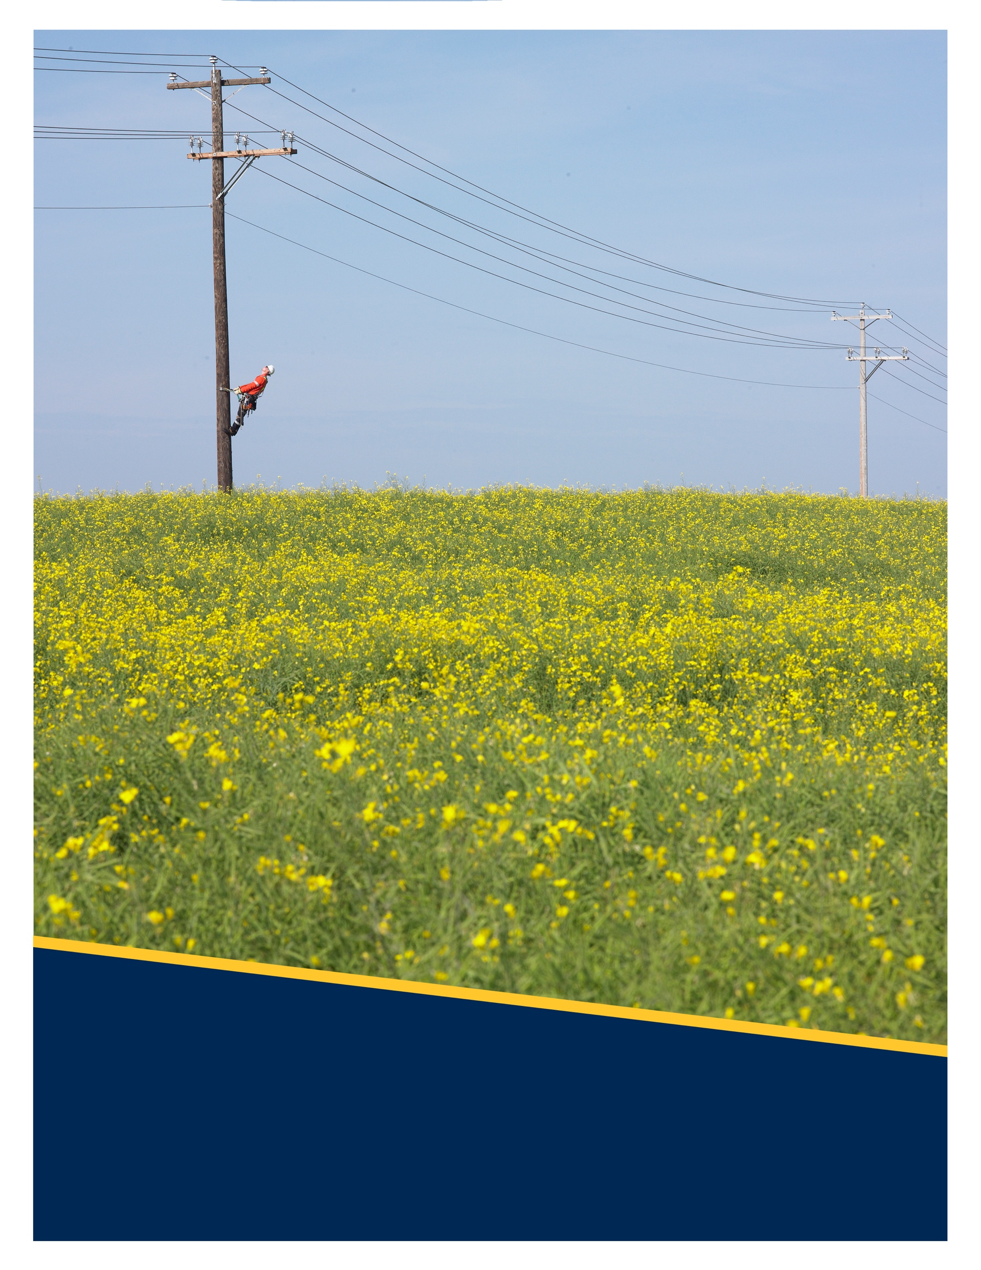
`
Licensed Occupancy Wireline Attachment Process
Version No: 1.0

Copyright © 2024 FortisAlberta. All rights reserved.
No modifications or reproductions are allowed without permissions.
Contents
1. Scope 3
2. Purpose 3
3. Schedule of Fees 3
4. Licensed Occupancy Wireline Attachment Process 4
5. CONTACTS FOR FURTHER CLARIFICATION 8
Version History 9

- Scope
  - This document outlines FortisAlberta’s application process and workflow for licensed occupant wireline attachments on poles.
  - The requirements for wireline attachment applications are detailed in D08-08.1 Licensed Occupant: Wireline Attachments. The D08-08.1 shall be used and complied with in conjunction with the Licensed Occupant Wireline Attachment Process.
- Purpose
  - To guide the licensed occupant of the process and workflow when making wireline attachment applications.
  - To facilitate the interaction between FortisAlberta and the licensed occupant for its wireline attachment applications.
- Schedule of Fees
  - The licensed occupant shall be responsible for any applicable fees as per the “Licensed Occupancy: Schedule of Fees” (link).

- Licensed Occupancy Wireline Attachment Process
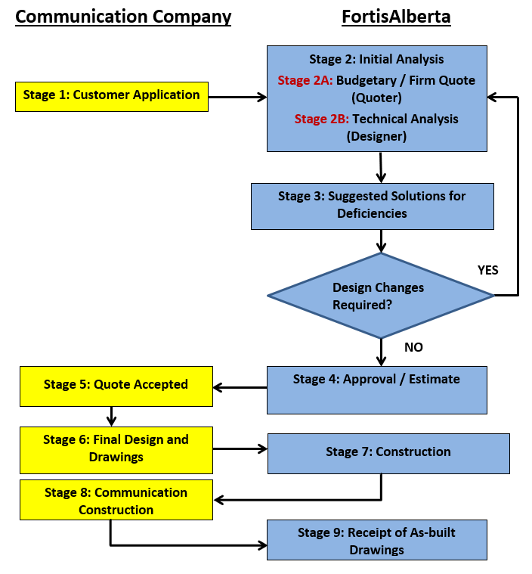

  - STAGE 1: Licensed Occupant Application

Call FortisAlberta: 310-WIRE (9473) or complete an application form in the FortisAlberta website “Get Connected”.

Provide the following information:
- contact information
- address and Legal Land Location of the project
- 3rd party Authorization (i.e., for Consultants)
- number of poles to attach

Electric service requests (for its devices and equipment, commonly referred to small connected devices) in addition to proposed wireline attachments should be made as one application to FortisAlberta. Refer to requirements specified in D08-08.3, Licensed Occupant Guide: Small Connected Devices.

The licensed occupant must indicate if they require a “budgetary estimate” or a “firm quote”. Details of budgetary estimate and a firm quote are discussed in Stage 2.

The licensed occupant should have obtained and gathered the required pole information (as specified in D08-08.1, Section 18) prepared in an electronic format, and ready for submission.
  - STAGE 2: Initial Analysis (FortisAlberta)

STAGE 2A: Basic Analysis (Quoter)
      - Budgetary Estimate (Quoter)
- FortisAlberta will only provide a budgetary cost of replacing the poles.
- If the licensed occupant would like to proceed with their project and obtain a “Firm Quote”, the licensed occupant must notify FortisAlberta and follow Section 4.2.1.2.
      - Firm Quote (Quoter)
- The licensed occupant must maintain a Licensed Occupancy Agreement with FortisAlberta.
- The licensed occupant has provided all the required information.
- FortisAlberta will complete a structure analysis on each pole proposed for attachment to determine if the pole needs replacement or not.
- FortisAlberta will provide a firm quote.

STAGE 2B: Technical Analysis (Designer and Engineer)
      - FortisAlberta will complete an evaluation and study (i.e., detailed pole analysis, identifying conflict, additional work) based on the project scope and information provided by the licensed occupant.
      - The licensed occupant must provide additional or missing information as identified and requested by FortisAlberta.
  - STAGE 3: Suggested Solutions for Deficiencies

FortisAlberta will identify and notify the licensed occupant of deficiencies or conflicts (i.e., future upgrades, conflicts, structural failures, not meeting code requirements) that will affect the licensed occupant application and may offer solutions (i.e., pole replacement, add guy, etc.) for consideration.
Note: FortisAlberta is not responsible for developing designs (acting as consultants) but to act primarily as an approving official.

If FortisAlberta has notified the licensed occupant of deficiencies or conflicts, the licensed occupant must provide a solution and re-submit their design to FortisAlberta.
  - STAGE 4: Approvals / Estimate

The following 3rd party approvals will be obtained, as applicable.

Railway Crossings
      - Details of the costs for railway crossings will be provided in FortisAlberta’s quote letter.
      - FortisAlberta will manage the railway crossing application to the railway property owner.
      - Prior to the application, FortisAlberta will provide a railway drawing and a “Letter to 3rd Party Company” to the licensed occupant.
      - The licensed occupant must complete and send the letter back to FortisAlberta.
      - FortisAlberta will submit the railway crossing application to the railway company.
      - If FortisAlberta receives a railway crossing approval, FortisAlberta will provide a copy of the approval to the licensed occupant.

Municipal Approval
      - The licensed occupant must provide a copy of the Municipal approval to FortisAlberta at this stage.

Quote Package and Estimate Prints
      - FortisAlberta will provide a print showing FortisAlberta’s scope of work and send a quote package to the licensed occupant.
  - STAGE 5: Quote Accepted

The licensed occupant must review the quote package. If accepted, the licensed occupant must return a signed copy of the quote letter back to FortisAlberta, and with the required payment.

FortisAlberta will start with the billing of license occupant attachments after FortisAlberta received the signed quote letter from the licensed occupant.
  - STAGE 6: Final Design and Drawings

The licensed occupant must submit three hard copies (electronic format is accepted) of the final design and stamped with “Issued for Construction (IFC)”.

FortisAlberta will review and accept (or reject) the licensed occupant’s IFC prints.

Upon acceptance by FortisAlberta, FortisAlberta will return one copy of the accepted IFC print to the licensed occupant. The licensed occupant must reproduce the FortisAlberta accepted IFC print for use in construction.

NOTE: If FortisAlberta does not need to complete any work (i.e., replace pole), the licensed occupant may proceed to Stage 8: Communication Construction.
  - STAGE 7: Construction

FortisAlberta will proceed with construction of its facilities and will notify the licensed occupant after the work is complete.

The licensed occupant must not attach any facilities on FortisAlberta structures until after the required FortisAlberta work is complete.

The licensed occupant may proceed to construction after the licensed occupant received a notification from FortisAlberta of construction complete.
  - STAGE 8: Communication Construction

The licensed occupant must call 310-WIRE (9473) and arrange for a FortisAlberta Area Coordinator (AC) for an overhead power line orientation and start-up construction meeting for the installation of licensed occupant’s facilities on FortisAlberta’s poles.

Overhead orientations, start-up meetings, and inspections
      - The licensed occupant should arrange an overhead orientation and start-up construction meeting on any additions or modifications of attachments as listed in Section 4.3.
      - The FortisAlberta Area Coordinator must have a copy of the FortisAlberta’s IFC print before proceeding to have a start-up meeting and overhead orientation.
      - The licensed occupant’s construction representatives must have a copy of the FortisAlberta accepted IFC print during the start-up and overhead orientation meeting.
      - The FortisAlberta Area Coordinator reserves the right to inspect and to schedule inspections on licensed occupant’s facility installations on poles.

Proposed Changes to Accepted IFC Prints
      - If the licensed occupant must make minor design or construction changes, the licensed occupant must coordinate with the FortisAlberta Area Coordinator.
      - If the licensed occupant must make major changes, the licensed occupant’s representative must coordinate with the FortisAlberta Designer and request in writing (i.e., letter, email, fax) indicating the proposed changes and the reasons for the changes, including sufficient details and/or plans to clearly outline or depict the scope of the proposed changes.
      - The FortisAlberta Design representative will review the request and check if the proposed changes can be completed and recorded as “red-line” as-built changes or whether the proposed changes are significant enough to warrant the submission of revised IFC engineering drawings for FortisAlberta’s Acceptance again.
      - If construction has begun and a physical obstruction requires changes to the proposed design or layout, it is the licensed occupant’s representative responsibility to coordinate the request as outlined above.
      - Approved deviations or changes in FortisAlberta accepted IFC prints shall be marked with a red ink pen on the IFC print. This will help ensure that FortisAlberta’s facilities are not put into jeopardy and that the changes will not affect the proposed design.
  - STAGE 9: Receipt of As-Built Drawings

No changes or deviations from Issued for Construction (IFC) print:
      - If there are no deviations from the FortisAlberta accepted IFC print, the licensed occupant’s representative must notify FortisAlberta’s Designer in writing, within thirty (30) days of its construction completion.

With changes or deviations from Issued for Construction (IFC) print:
      - The licensed occupant’s representative is responsible for all corrective actions and costs related to correcting any deficiencies or any non-approved alterations made with reference to FortisAlberta accepted IFC prints.
      - If there are changes or deviations from the accepted IFC prints, the licensed occupant must note these changes with red ink on the FortisAlberta’s accepted IFC prints (referred to “as-built” drawings). The licensed occupant must provide the “as-built” drawings to the FortisAlberta Designer within thirty (30) days upon completion of their work so that FortisAlberta may verify the proper installation of the communication facilities.

Railway Crossing As-Built Drawings
      - The licensed occupant must supply FortisAlberta Designer of “as-built” records of the railway crossing installation as soon as construction is complete.
- CONTACTS FOR FURTHER CLARIFICATION
Please forward your questions to Licensed Occupancy mailbox licensedoccupancy@fortisalberta.com.

Version History

Version | Comments | Date
0 | Document created. | January 19, 2023
1.0 | Section 3, Schedule of fees updated.  Section 5, Updated contact information. | January 24, 2024

