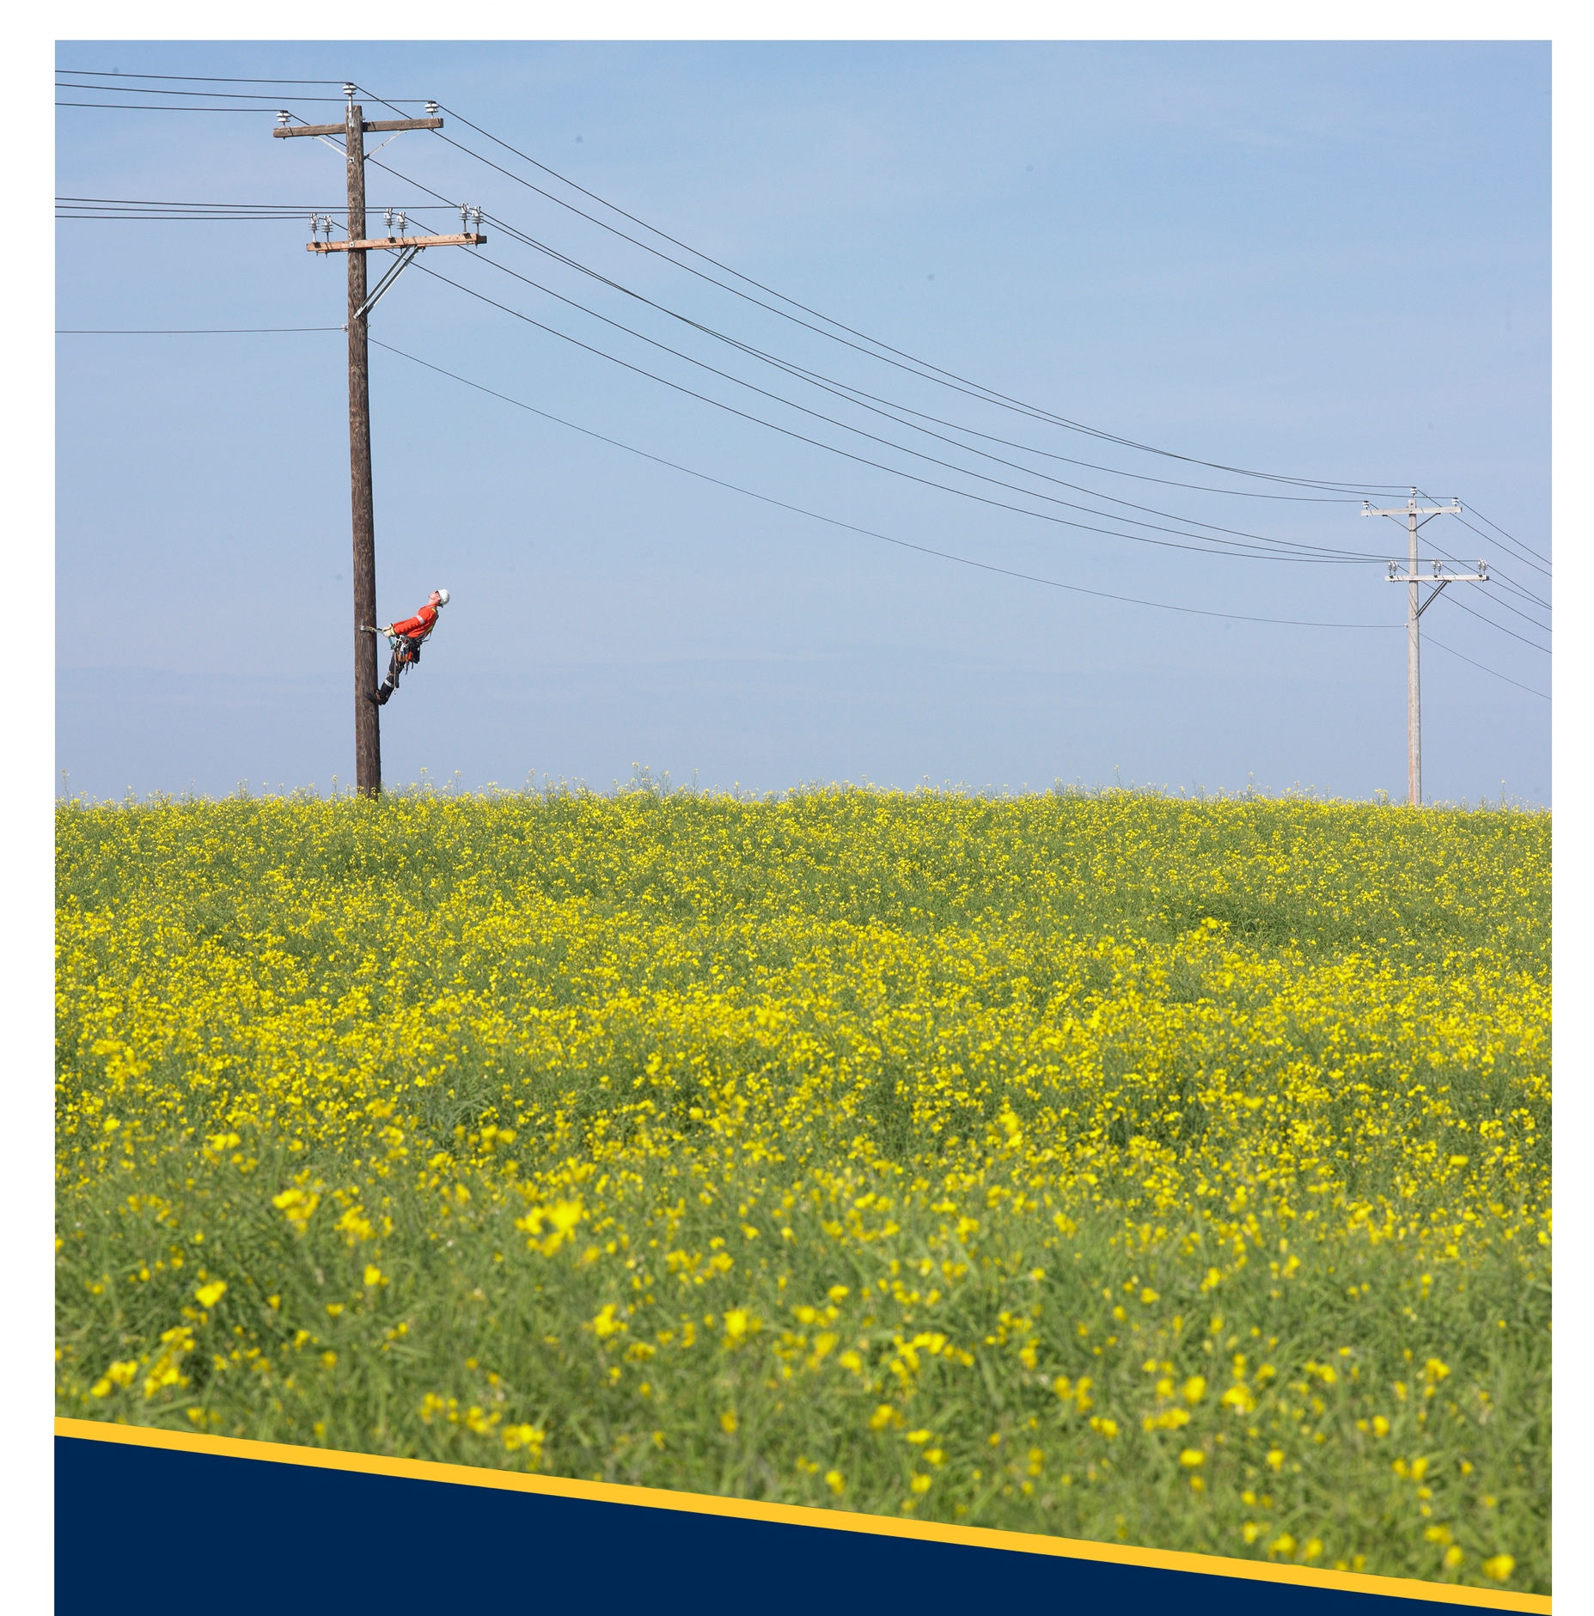
Licensed Occupancy
Small Connected Devices Attachment Process
Revision No: 1.1


Copyright © 2023 FortisAlberta. All rights reserved. This document is the proprietary and confidential property of FortisAlberta Inc.
No modifications, reproduction, or further distribution of this document is permitted, in whole or in part, without written consent of FortisAlberta.
FortisAlberta accepts no liability for unauthorized use of this document. Printed on Jan. 24, 2024 at 2:17 PM.
The current revision is on FortisAlberta Standards Database.

Table of Contents
1. Scope 3
2. Purpose 3
3. Schedule of Fees 3
4. Licensed Occupancy Small Connected Devices Attachment Process 3
5. CONTACTS FOR FURTHER CLARIFICATION 6

The previously published revision was Rev #1, July 27, 2023.

Scope

This document outlines FortisAlberta’s application process and workflow for licensed occupant Small Connected Device (SCD) attachments on poles and on strand.

The D08-08.3 Licensed Occupant Guide: Small Connected Device Attachments details the requirements for the safe installation, operation, and servicing of SCD attachments on pole and on strands.

Purpose

To guide the licensed occupant in the process and workflow when making SCD attachment applications.

To facilitate the interaction between FortisAlberta and the licensed occupant in processing SCD attachment applications.

Schedule of Fees

The licensed occupant shall be responsible for any applicable fees as per the “Licensed Occupancy: Schedule of Fees” (link).

Licensed Occupancy Small Connected Devices Attachment Process

STAGE 1: Licensed Occupant Application
- Call FortisAlberta: 310-WIRE (9473) or complete an attachment and service request in the FortisAlberta website “Get Connected Joint Use Attach to FortisAlberta Equipment”.
- In addition, and for each device type, the licensed occupant must complete the “Licensed Occupancy Small Connected Device Application Form” by supplying the latest information available. Missing or lacking information submissions will be returned to the customer. Additional information is provided below to assist the customer in completing the application form.

Customer and General Information

Provide Company information including contact person(s), planned date of installation, expected start date of operation, and planned maintenance schedules.

Description of System

Specify municipal service area and provide a map to indicate proposed location of devices.

Detailed location of device(s) such as coordinates (Latitude, Longitude) or legal land description, addresses and position.

Provide antennae direction, height, gain, and power of the device.

Provide a detailed description of the device or system.

Indicate any special conditions to install the device(s) – such as Radar.

Does the small device require regulatory approval to operate in the area where the pole is located? (i.e., ISED licenses, Cellular provider approvals, NAV Canada, Transport Canada, Public Consultation)

Device Details

Indicate device type (such as Booster, Land Mobile Radio, Camera, Wi-fi, Small Cell)

Specify the brand, model, and manufacturer of the device.

Physical and Power Characteristic of the device

Mass/Weight (kg)

Dimensions (height, width, depth)

Indicate height of attachment from the top of the device to ground level.

Specify if CSA approves device.

Attachment material details (i.e., clamps, straps, stand-off brackets)

Power requirements

Device voltage (i.e., 110V)

Maximum Wattage (i.e., 200W)

Number of phase (i.e., single phase)

Number of wires (i.e., 2 Wire)

Radio Frequency (RF) Characteristics of device

Provide coverage (footprint) of wireless devices: (i.e., GIS spatial data shapefile, geodatabase, heat maps)

Provide operating frequency bands, and bandwidth of the device.

Safety Code 6 – Completed study indicating controlled and uncontrolled environment exposure limits. The licensed occupant must provide an Authenticated/Validated Safety Code 6 study.

Provide specifications sheets of the device.

Drawings and Schematics

Provide plan view drawings, diagrams, photographs, and schematics as you can to get a clear understanding of your request.

Network Design

Installation Plan

Site Plan indicating location of fiber optic cables and wireless devices.

Schematic/Block Diagram

Pictures of device.

- The Customer should arrange to meet and to collaborate with FortisAlberta Design representative in verifying proposed poles for licensed occupancy in the field, prior to finalizing plans of licensed occupancy attachments.

NOTE: The FortisAlberta representative will assist the customer in identifying the recommended poles to attach on. This is to avoid rejecting multiple customer submissions on poles that are restricted. The customer may then revisit their design plans by placing their devices on the recommended pole locations.
- The licensed occupant must make their electric service requests (for its devices and equipment, commonly referred to SCD) as one application to FortisAlberta. Refer to requirements specified in D08-08.3, Licensed Occupant Guide: Small Connected Devices.
- The licensed occupant should have completed the “Licensed Occupancy Small Connected Device Application Form,” prepared in an electronic format, and ready for submission.

STAGE 2: Initial Analysis (FortisAlberta)

STAGE 2A: Basic Analysis (Quoter)
To proceed with the firm quote:

the licensed occupant must maintain a Licensed Occupancy Agreement with FortisAlberta.

the licensed occupant has provided all the required information.
The application will then proceed to the next stage.

STAGE 2B: Technical Analysis (Designer and Engineer)
The licensed occupant must provide additional or missing information as identified and requested by FortisAlberta.
FortisAlberta will complete an evaluation and study (i.e., site visit, pole analysis and profile, vertical pole separations, electric servicing requirements) based on the project scope and information provided by the licensed occupant.

STAGE 3: Approvals / Estimate
- Municipal Approval - The licensed occupant must provide a copy of the Municipal approval to FortisAlberta at this stage.
- Quote Package and Estimate Prints - FortisAlberta will provide a firm quote with an estimate print showing FortisAlberta’s scope of work and customer devices height of attachment of devices. FortisAlberta will send a quote package to the licensed occupant.

STAGE 4: Quote Accepted
The licensed occupant must review the quote package and the estimate print. If accepted, the licensed occupant must return a signed copy of the quote letter back to FortisAlberta, and with the required payment.
NOTE: FortisAlberta will start with the billing of license occupant attachments (i.e., pole attachment fee) after FortisAlberta received the signed quote letter from the licensed occupant.

STAGE 5: Construction (Make Ready Work)
FortisAlberta will proceed with construction of its facilities and will notify the licensed occupant after Make Ready Work is complete.
The licensed occupant must not attach any facilities on FortisAlberta structures until after the Make Ready Work is complete.

STAGE 6: Licensed Occupant Construction and Notification of Construction Complete
The licensed occupant must call 310-WIRE (9473) and arrange for a FortisAlberta field representative for an overhead power line orientation and start-up construction meeting prior to installing the small connected device on pole or on strands.
Overhead orientations, start-up meetings, and inspections
  - The licensed occupant construction representative must have a copy of the FortisAlberta estimate print with details of the height of attachment of the small connected device on the pole.
  - The FortisAlberta Field representative reserves the right to inspect and to schedule inspections on licensed occupant’s facility installations on poles.
  - Licensed Occupant accountabilities:
- The licensed occupant shall be responsible for the installation of its facilities on approved poles and/or strands.
- The licensed occupant shall attach its small connected devices based on approved heights of attachments on each pole (as specified in the estimate print) or on approved strand location.
- Connect the licensed occupancy device conductors (Line, Neutral, Ground wires) at the load side of the breaker, neutral, and ground terminals, respectively, inside the FortisAlberta load center. NOTE: Ensure the breaker is in the “OFF” position before making any connections.
- Each attached device must have a clear/unique weatherproof tag identifying owner, contact phone number and device identifier.
- Notify FortisAlberta field representative of construction completion, and request for inspections and acceptance of completed licensed occupancy installations on poles.
- Correct any deficiencies of attachments as identified by the FortisAlberta field representative.
- Turn the breaker to the “ON” position (inside the load center) to energize the licensed occupancy device on the pole.
- Licensed occupant representative to contact retailer to request service connection to have power turned on at each site.
Licensed Occupant Proposed Changes to Attachment on Poles
- If the licensed occupant must make design or construction changes, the licensed occupant must coordinate with the FortisAlberta Field representative.
- FortisAlberta field representative may approve minor changes. Major changes may require FortisAlberta Design representative review and approval before making changes. NOTE: Major changes may require scope change in make ready work. This may move project back to the process of quoting and estimating.

STAGE 7: FortisAlberta Acceptance of Licensed Occupant Attachment
FortisAlberta will complete inspection of small connected device attachments on pole. Where customer installations satisfy FortisAlberta standards and approved height of attachments, the FortisAlberta field representative may proceed to accept the licensed occupancy installations on poles.

CONTACTS FOR FURTHER CLARIFICATION
Please forward your questions to Licensed Occupancy mailbox licensedoccupancy@fortisalberta.com.

Revision Tracking Table
Rev | Date | Summary of Changes
0 | March 10, 2023 | Document created.
1 | July 25, 2023 | Included details of Licensed Occupancy SCD Application Form.
1.1 | January 24, 2024 | Section 3, Updated schedule of fees.  Section 5, Updated contact information.

