

Licensed Occupant Guide: Distributed Energy Resources
D08-08.4
Revision No: 1.0

Copyright © 2023 FortisAlberta. All rights reserved. This document is the proprietary and confidential property of FortisAlberta Inc.
No modifications, reproduction, or further distribution of this document is permitted, in whole or in part, without written consent of FortisAlberta.
FortisAlberta accepts no liability for unauthorized use of this document. Printed on Dec. 12, 2023 at 9:18 AM.
The current revision is on FortisAlberta Standards Database.

YYYY / MM / DD: 2023 / 12 / 12
Prepared |  | Approved | Ownership | Authentication | Responsible Member Validation
Chris Mateo, P.Eng.  Sr. Standards and Projects Engineer |  | Kevin van Popta, P.Eng.  Principal Engineer, Standards & Operations | Licensed Occupancy Steering Committee and  Standards & Projects Engineering | 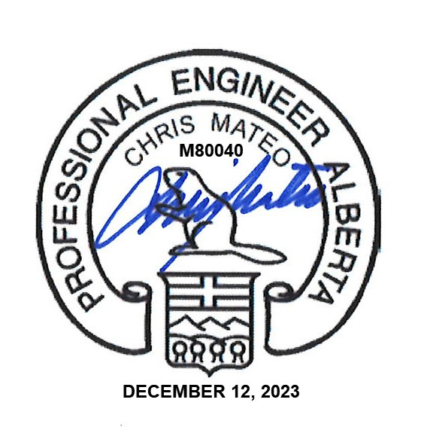  Authenticated and validated original filed with the Engineering Department | Responsible Member Validation
 |  |  |  |  | APEGA PERMIT NUMBER: P07387
Kevin Van Popta, P.Eng.


Additional Reviewers and/or Contributors | Ken Davis, Utility Services Manager  Shawn Morgan, Supervisor Field Technical Services

Table of Contents
1. Scope 3
2. Purpose 3
3. Normative References 3
4. Glossary 3
5. Legislation 4
6. General Requirements 6
7. Supply of Pole for Attachments 7
8. DER Facility and FortisAlberta 8
9. Customer Junction Box at the Recloser Pole: 11
10. DER Facility and Transmission Utility 15
11. Load Center and Standard Servicing for Customer Devices on poles 15
12. Backup Power (Batteries) 17
13. Maintenance Work on the Pole 17
14. Grounding and Bonding 17
15. Customer Responsibilities 17
16. FortisAlberta Responsibilities 19
17. Vertical Separations at the Pole 19
Annex A Remote and Transfer Trip Schemes (Informative) 21
Annex B Connection Authorization Form (Normative) 22
Annex C Example of Proposed DER Attachments on Pole (Informative) 23
Annex D DTE and DCE Devices (Informative) 24
Annex E Bibliography (Informative) 25

The previously published revision was Rev #0, July 27, 2022. Significant content changes shown in purple for convenience.

Scope

This document provides the details and requirements for attaching and approving Distributed Energy Resource (DER) Attachments on FortisAlberta poles. This document also provides various ways and options in providing electric service to DER attachments, as required.

The requirements and instructions in managing and approving telecommunication wireline attachments on FortisAlberta poles are provided in D08-08.1 [B1].

The requirements and instructions in managing and approving the attachment and servicing of municipal attachments on FortisAlberta poles are provided in D08-08.2 [B1].

The requirements and instructions in managing and approving the attachment and servicing of small connected devices on FortisAlberta poles are provided in D08-08.3 [B1].

The application process to attach on FortisAlberta poles is provided in the Joint Use Process (external) [B2] document.

Purpose

To provide details and requirements for the safe installation and operation of DER attachments on FortisAlberta poles and to meet applicable codes and regulations.

Normative References

Workers shall be competent in FortisAlberta standards:
- D08-08 – Joint Use: General (Internal Standard Only) [B1]
- D08-08.3 – Joint Use: Small Connected Devices [B1]
- FortisAlberta Joint Use Process (External) [B2]

Glossary
DER Attachment(s): are telecommunication facilities used to send remote or transfer trip signals from the DER facility to a distribution or transmission facility and vice versa. DER attachments typically include antennae, radios, control or junction box, fibre optic cables, and accessories.
Effectively grounded: permanently connected to earth through a ground connection of sufficiently low impedance and having sufficient current-carrying capacity to prevent the buildup of voltages that can result in undue hazard to connected equipment or to persons.
Licensed Occupant: the party that has entered into an agreement with FortisAlberta that allows it to attach its facilities to FortisAlberta poles. The licensed occupant is referred to as the Licensee within the agreement.
Remote Trip signals: are signals sent by the DER facility owner to the distribution utility (i.e., FortisAlberta) to disconnect the DER facility from the distribution utility due to various reasons, such as DER breaker failure. The DER facility sends a trip signal to a FortisAlberta protective device (such as a recloser or an MVI structure) to trip open. As such, remote transfer trip signal interconnections and licensed attachments are installed on a pole adjacent to a FortisAlberta recloser structure or in a padmounted MVI structure. See Annex A.
Transfer Trip signals: are signals sent by the distribution utility (i.e., FortisAlberta) to the DER facility for the purpose of disconnecting the DER system from the grid. This protection scheme event happens when power from the electric utility is cut off. As such, the DER facility must stop feeding power to the distribution utility grid - known as anti-islanding. Trip signals are sent from a FortisAlberta recloser structure to trip open a DER facility. As such, the interconnections and licensed attachments are installed on a pole adjacent to a FortisAlberta recloser structure. NOTE: MVI structures are not used to send transfer trip signals to the DER facility. See Annex A.

Legislation

Alberta Electrical Utility Code (AEUC)
The Alberta Electrical Utility Code (AEUC) [B3], provides the minimum safe limits of approach for persons and equipment performing activities near overhead power lines and definitions of utility worker and qualified utility worker.

A person must notify FortisAlberta, by calling 310-WIRE (9473), before any activities are undertaken or equipment is operated within 7.0 meters of FortisAlberta’s electric distribution system, to:
- Determine the voltage of the powerline; and
- Establish the safe limit of Approach distance as listed in Section 2-014 and Table 1.

Section 2-014 and Table 1, safe limits of approach
- 0 – 750 V insulated, or polyethylene covered conductors 0.3 m
- 0 – 750 V bare, uninsulated 1.0 m
- Above 750 V insulated conductors ^{2,} 1.0 m
- 0.75 kV – 40 kV 3.0 m

The required safe limits of approach do not apply to movement of persons, equipment, buildings, vehicles, or objects under FortisAlberta’s overhead powerlines.

Occupational Health and Safety Code
Occupational Health and Safety Code – Alberta Regulation 191/2021 [B4] and Explanation Guide provides further guidance on the safe limit of approach distances as specified in the AEUC.

Section 225 (2), An employer must notify the operator of an energized overhead power line before work is done or equipment is operated in the vicinity of the powerline at distances less than the safe limits of approach as specified below and obtain the operator’s assistance in protecting workers involved.
- 0 – 750V insulated or polyethylene covered conductors 0.3 m
- 0 – 750V bare, uninsulated 1.0 m
- Above 750V insulated conductors ^{4,} 1.0 m
- 0.75V – 40kV 3.0 m

CSA C22.3 No. 1-20, Overhead Systems

CSA C22.3 No. 1-20 Overhead Systems [B5], specifies the Minimum Vertical Separations at a Joint Use structure and working space to allow workers to have access to equipment and conductors and to allow for the installation of the equipment on the structure. FortisAlberta’s interpretation is that these separations do not include the minimum approach distance required by AEUC.
- 0 – 750V supply conductors and Communication line plant 1.0m
- > 0.75kV up to and less than 22kV supply conductors 1.2m
- Luminaires span wires or brackets and communication line plant
- Not effectively grounded 1.0m
- Effectively grounded 0.1m

Safety Code 6: Health Canada’s Radiofrequency Exposure Guidelines [B6]
Safety Code 6 provides technical information for guiding individuals or groups in their understanding of Health Canada’s radiofrequency (RF) exposure guidelines.

Uncontrolled and controlled environments
Controlled environments are defined as those that meets the following conditions:
- The RF field intensities were characterized by means of measurements, calculations, or modelling,
- The person exposed is aware of the potential for RF exposure and are cognizant of the intensities of the RF field in their environment, and
- The person exposed is aware of the potential health risks associated with RF field exposures and can control their risk using mitigation strategies.
Situations that do not meet the above conditions are considered uncontrolled environments.

Safety signs for RF protection
- Areas
Signs should be used to label areas where RF exposure levels may exceed exposure limits for controlled and uncontrolled areas.
- Devices
A Caution sign may be used to identify RF energy emitting devices that can produce exposures that can lead to injury from misuse.
A Danger sign may be applied to any device, if it produces exposure levels that pose a risk of immediate and severe injury.

General Requirements

A licensing occupancy project shall be initiated where there is a need to attach a DER facility on the Pole. This is to facilitate the review of DER Attachments on the pole; check if a licensed occupancy agreement is in place; scope the requirements of providing electric service, as required; and to keep records of DER Attachments on FortisAlberta poles.

The FortisAlberta Protection and Control (P&C) Engineering department shall be consulted on licensing occupancy requests requiring transfer trip and remote trip interconnections.
NOTE: The FortisAlberta P&C Engineer would collaborate with DER facility representative to define the scope of the DER interconnection and required protection assessments.

The Licensed Occupant shall not attach or perform any work on FortisAlberta poles without an approval by FortisAlberta. The FortisAlberta approval shall be in the form of acceptance of customer Issued for Construction (IFC) prints.

The Licensed Occupant proposing to attach DER facilities on FortisAlberta poles shall have and maintain a licensed occupancy agreement with FortisAlberta. To obtain more information, please contact FortisAlberta’s Contracts Services Department (e-mail: contracts@fortisalberta.com).

FortisAlberta is required to meet the requirements of the Alberta Electrical Utility Code (AEUC) [B3]. Therefore, the Licensed Occupant must also follow and meet the requirements of the Alberta Electrical Utility Code (AEUC) [B3].

The Licensed Occupant shall be responsible for the design, supply, and installation of their communication system on FortisAlberta poles.

The Licensed Occupant is to install their DER Attachments in accordance with the accepted IFC prints by FortisAlberta while respecting the applicable electrical safe limits of approach. The Licensed Occupant shall be responsible to utilize competent workers, as per Occupational Health and Safety Code – Alberta Regulation 191/2021 and other applicable requirements.

The provision of electrical services associated with the installation of DER Attachments on FortisAlberta poles shall meet FortisAlberta standards, and all applicable provisions of Alberta Electrical Utility Code (AEUC) [B3] and Canadian Electrical Code C22.1 [B7].

The Licensed Occupant shall secure all necessary permits and provide a copy to FortisAlberta representative. This includes but is not limited to an electrical permit, municipal approvals, land use, and environmental permits.
NOTE: In the absence of an electrical permit or inspection certificate (where the permitting authority does not provide permit or inspect electrical service installations on poles), the Licensed Occupant shall sign a Connection Authorization Form (see Annex B) and submit to FortisAlberta representative – indicating that the Licensed Occupant installation complies with applicable regulations and is ready to be connected to the electric distribution system.

The Licensed Occupant shall provide details of the device which may cause hazards or risks to a worker working on the pole.

The Licensed Occupant shall label their equipment on the pole. A UV rated adhesive label is to be used and shall include the following information:
- Project Name
- Date Installed
- Customer Name and Contact Number
- FortisAlberta Reference Project Number

The Licensed Occupant shall pay the applicable costs and fees as listed below:
- Application fee – administration fee billed at time of application
- Device review fee – fee to review Attachments billed at time of application
- Interconnection fee – fee to connect Attachment to the distribution system and will be part of FortisAlberta quotation.
- Project costs – refers to FortisAlberta costs needed to prepare the poles for attachments and are presented in a FortisAlberta quotation.
- Pole attachment fee – annual fee for attaching on FortisAlberta pole and are normally billed monthly.

The Licensed Occupant shall ensure all its interconnecting equipment is operational and clear of defect prior to interconnection to FortisAlberta equipment.

The Licensed Occupant shall complete a bi-directional OTDR test on fiber optic strands at 1550nm.

Supply of Pole for Attachments

If a new pole is required to attach DER Attachments, a request can be made to have FortisAlberta supply and install it.

The Licensed Occupant shall be responsible to pay for the associated costs of the installation of the new pole.

This installation is subject to applicable laws, approvals, land rights and engineering requirements.

Locations are generally restricted to acceptable locations within government road allowances and utility right of ways as determined by FortisAlberta. FortisAlberta will not supply and install pole on private property, in a location that requires regular land access costs, or one that has accessibility concerns.

The addition of a new pole may affect adjacent structures, such as with uplift issues or additional loading. As such, the Licensed Occupant shall pay the required changes in the system in accommodating this new pole.

DER Facility and FortisAlberta
DER attachments, interconnections, and servicing may be completed in various ways which depends on the location and existing electric distribution facilities.

Option 1 – Licensed Occupant installs and attaches DER facilities on their private pole.

Licensed Occupant installs their facilities on their private pole. The private pole is installed and maintained by the customer. This option is preferred where the DER customer could install a private pole on their property or on an easement. The private pole shall be installed a minimum of 15m away (and up to a maximum of 30m) from the electric distribution facilities (including poles, equipment, guys, and conductors). See Figure 1.
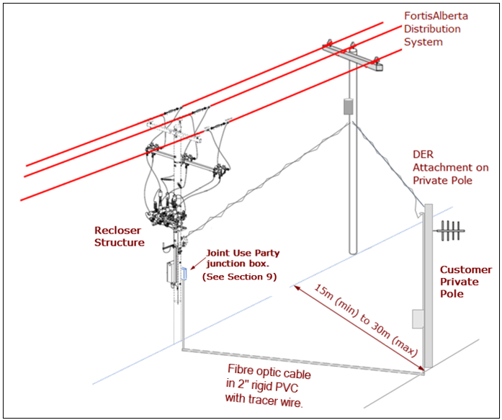

Figure 1: DER Attachments on private pole

The provision of electric service to DER Attachments, located on private pole, may be completed through an overhead or underground service and shall be completed in accordance with CEC C22.1 [B7] and FortisAlberta Service and Metering Guide [B9].
NOTE: The 3kVA transformer feeding the recloser structure shall not be used in providing electric service to the DER devices. Instead, a separate transformer shall be used in servicing these DER devices.

The fibre optic cable interconnecting the DER and the FortisAlberta control box shall be installed underground in a 2” rigid PVC with a tracer wire (to help identify underground facilities for locates).
NOTE: The overhead or aerial installation of customer telecommunication control cables at the recloser pole is not allowed. This is mainly in consideration of required vertical separations between power and communication facilities, maintaining minimum limits of approach, and grounding of the DER facilities at the recloser structure. The recloser structure is a busy structure with equipment, control boxes, cables, and antennae on the pole. The addition of these telecommunication cables to attach on the pole adds more facilities and would further restrict access and working space at the pole.

The attachments and interconnections of DER facilities at the recloser structure shall be completed in accordance with Section 9.

The grounding and bonding of the DER attachments on the pole shall be in accordance with Section 14.

When interconnecting with a FortisAlberta MVI structure, the recloser structure is simply replaced by an MVI padmounted structure. The same requirements provided in Section 8.1.1 to 8.1.3 shall be followed.

Option 2 – DER Attachment on an in-line adjacent pole, 15m away from a recloser structure

An in-line adjacent pole may be used for DER attachment. If not available, FortisAlberta may supply and install this pole in accordance with Section 7.
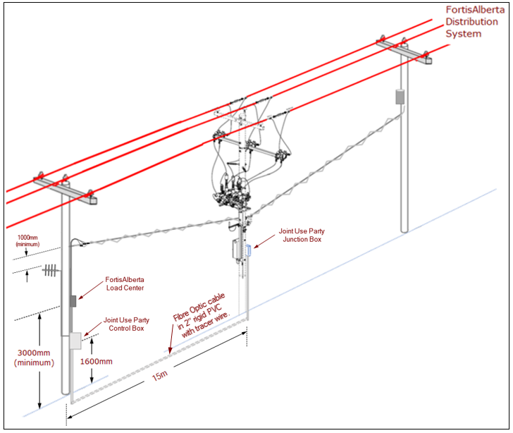

Figure 2: DER Attachments on an in-line adjacent pole

Electric service will normally be provided from an overhead transformer and in accordance with FortisAlberta Service and Metering Guide [B9].
NOTE: The 3kVA transformer feeding the recloser structure shall not be used in providing electric service to the DER devices. Instead, a separate transformer shall be used in servicing these DER devices.

The fibre optic cable interconnecting the DER facility to the FortisAlberta control box shall be installed underground in a 2” rigid PVC from the DER private pole to the recloser or MVI structure.
NOTE: The overhead or aerial installation of customer telecommunication control cables at the recloser pole is not allowed. This is mainly in consideration of required vertical separations between power and communication facilities, maintaining minimum limits of approach, and grounding of the DER facilities at the recloser structure. The recloser structure is a busy structure with equipment, control boxes, cables, and antennae on the pole. The addition of these telecommunication cables will put more facilities and would further restrict access and working space at the pole.

The attachments and interconnections of DER facilities at the recloser structure shall be completed in accordance with Section 9.

FortisAlberta to install a load center and provide electric service in accordance with Section 11.

The grounding and bonding of the DER attachments on the pole shall be in accordance with Section 14.

The Licensed Occupant must provide details of proposed attachments on the pole and submit an Issued for Review drawings to FortisAlberta representative. An example of an Issued for Review drawings of DER Attachments is available in Annex C.

When interconnecting with a FortisAlberta MVI structure, the recloser structure is simply replaced by an MVI padmounted structure. The same requirements provided in Section 8.2.2 to 8.2.4 shall be followed.

Customer Junction Box at the Recloser Pole:

A fibre optic cable must be used to interconnect the DER control device to the FortisAlberta recloser structure. The Licensed Occupant shall provide a 6-pair fibre optic cable that is single mode (or multi-mode) for Mirror bit bi-directional communications.

The fibre optic cable shall be installed in a 2” rigid PVC conduit, coming up to the junction box mounted on the recloser structure. See figure 3.

The Licensed Occupant shall supply and install a junction box at the recloser pole and meet the following requirements:
- Mount at 1.6m from ground to the centerline of the junction box.
- Must have dimensions of 12” (W) x 12” (H) x 10” (D), NEMA 3R, complete with back pan, and locking mechanism to accept a 5/16” diameter shackle.
- Must have knockout provisions for one – 2” rigid PVC conduit and one - 1” liquid tight flexible conduit.
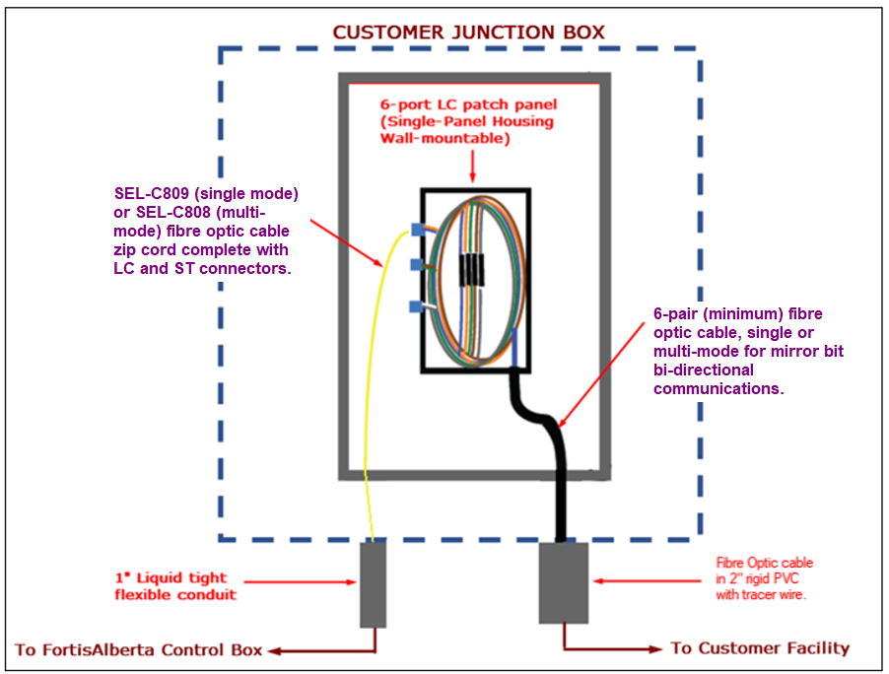

Figure 3: Customer junction box

In the junction box, the Licensed Occupant shall supply and install a fibre optic patch panel where the total fibre optic cable length is greater than 15m.
15m and less underground fibre optic cable do not require a patch panel. In this case, the ruggedized fibre optic cables shall be routed through the customer junction box and directly connected to the transceivers.
The patch panel must have 6x LC terminations, 2 strands to be patched into FortisAlberta control cabinet and 4 spare strands to be capped with factory provided dust caps.
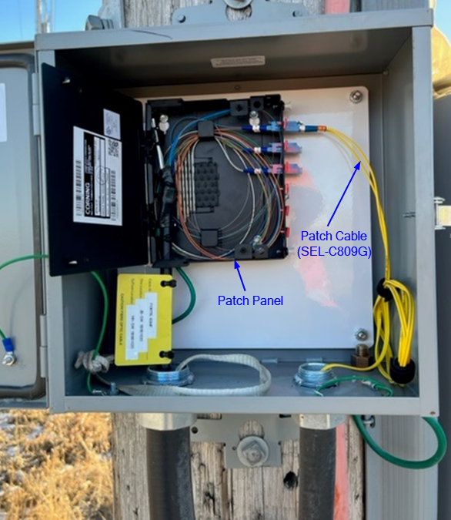

Figure 4: Customer Junction Box with Fibre Optic Patch Panel

The Licensed Occupant shall provide 1” liquid tight flexible conduit with appropriate fittings to connect between customer control box and FortisAlberta control box. Connections of flexible conduit at the FortisAlberta control box will be completed by FortisAlberta representatives.

The Licensed Occupant shall provide the following materials:
- 2 x 915900575—Mounting Kit for SEL Transceiver; includes mount and SEL-C641 cable (6 ft, DB-9 female to DB-9 male
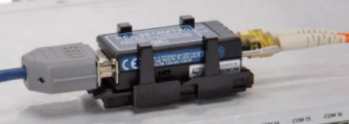

Figure 5: Mounting Kit for SEL Transceiver
- 4 x SEL-C809 Single mode (or SEL-C808 Multi mode) Fiber-Optic Cable zip cord 2 fiber 9 Micrometer Core Diameter Part Number: C809G020LSX0003 (2 cables for send and receive; 2 cables for spare send and receive).
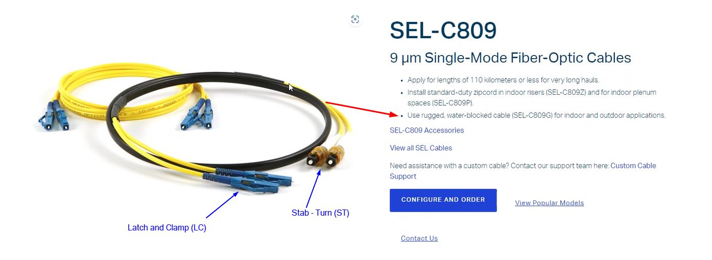

Figure 6: SEL-C809G - Patch Cables
- 2 x SEL-2829MX1 for Single-Mode Fiber-Optic Transceiver/Modem or 2 x SEL-2815M for multi-mode fibre optic cable.
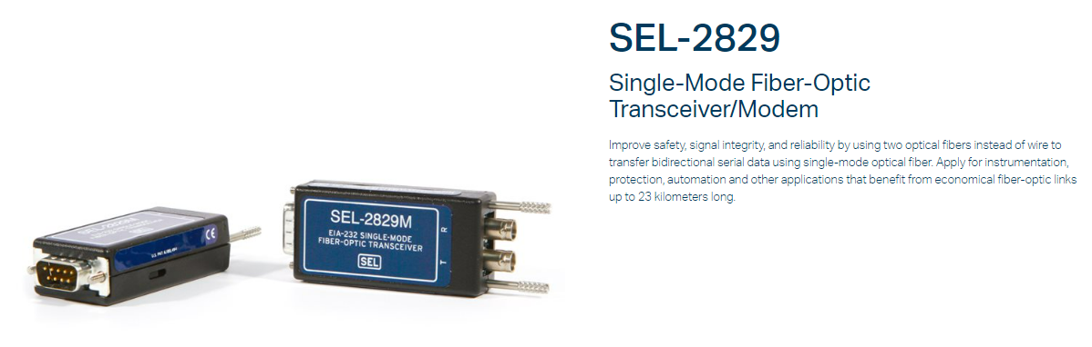

Figure 7: SEL-C809G - Patch Cables

The fibre optic cable shall be installed inside a 1” liquid tight flexible conduit (complete with connectors) and shall extend up to the FortisAlberta control box. Termination of fibre optic cable at FortisAlberta control box will be completed by FortisAlberta representatives.
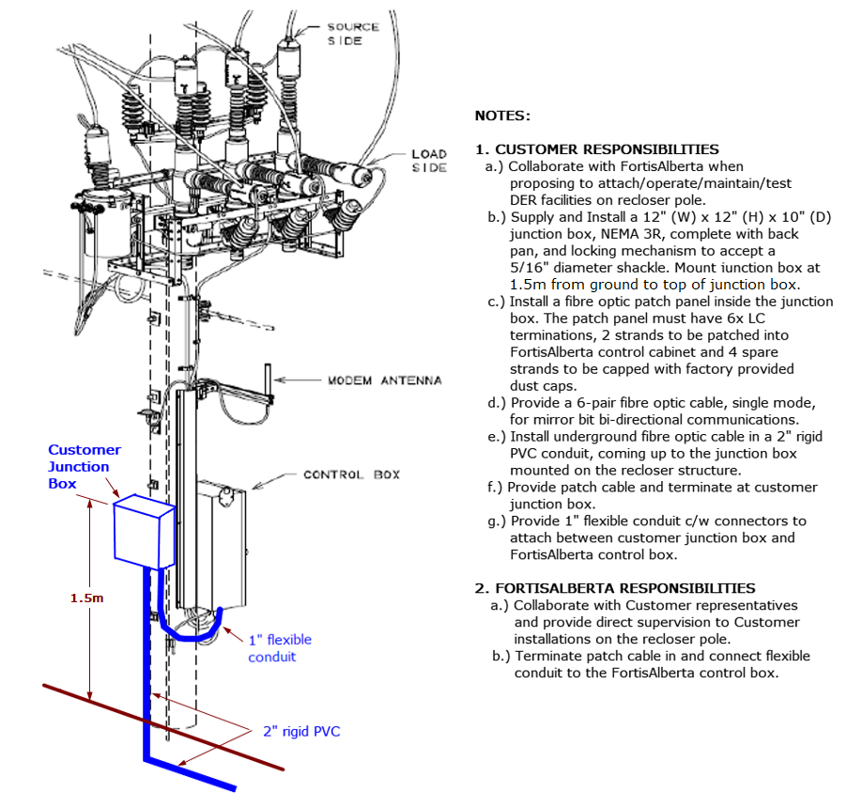

Figure 8: Fibre optic cables fed underground to the recloser structure.

DER Facility and Transmission Utility

DER customers may also request to attach remote and transfer trip devices on poles intended to coordinate with transmission utility facilities. These requests will generally require electric service and antennae are normally required to be attached higher on the pole for line-of-sight communications.

Since the interconnections happens between a DER facility and a transmission utility, these DER attachments do not need to be inter-connected to FortisAlberta protective devices. Instead, these DER Attachments are like small connected devices that may require to attach and take service on FortisAlberta pole. Please refer to D08-08.3 Joint Use, Small Connected Devices [B1].

FortisAlberta to install a load center and provide electric service in accordance with Section 11.

Load Center and Standard Servicing for Customer Devices on poles

The load center must be rated for outdoors, single phase, 2Wire, 15A, 120/240V AC system. See Figure 5.
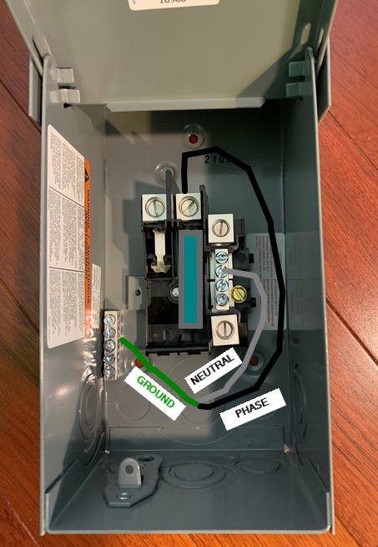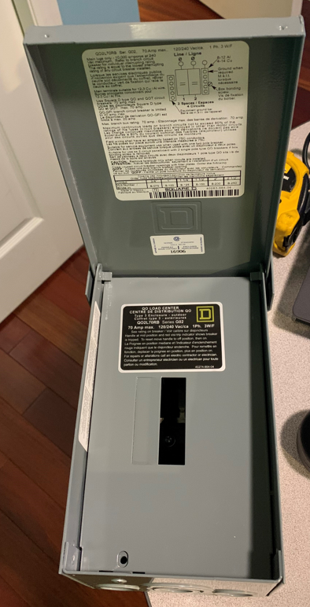

Figure 9: Load Center: showing the Line, Neutral, and Ground (3Wire) connections in the load center

The load center shall be installed a minimum of 3 meters from ground. See Figure 6.
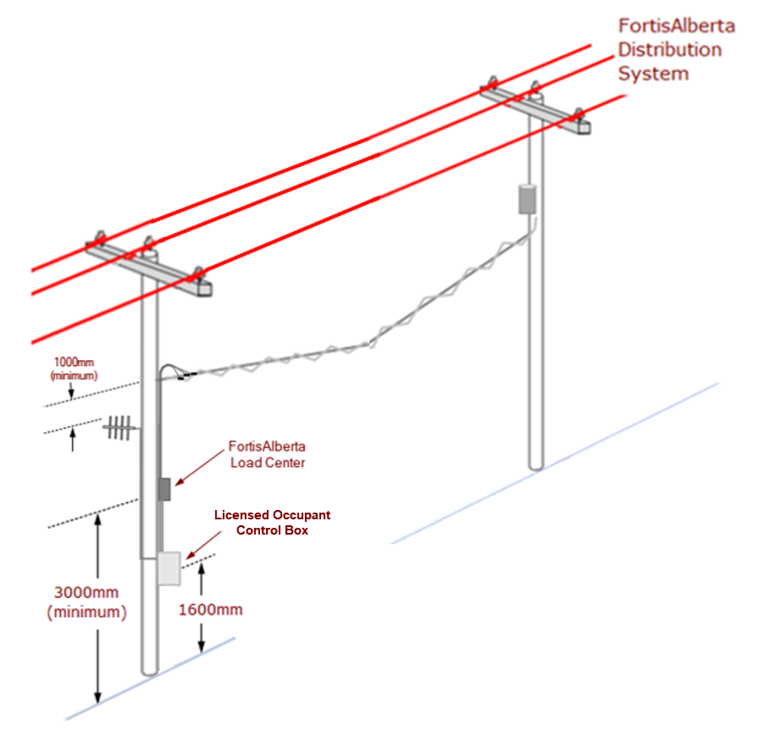

Figure 10: Load center and DER Attachments on an in-line adjacent pole

FortisAlberta will supply and install the load center on the pole, complete with line side service cables installed in liquid tight flexible conduits. The costs of these installations will be attributed to the customer through the interconnection fees.

The demarcation point of electric service will be at the load side of the load center.

The Licensed Occupant shall be responsible to supply the load side service conductors and connect their devices at the load side of the disconnect switch.

The Licensed Occupant shall install the load side service conductors in PVC or liquid tight flexible conduits (for mechanical protection), strapped directly on the pole, and shall be continuous from the load center up to the Licensed Occupant control box on the pole.

Backup Power (Batteries)

The radios on the pole may be an integral part of the signal scheme that is designed for the DER facility. If these radios lose power for any reason, the scheme automatically trips the DER facility main breaker on a communication fail.

Radio direct transfer schemes may require batteries to keep the radio powered during power outages (i.e., when the Fortis recloser is opened or when Altalink trips the line). The DER facility powerhouse needs to know if a signal has been initiated by FortisAlberta or AltaLink. As such, FortisAlberta will allow backup power for these devices on the pole. The backup power shall be limited to the required power and voltage of the attached devices on the pole.

Maintenance Work on the Pole

Where maintenance is required on the Pole, compelling the need to power down the radios to avoid harmful radio frequency exposures to the worker, arrangements should be made with the DER facility representative. The required maintenance work on the Pole will necessitate a DER facility outage to be arranged in advance.
NOTE: Maintenance work shall be coordinated between parties as per the DER Operating Agreement.

Grounding and Bonding

FortisAlberta will install and maintain the grounding electrode and grounding wires on the Pole.

The DER facility shall be bonded and grounded to the grounding downlead on the pole. The minimum bonding conductor shall be a minimum of # 6 AWG Cu insulated wire. Parallel Groove Compression connectors shall be used in making bonding connections to ground leads and shall be air sealed. The connection shall be made by a qualified utility worker. This is typically coordinated between FortisAlberta and the DER customer, where FortisAlberta representative may perform that actual work if the DER worker is not qualified, and it is agreed upon.

Customer Responsibilities

The Licensed Occupant shall be responsible for the design and installation of their facilities on the Poles.

Provide details of devices and equipment on the pole.
- Mass (kg)
- Dimensions (mm) (height, width, depth)
- Proposed Height of Attachments (top of box) (mm)
- Device Specifications (CSA Approved)
- Safety Code 6 information [B6]
- Power requirements
- Maximum Wattage (i.e., 150W)
- Number of phase (i.e., single phase)
- Number of wire (i.e., 2W or 2-Wire)

Submit two (2) hard copies of Issued for Review (IFR) drawings for review by FortisAlberta.
NOTE: FortisAlberta may elect to accept an electronic format of submission. Such acceptance is at FortisAlberta discretion and can be revoked at any time and make request to provide the required hard copies.

Drawings issued for FortisAlberta review must be stamped “Issued for Review (IFR)”.

Submit Issued for Construction (IFC) drawings for acceptance by FortisAlberta.

Drawings issued for FortisAlberta acceptance must be Authenticated and must be stamped “Issued for Construction (IFC).”

Drawings must include a signing block for FortisAlberta review and acceptance of the proposed attachment.
NOTE: Once FortisAlberta has accepted the drawings, these drawings are deemed “final” and frozen. All construction by the Customer representatives must be carried out in accordance with the FortisAlberta signed and accepted plans.

Issued for Construction (IFC) prints shall contain the minimum information as listed below:
- Plan view of the proposed pole locations.
- Details and dimensions of devices and attaching materials.
- Proposed attachment details on the Pole (typical installation)

Submit three hard copies (for file copy, FortisAlberta field representative copy, and Customer representative copy) of Issued for Construction (IFC) prints.
NOTE: FortisAlberta may elect to accept an electronic format of submission. Such acceptance is at FortisAlberta discretion and can be revoked at any time and make request to provide the required hard copies.

Upon receipt of Acceptance and approval to attach, the Licensed Occupant shall call 310-WIRE to arrange for an overhead orientation and pre-construction meeting with the local Area Coordinator (or equivalent representative).
NOTE: The accepted Issued for Construction (IFC) prints shall be made available on site and during the meeting. This is to help ensure for the Licensed Occupant and FortisAlberta Area Coordinator (or equivalent representative) are on the same page in understanding the scope of work on the Poles. The meeting will not proceed in the absence of an accepted IFC print.

Arrange with FortisAlberta local field representatives for attachment inspections.

Request for service connections.

Provide as-built drawings of completed attachments on the Pole, within 60 calendar days, upon construction completion.

FortisAlberta Responsibilities

Review completeness of information of proposed attachments on poles.

Review Issued for Review (IFR) drawings and provide recommendations and changes on the drawings, as required. Return a copy of the Issued for Review (IFR) drawings back to the customer representatives with completed review and comments.

Review and accept customer Issued for Construction (IFC) print. FortisAlberta acceptance of customer Issued for Construction (IFC) drawings shall indicate the name, signature, and date signed by the FortisAlberta representative.

Provide written approval to attach and return a copy of the accepted Issued for Construction (IFC) drawings back to the customer representative.

Attend pre-construction site meetings and provide overhead orientations.

Inspect customer attachments.

Connect service to the distribution system, as required.

Complete interconnection to the recloser control box, as required.

Assist Licensed Occupant with commissioning to test and verify the operation of the anti-islanding and remote trip function.

Assist Licensed Occupant with trouble shooting non communicating sites with confirmation that the mirror bit communication is operational to the serial port of the SEL relay.

Vertical Separations at the Pole

The required separations between the lowest primary supply facilities and the highest small connected device facility shall be 3.6m.

The required separations between the lowest secondary supply facilities and the highest small connected device facility shall be 1.6m.

The required vertical separations will help ensure the minimum limits of approach to the nearest primary and secondary supply facilities are maintained by the 3rd party worker on the pole.
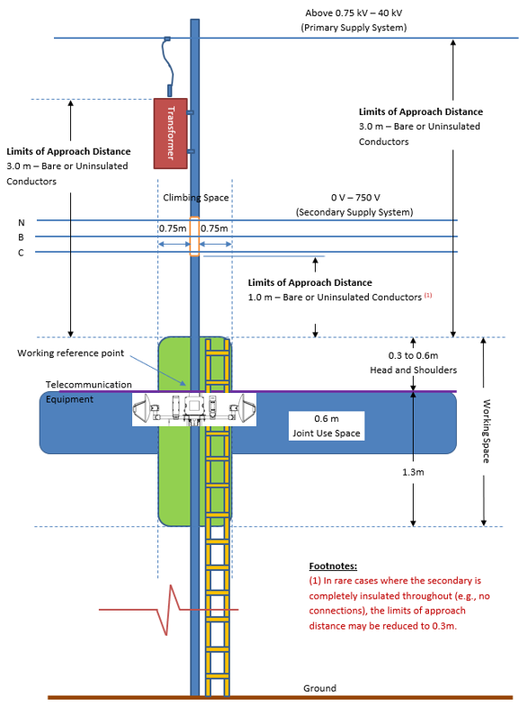

Figure 11: Sketch showing telecommunication equipment and a 3.6m safe limits of approach
(includes minimum 3.0m limits of approach distance + 0.6m head and shoulders).

Remote and Transfer Trip Schemes (Informative)

Radio signals:
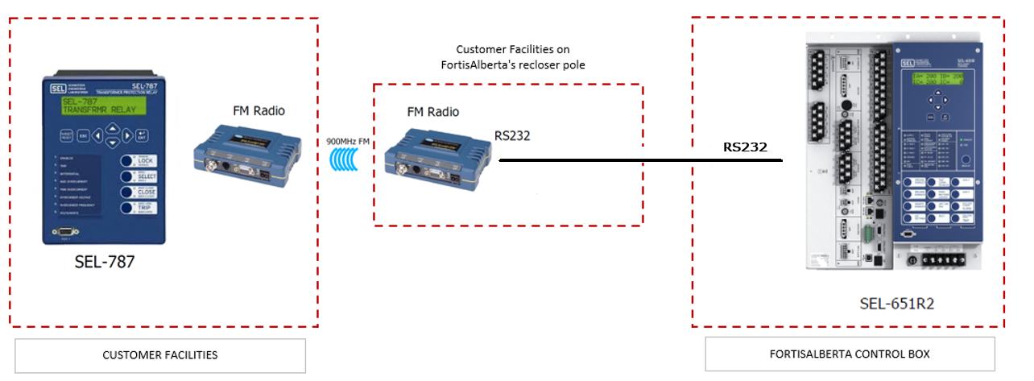

Hardwired fibre optic cables:
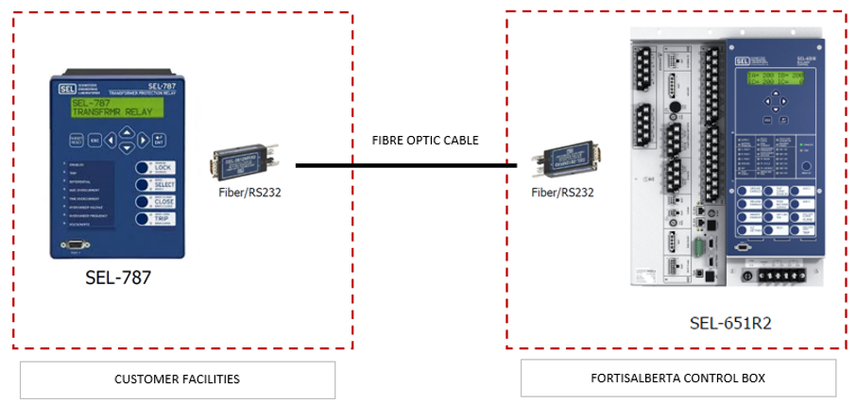

Connection Authorization Form (Normative)
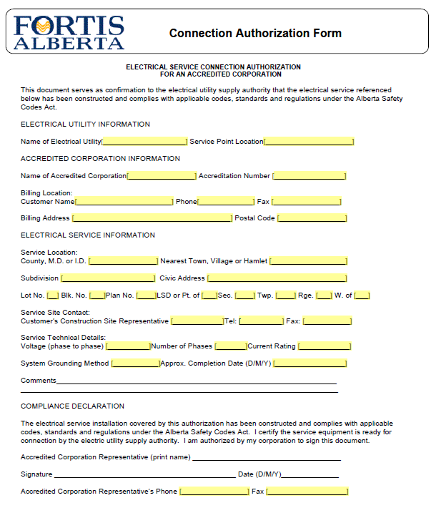

Example of Proposed DER Attachments on Pole (Informative)
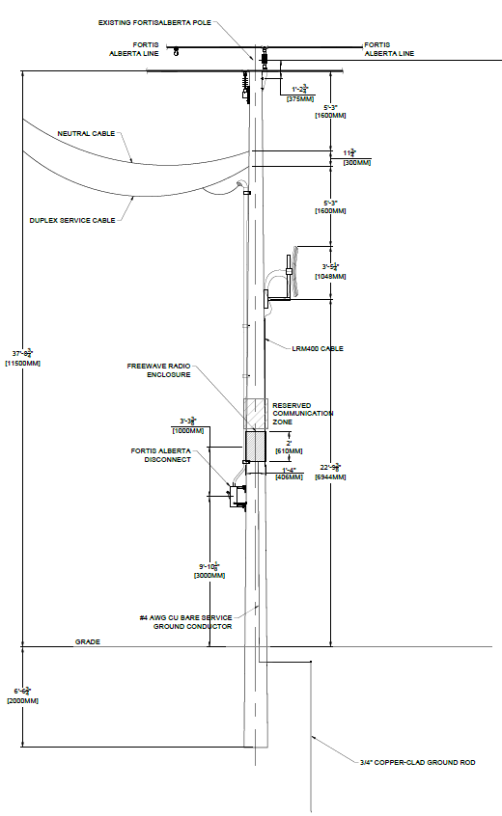

DTE and DCE Devices (Informative)
A DCE and DTE devices contain the same pin numbers and names, but their functions for transmitting and receiving data are opposite.
Fortis relay equipment is a Data Terminal Equipment (DTE). An example of DTE are customer relays, routers, and bridges. DTE devices are the source or destination of data. DCE devices are responsible for communicating those data. An example of DCE are radios or modems.
A null modem cable shall be used when two DTE devices are connected or when two DCE devices are connected.
A straight-through cable shall be used if a DCE device is connected to a DTE device.
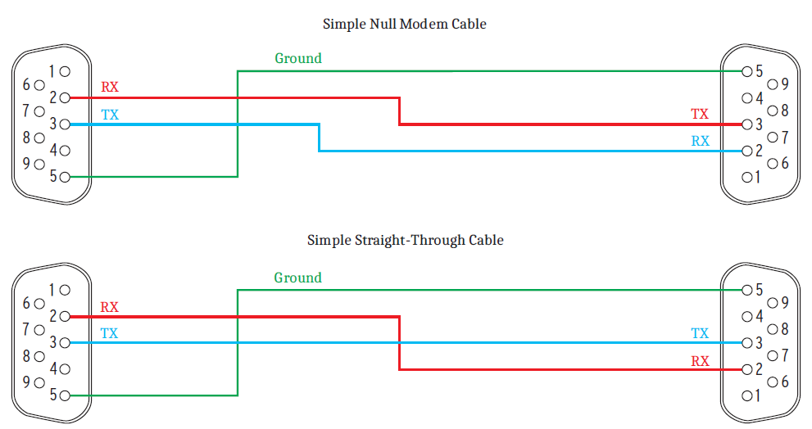

Bibliography (Informative)
[B1] FortisAlberta Licensed Occupant related standards.
  - D08-08 – Standards for use by internal FortisAlberta parties.
  - D08-08.3 – Joint Use: Small Connected Devices
[B2] FortisAlberta Joint Use Process, External. Available in the FortisAlberta external website.
[B3] Alberta Electrical Utility Code (AEUC), 6th Edition, Summer 2022
[B4] Occupational Health and Safety Code - Alberta Regulation 191/2021
[B5] Canadian Standards Association (CSA) C22.3 No.1-20, Overhead Systems
[B6] Safety Code 6, available from the government of Canada. “Limits of Human Exposure to Radiofrequency Electromagnetic Energy in the Frequency Range from 3 kHz to 300 GHz”.
[B7] Canadian Electrical Code (CEC) Part 1, Safety Standard for Electrical Installations
Licensed Occupancy Agreement
[B8] Electric Distribution System Franchise Agreements
[B9] FortisAlberta Service and Metering Guide, available on the FortisAlberta externa l website.

Revision Tracking Table
Rev | Date | Summary of Changes
0 | July 27, 2022 | Created document.
1.0 | December 12, 2023 | Figure 3: Updated showing single and multi mode options.  Section 9.6: Provided materials for use in single and multi-mode options.

Table 1, Safe Limits of Approach Distance from Overhead Power Lines for Persons and Equipment, AEUC 2022.
Conductors must be insulated or covered throughout their entire length to comply with these groups.
Conductors must be manufactured to rated and tested insulation levels.
Conductors must be insulated or covered throughout their entire length to comply with these groups.
Conductors must be manufactured to rated and tested insulation levels.
Table 23, Minimum Vertical Separations at a Joint Use Structure, CSA C22.3 No. 1-20.

