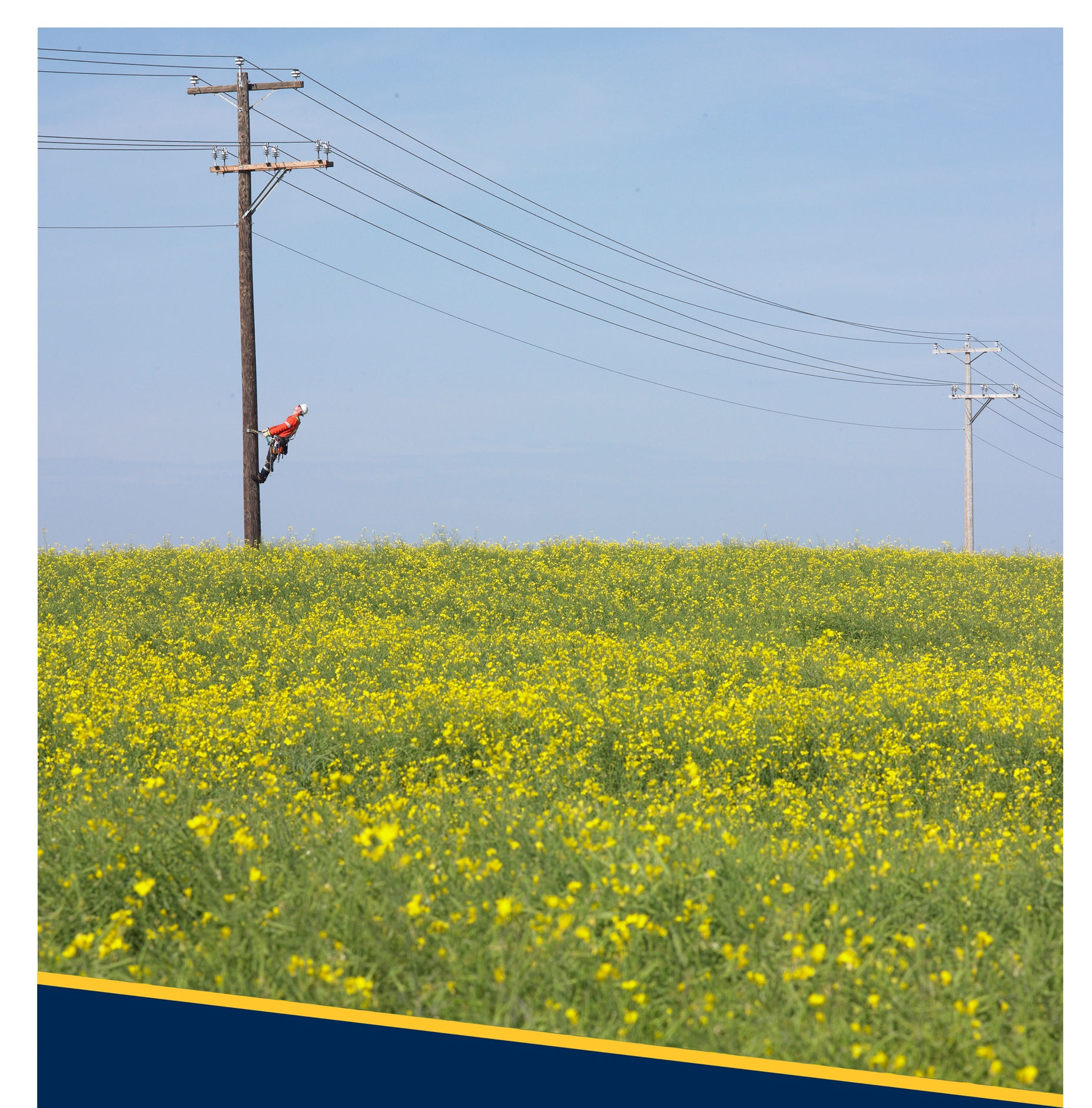

Licensed Occupant Guide:
Small Connected Devices
D08-08.3
Revision No: 1.2

Copyright © 2024 FortisAlberta. All rights reserved. This document is the proprietary and confidential property of FortisAlberta Inc.
No modifications, reproduction, or further distribution of this document is permitted, in whole or in part, without written consent of FortisAlberta.
FortisAlberta accepts no liability for unauthorized use of this document. Printed on Sep. 10, 2024 at 11:36 AM.
The current revision is on FortisAlberta Standards Database.

YYYY / MM / DD: 2024 / 09 / 10
Prepared |  | Approved | Ownership | Authentication | Responsible Member Validation
Chris Mateo, P.Eng.  Standards and Projects Engineer |  | Kevin van Popta, P.Eng.  Principal Engineer, Standards & Operations | Licensed Occupancy Steering Committee and  Standards & Projects Engineering |   Authenticated and validated original filed with the Engineering Department | Responsible Member Validation
 |  |  |  |  | APEGA PERMIT NUMBER: P07387
Kevin Van Popta, P.Eng.


Additional Reviewers and/or Contributors | Ken Davis, Utility Services Manager

Table of Contents
1. Scope 3
2. Purpose 3
3. Normative References 3
4. Glossary 3
5. Legislations 4
6. General Considerations 7
7. Rates, Riders, and Options 7
8. General Requirements 8
9. Supply of Licensed Occupancy Pole 10
10. Load Center and Standard Servicing 11
11. Recommended and Restricted Poles for Licensed Occupant Attachments 11
12. Small Connected Devices 14
13. Licensed Occupancy Poles and Vertical Separations at the Pole 19
14. Small Connected Device on FortisAlberta Pad-mounted Equipment 21
15. Connections, Shutdown, and Notifications for Equipment & Devices 21
16. Use of 3 kVA transformer servicing SCDs 24
17. Mapping of FortisAlberta Electrical Facilities 24
Annex A FortisAlberta’s Facilities through Altalis.com (Informative) 25
Annex B Alberta Electrical Utility Code (AEUC), 6th Edition (Normative) 27
Annex C Connection Authorization Form (Normative) 29
Annex D Transformer and Voltage Drop Calculations (Normative) 30
Annex E Bibliography (Informative) 31

The previously published revision was Rev #1.1, December 12, 2023. Significant content changes shown in purple for convenience.

Scope

This document details the requirements and instructions in approving the attachment and servicing of small connected devices on poles and strand mount installations.

The requirements and instructions in managing and approving Telecommunication Wireline attachments on FortisAlberta Poles are provided in D08-08.1 (external) [B1].

The requirements and instructions in managing and approving Municipal attachments are provided in D08-08.2 (external) [B1].

The requirements and instructions in managing and approving Distributed Energy Resources attachments are provided in D08-08.4 (external) [B1].

The requirements and application process for servicing and attaching small connected devices on poles and strand mount installations are provided in the Licensed Occupancy Small Connected Devices Attachment Process (external) [B2].
NOTE: D08-08 series documents can be found in the FortisAlberta Licensed Occupancy - Joint Use website.

Purpose

To provide details and requirements for the safe installation, operation, and servicing of small connected device attachments on poles and/or on strands to meet applicable codes and regulations.

Normative References

Workers shall be competent in FortisAlberta standards:
- D08-08.1 – Licensed Occupant Guide: Wireline Attachments (external) [B1]
- D08-08.2 – Licensed Occupant Guide: Municipal Attachments (external) [B1]
- D08-08.4 – Licensed Occupant Guide: Distributed Energy Resources (external) [B1]
- Licensed Occupancy Wireline Attachment Process (external) [B2]
- Licensed Occupancy Small Connected Devices Attachment Process (external) [B2]
- Limits of Approach for Telecommunications Workers H&S 7.5 (external) [B2]

Glossary
Licensed Occupant / Occupancy: the party that has entered into an agreement with FortisAlberta that allows it to attach its facilities on poles or on strands. The licensed occupant is the Licensee within the Licensed Occupancy Agreement.
Make Ready Work: the work required by FortisAlberta in preparing the pole to be ready, servicing requirements, and fit (compliant to applicable safety code, engineering standards, and by-law) for the required licensed occupant attachment or alterations.
Pole(s): Certain electric distribution poles owned by FortisAlberta which are in the area within which FortisAlberta operates its electric distribution system as prescribed by the Alberta Utilities Commission under the Hydro and Electric Energy Act (Alberta), as amended.
Primary Underground Risers: are primary supply facilities, installed in ducts, transitioning from overhead to underground installations or vice versa. Small Connected Devices and Telecommunication risers are not allowed on poles with primary underground risers.
Secondary Underground Risers: are secondary supply facilities transitioning from overhead to underground installations or vice versa. Small Connected Devices and Telecommunication risers may be attached on poles with existing secondary underground risers.
Telecommunication Risers: are telecommunication facilities, installed in ducts, transitioning from overhead to underground installations or vice versa.
Safety Code 6: is a document that sets out recommended safety limits for human exposure to radio frequency electromagnetic fields (EMF) in the frequency range from 3 kHz o 300 GHz.
Small Connected Devices: Small sized equipment that may include cabinets; security cameras; wireless devices attached on pole or strand mounted; antennas; microcell (small cell); base/repeater radios; Wi-Fi/Access points; radar detectors; dual LED obstruction light antenna, and control boxes. Small connected devices usually have loads of up to 1kw, 1phase, 120/240V.

Legislations

Alberta Electrical Utility Code (AEUC) (See Annex B)

The Alberta Electrical Utility Code (AEUC) [B3] provides the rule which applies to activities near overhead power lines and not the movement of persons, equipment, buildings, vehicles, or objects under overhead powerlines.

A person must contact FortisAlberta, by calling 310-WIRE (9473), before any activities (such as movement of persons, equipment, buildings, vehicles, or objects under overhead powerlines) are undertaken or equipment is operated within 7.0 meters of FortisAlberta’s electric distribution system, to:
- determine the voltage of the powerline; and
- establish the safe limit of approach distance as listed in Table 1.

Table 1, Safe Limits of Approach Distances from Overhead Power Lines for Persons and Equipment
- 0 – 750 V insulated, or polyethylene covered conductors ⁽⁾ 0.3 m
- 0 – 750 V bare, uninsulated 1.0 m
- Above 750 V insulated conductors ⁽¹⁾ ⁽⁾ 1.0 m.
- 0.75 kV – 40 kV 3.0 m
NOTE:
- The minimum separation required between the lowest primary facility and the highest part of the small connected device is 3.6m = 3.0m (safe limits of approach) + 0.6m (head shoulders). Please refer to Section 13.2 and Figure 11.
- The minimum separation required between the lowest secondary facility and the highest part of the small connected device is 1.6m = 1.0m (safe limits of approach) + 0.6m (head and shoulders). Please refer to Section 13.3 and Figure 11.

Province of Alberta, Occupational Health and Safety Code
Alberta Occupational Health and Safety Code 2023 [B4] and Explanation Guide provides further guidance on the safe limit of approach distances as specified in the AEUC.

Safe limit of approach distance, Section 225
- Before work is performed or equipment is operated within 7 metres of an overhead power line, an employer must determine the voltage of the powerline, and establish the appropriate safe limit of approach distance listed in Schedule 4.
- An employer must ensure that the provided safe limit of approach distance is maintained and that no work is done, and no equipment is operated at a distance less than the established safe limit of approach distance.
- Before work is done or equipment is operated in the vicinity of an overhead power line at a distance less than the established safe limit of approach distance listed in Schedule 4, an employer must notify FortisAlberta, by calling 310-WIRE (9473) and obtain assistance in protecting workers involved.
- Schedule 4:
0 – 750V insulated or polyethylene covered conductors ⁽⁾ 0.3 m
0 – 750V bare, uninsulated 1.0 m
Above 750V insulated conductors ⁽³⁾ ⁽⁾ 1.0 m
0.75V – 40kV 3.0 m
NOTE:
- The minimum separation required between the lowest primary facility and the highest part of the small connected device shall be 3.6m = 3.0m (safe limits of approach) + 0.6m (head and shoulders). Please refer to Section 13.2 and Figure 11.
- The minimum separation required between the lowest secondary facility and the highest part of the small connected device shall be 1.6m = 1.0m (safe limits of approach) + 0.6m (head and shoulders). Please refer to Section 13.3 and Figure 11.

Part 20: Radiation Exposure, Section 291, Prevention and Protection
“If a worker may be exposed to ionizing radiation at a work site, an employer must.
- Develop and implement safe work practices and procedures to be used when the worker works with or approaches the radiation source,
- If practicable, involve affected workers in the development and implementation of the safe work practices and procedures, and
- Inform affected workers of the potential hazards, including reproductive hazards, of ionizing radiation and the radiation source and the precautions to be taken to protect the workers and other persons from those hazards.”

CSA C22.3 No. 1-20, Overhead Systems

CSA C22.3 No. 1-20, Overhead Systems [B5], specifies the Minimum Vertical Separations at a Joint Use structure ⁽⁾ and working space to allow workers to have access to equipment and conductors and to allow for the installation of the equipment on the structure. FortisAlberta’s interpretation is that these separations do not include the minimum approach distance required by AEUC.
- 0 – 750V supply conductors and Communication line plant 1.0m
- > 0.75kV up to and less than 22kV supply conductors 1.2m
- Luminaires span wires or brackets and communication line plant.
  - Not effectively grounded 1.0m
  - Effectively grounded 0.1m

CAN/ULC-S801-14-REV1 – Standards on Electric Utility Workplace Electrical Safety for Generation, Transmission, and Distribution

Section 9, Radio Frequency Hazards
- When work is performed in proximity to communication antennas in the range of 3 kHz to 300 GHz, workers shall not be exposed to radiation levels that exceed Health Canada – Safety Code 6 requirements.
- Employer shall ensure safe work methods are in place to manage exposure limits; RF minimum approach distances; lockout and/or tagging procedures; RF protective clothing; fall protection; climbing plans; rescue training and emergency response; and third-party agreements.

Safety Code 6: Health Canada’s Radiofrequency Exposure Guidelines
Safety Code 6 [B9] provides technical information for guiding individuals or groups in their understanding of Health Canada’s radiofrequency (RF) exposure guidelines.

Uncontrolled and controlled environments
Controlled environments are defined as those that meets the following conditions:
- The RF field intensities were characterized by means of measurements, calculations, or modelling,
- The person exposed is aware of the potential for RF exposure and are cognizant of the intensities of the RF field in their environment, and
- The person exposed is aware of the potential health risks associated with RF field exposures and can control their risk using mitigation strategies.
Situations that do not meet the above conditions are considered uncontrolled environments.

Safety signs for RF protection
- Areas
Signs should be used to label areas where RF exposure levels may exceed exposure limits for controlled and uncontrolled areas.
- Devices
A Caution sign may be used to identify RF energy emitting devices that can produce exposures that can lead to injury from misuse.
A Danger sign may be applied to any device, if it produces exposure levels that pose a risk of immediate and severe injury.

General Considerations

The safety of workers and public, accessibility, maintainability, security, and reliability of FortisAlberta electric infrastructure are to be paramount.

Where applicable, small connected device must meet CSA C22.3 Part 1 (Overhead Systems), Health Canada Safety Code 6, the Power Utility Standards, and Telecommunication regulation requirements. In cases where requirements overlap, whichever requirement is more stringent shall apply.

Small connected device and electric servicing shall meet the AEUC [B3], Canadian Electrical Code C22.1 [B8], and provision of service shall be as per FortisAlberta’s Service and Metering Guide [B6].

Application for licensed occupancy attachments shall be on a first permit submission – first served basis. FortisAlberta will not grant the attacher exclusive use, vested rights, or franchise licensed occupancy of its facilities to third party attachers. The attacher is required to share the pole with the Power Utility or other third party attachers. NOTE: The approved application will be valid for 6 months. If after 6 months no work has been completed the approval will be rescinded.

Rates, Riders, and Options

Option D Flat Rate is a rate option available for servicing small connected device with load requirements that are predictable. If the loads change over time or if the loads are no longer predictable, FortisAlberta may meter the service at the customer’s cost and bill accordingly at FortisAlberta’s discretion.

Virtual Aggregation Billing
Small connected devices may qualify for aggregate billing under one site ID with the following restrictions:
- The device must be attached to the FortisAlberta approved pole.
- The device has an electrical load requirement of less than 1 kW.
- Devices of the same type and located within the same municipal service area (i.e., municipality, town, hamlet).
NOTE: Devices located in different municipal service areas will each have its own site ID for separate aggregated billing.
- The device must be approved by FortisAlberta. NOTE: Licensed Occupant must submit and complete a FortisAlberta Licensed Occupancy Small Connected Device Application form for each device type for review and approval.

General Requirements
  - Compliance to FortisAlberta Standards, Codes, and Regulations
    - Licensed occupant proposing to attach on FortisAlberta poles are responsible to comply with the latest edition of the Alberta Electric Utility Code and other regulations with jurisdiction over the proposed attachment on poles.

The licensed occupant shall be responsible to utilize competent workers, as per Occupational Health and Safety Code – Alberta Regulation 191/2021 and other applicable requirements. The licensed occupant shall install their small connected devices within the space as approved by FortisAlberta while respecting the applicable electrical safe limits of approach.

Electrical services associated with the installation of small connected devices on FortisAlberta structures shall meet FortisAlberta standards, and all applicable provisions of Alberta Electrical Utility Code (AEUC) [B3] and Canadian Electrical Code C22.1 [B8].
  - Licensed Occupancy Agreement [B7]
    - Licensed occupancy agreement is an agreement between FortisAlberta and the Licensed Occupant, where the latter wishes to install equipment on poles and/or on strand, and FortisAlberta is agreeable upon the terms and conditions contained in this agreement.
    - Licensed occupant proposing to attach on FortisAlberta’s electric distribution poles and/or on strand, that are commercial in nature, shall complete and maintain a licensed occupancy agreement with FortisAlberta prior to any work or attachment is made on FortisAlberta poles or on Licensed Occupant strand.
    - Before any activities are undertaken or equipment operated to install telecommunication attachments on FortisAlberta poles, the licensed occupant shall call 310-WIRE (9473) and arrange for a powerline orientation and start-up construction meeting with a FortisAlberta local Area Coordinator (or equivalent).
    - To obtain more information, please contact FortisAlberta’s Licensed Occupancy Department
(e-mail: licensedoccupancy@fortisalberta.com).
    - Disclaimer: If there is any discrepancy between any provision of this Licensed Occupancy Guide and any provision of the Licensed Occupancy Agreement, the provisions in the Licensed Occupancy Agreement shall prevail.

  - Approvals

Municipal Approval
FortisAlberta maintains an Electric Distribution System Franchise Agreements [B10] with certain municipalities in its service area.
FortisAlberta is required to direct the licensed occupant, proposing to attach on FortisAlberta poles located within the local municipal service area or right of way, to obtain the local municipal approval.
The licensed occupant proposing to attach on FortisAlberta’s electric distribution poles and/or on strand shall obtain the local municipality approval and to provide a copy of the municipal approval to FortisAlberta representative.

Electrical Permit or Connection Authorization Form
The licensed occupant shall submit an electrical permit (issued by a local municipal inspector) or a completed and signed FortisAlberta Connection Authorization Form to licensedoccupancy@fortisalberta.com, in accordance with the conditions specified below, prior to attaching devices on the pole.
The local inspection authority may or may not issue an electrical permit for small connected devices attached on FortisAlberta poles. As such, the licensed occupant shall check with the local municipality/inspector if they would grant an electrical permit. If the local electrical inspector will issue an electrical permit, the electrical permit shall be submitted to licensedoccupancy@fortisalberta.com prior to attaching devices to FortisAlberta poles or streetlights.
In the absence of an electrical permit (where the permitting authority does not provide permit or inspect electrical service installations on Poles), the licensed occupant shall complete and sign a Connection Authorization Form (see Annex C) – indicating that the licensed occupant installation is okay to be connected to the electric distribution system. Completed Connection Authorization Form shall be submitted to licensedoccupancy@fortisalberta.com prior to attaching devices to FortisAlberta poles or streetlights.

Other applicable approvals (i.e., land use, environmental permits, etc.) which may be identified and required by FortisAlberta.

The licensed occupant shall review the Licensed Occupancy Small Connected Devices Attachment process prior to completing the Licensed Occupancy Small Connected Device Application Form (link) as part of their application.

Safety Code 6 Report
The Licensed Occupant shall complete and submit to licensedoccupancy@fortisalberta.com, a Safety Code 6 report on proposed wireless facilities, to attach on FortisAlberta poles, emitting hazardous radio frequencies. The Safety Code 6 report shall be Authenticated and completed as per APEGA’s Professional Practice Standard (2022): Authenticating Professional Work Products.

As-Built Drawings
As-Built Drawings are to be submitted to licensedoccupancy@fortisalberta.com within 30 days after Licensed Occupant construction complete.
The As-built Drawings shall include the following information:
- Cover Page and signed by licensed occupant representative:
  - “I hereby declare that the as-built data provided are true and correct to the best of my knowledge.”
  - Date
  - FortisAlberta Project Reference # (i.e., CRM #)
  - Customer representative full name (printed) & signature
  - Company title
  - Telephone number
  - E-mail address
- Plan View Map showing the location of the pole with licensed occupant attachment.
- FID# (FortisAlberta Feature Identifier Number) of the pole structure
- As-Built picture of each pole with installed small connected device
- Height of attachment of Disconnect Switch (Proposed design and As-Built) for each pole.
- Height of attachment of Small Connected Device (Proposed design and As-Built) for each pole.

Number of Small Connected Device Licensed Occupant and Small Connected Devices attachments on a pole:
Only one (1) Small Connected Device Licensed Occupant is allowed on a pole. The Small Connected Licensed Occupant may be allowed to attach up to a maximum of two (2) small connected devices requiring an electric service on the pole, if approved by FortisAlberta representatives.

Applicable Fees
The licensed occupant shall be responsible for any applicable fees as per the “Licensed Occupancy: Schedule of Fees” (link).

Supply of Licensed Occupancy Pole

If a new licensed occupancy pole is required to attach small connected devices, a request can be made to have FortisAlberta supply and install it.

The licensed occupant shall be responsible to pay for the associated costs of installing the new pole.

The pole installation is subject to applicable laws, approvals, land rights and engineering requirements.

The pole locations are restricted to acceptable locations within government road allowances as determined by FortisAlberta. FortisAlberta will not supply and install a pole on private property; in a location that requires regular land access costs; or one that has accessibility concerns.

The addition of a pole may affect the adjacent structures, such as with uplift issues or additional loading. As such, the customer shall pay the required changes in the system in accommodating this new licensed occupancy pole.

Load Center and Standard Servicing

FortisAlberta will supply and install the load center on the pole. The load center must be rated for outdoors, single phase, 2Wire, 15A, 120/240V AC system.

The standard service voltage for small connected devices is 120V_{LG}, 1-Phase, 2-Wire.
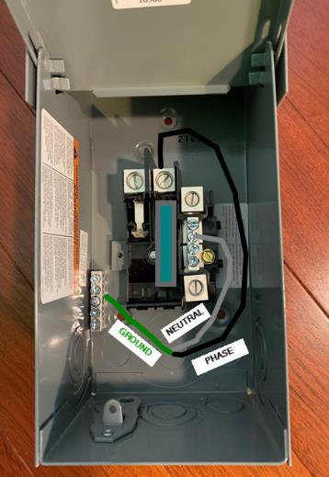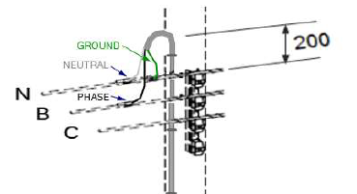

Figure 1: Showing connections to the load center and to the supply system.

Recommended and Restricted Poles for Licensed Occupant Attachments

Recommended poles for licensed occupancy attachments
- Streetlight poles – for the intent of this document, streetlight poles shall refer to underground fed steel streetlight poles. Streetlight poles are available for licensed occupancy attachments, unless identified as restricted in the following sections. Streetlight poles may be utilized as a raceway for communication cables (installed in duct inside the streetlight pole) and attachment point for small connected devices upon FortisAlberta review and approval. Streetlight poles are to be inspected, evaluated for structure loading, and appropriateness before giving approvals to attach.
There are streetlights which are controlled by relays and do not have a 24/7 electric service available on them. Where small connected devices are proposed on these streetlight poles, the make ready quote shall include the work required to upgrade the facilities to ensure 24/7 power is available on these streetlight poles.
Streetlight poles are not to be used for licensed occupancy wireline attachments (such as telecommunication cables) as these streetlight structures are not intended to support these wireline attachments.
- Tangent wood poles (simple framing for supporting conductors without guying or dead ends) usually provide reduced complexity, better clearances, and more space for licensed occupancy attachments. These may include a single phase transformer on the tangent pole. Due to operational reasons, two thirds of the pole typically must be free for climbing, which restricts some pole types. Wood poles are to be inspected, evaluated for structure loading and appropriateness before giving approvals to attach.

Restricted poles for licensed occupancy attachments
- FortisAlberta owned poles located on private property – Attachments of small connected devices on poles located on private property are not allowed. NOTE: The pole locations are restricted to acceptable locations within government road allowances.
- Decorative streetlight poles – Attachments of small connected devices on decorative streetlight poles are not allowed. NOTE: Decorative streetlight poles are specifically meant for municipal beautification and are normally built with smaller diameter steel poles which would restrict the installation of customer cables and conduits in the pole. In addition, the placement of luminaires is on the roadside where small connected devices are also proposed to be installed which would affect the intended road lighting pattern of the streetlight pole.
- Wood and streetlight poles with existing licensed occupancy attachments (e.g., security cameras, small cells). NOTE: Only one licensed occupant is allowed to attach small connected device on the pole.
- Streetlight poles with visible signs of rusts and dents. Rusts and dents affect the integrity of streetlight poles. Streetlight poles with rusts and dents, as verified in the field, shall be replaced when required for licensed occupancy attachments.
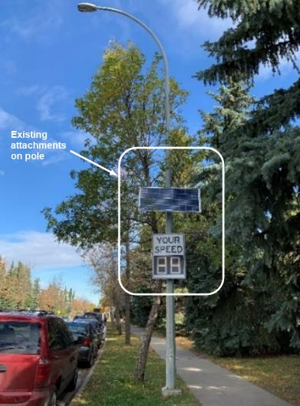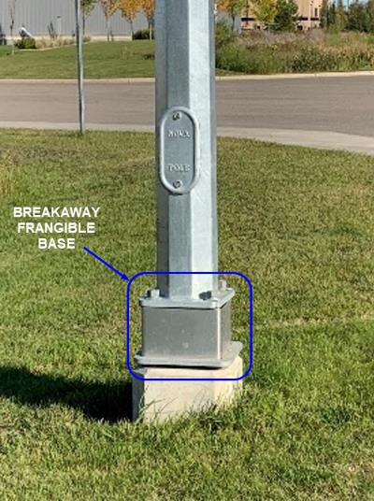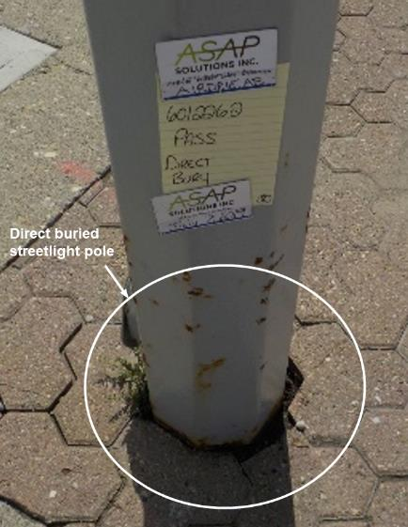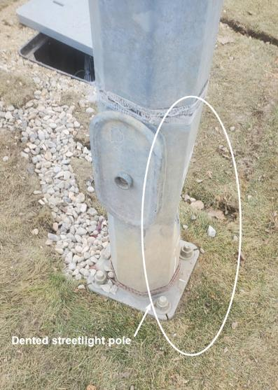

Figure 2 – Existing attachments (Top Left), Breakaway Pole (Top Right), Direct buried (Lower Left), Dented Pole (Lower Right)
- Streetlight poles on breakaway bases – Licensed occupancy attachments are not allowed on these. Streetlight poles on breakaway bases are intended to improve traffic safety and are not meant to handle the additional structure loading of a licensed occupancy attachment. Breakaway bases are not to be replaced with standard bases, for the purpose of allowing licensed occupancy attachments, due to its intended purpose and use (which is for lighting and traffic safety).
- Direct buried streetlight poles – Licensed occupancy attachments are not allowed on these unless replaced. Direct buried streetlight poles are older standard structures and will have to be replaced when required for licensed occupancy attachments. The actual condition of the portion of streetlight pole buried underground is unknown unless verified and tested. Thus, additional loading on the structure may cause the structure to fail.
- For wood poles with equipment or switching devices (e.g., primary underground risers, jumpers (hot-line clamps), regulator banks, MVIs, capacitor banks), no attachments are allowed. Refer to figure 3. The licensed occupancy attachment will restrict maintenance and operations work on these normally accessed structures.
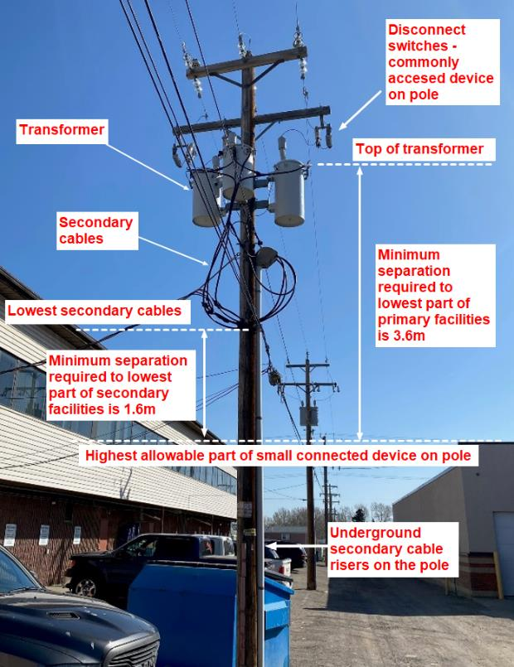

Figure 3: (RESTRICTED) Pole with equipment showing vertical separations required at the pole.

Small Connected Devices

General
- Figure 4 shows several small connected devices attached on FortisAlberta poles.
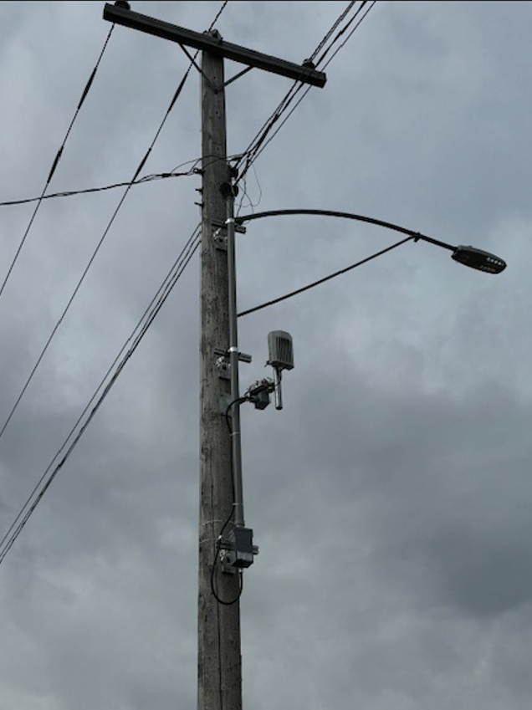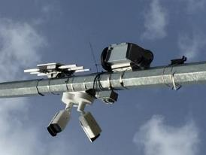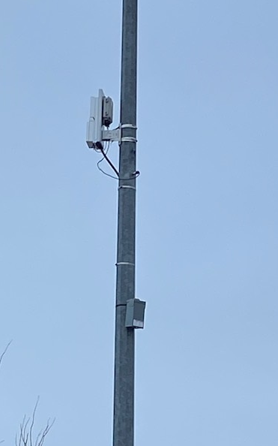

Figure 4 – Wi-fi Device (Left), Security Cameras (Center) and Telecommunication antennae (Right)
- Licensed occupant small connected devices shall be installed in accordance with all applicable codes and regulations.
- The licensed occupant shall install a field labeling and tag identification (site identifier) of any equipment installed on a wood or streetlight pole. The labeling shall include and show the correct warning or danger signs and contact information of the licensed occupant. The field labeling shall be installed below the location of the load center on the pole. Refer to Figure 5.
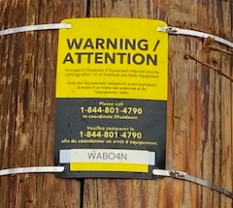

Figure 5: Labelling and tag identification of a small connected device attached on FortisAlberta pole.
- Licensed occupant small connected devices and control devices (e.g., transformers, cables, etc.) shall be rated for outdoor installations.

Attachments on wood poles
- Small connected devices are to be attached below the wireline licensed occupancy (joint use) zone, on a wood pole.
NOTES
- If there is no wireline licensed occupant on the pole, then the required vertical clearances to the supply facilities as required in this document shall be met. Small connected devices are not to be attached between or above the allocated space for primary and secondary facilities on the wood pole. Refer to Figure 10.
- If there are municipal attachments (e.g., signs, banners, security cameras) on the pole, the municipal attachment shall be either relocated below the load center (disconnect switch) or removed from the pole, of which will require a municipal approval. FortisAlberta will not start make-ready work until municipal attachment is relocated below the load center or removed from the pole.
- If existing power and communication zones space allocations are different than shown in Figure 10, a request may be made to FortisAlberta to make adjustments on the existing height of attachments to allow for the installation of the small connected device on the pole.
- The minimum height of attachment to the bottom of the load center on the pole shall be three meters from ground. The minimum separation between the top of the load center and the bottom of the small connected device shall be 1.0m.
- Third party equipment and devices shall be attached on stand-off brackets (using pole straps or screws/bolts) on wood poles to allow access (be able to climb the pole to access supply facilities). Customer supplied stand-off brackets shall be in alignment with FortisAlberta installed stand-off brackets. Two-thirds of the circumference of the pole shall be kept free to allow workers to climb up the pole.
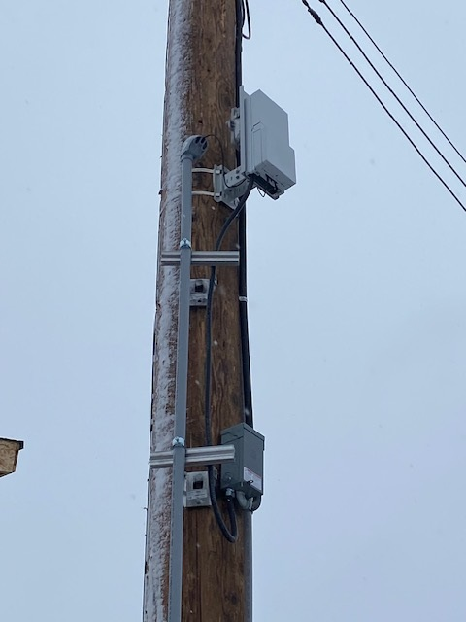

Figure 6: Small Connected Devices and risers placed on straps and stand-off brackets, accordingly.
- The load center, supply secondary cables in conduits, and customer devices and conduits shall all be placed on stand-off brackets on the pole. Customer supplied stand-off brackets shall be in alignment with FortisAlberta installed stand-off brackets. NOTE: FortisAlberta and licensed occupant representatives to discuss and confirm location and placement of stand-off brackets on the pole prior to installation. Refer to Figure 7.
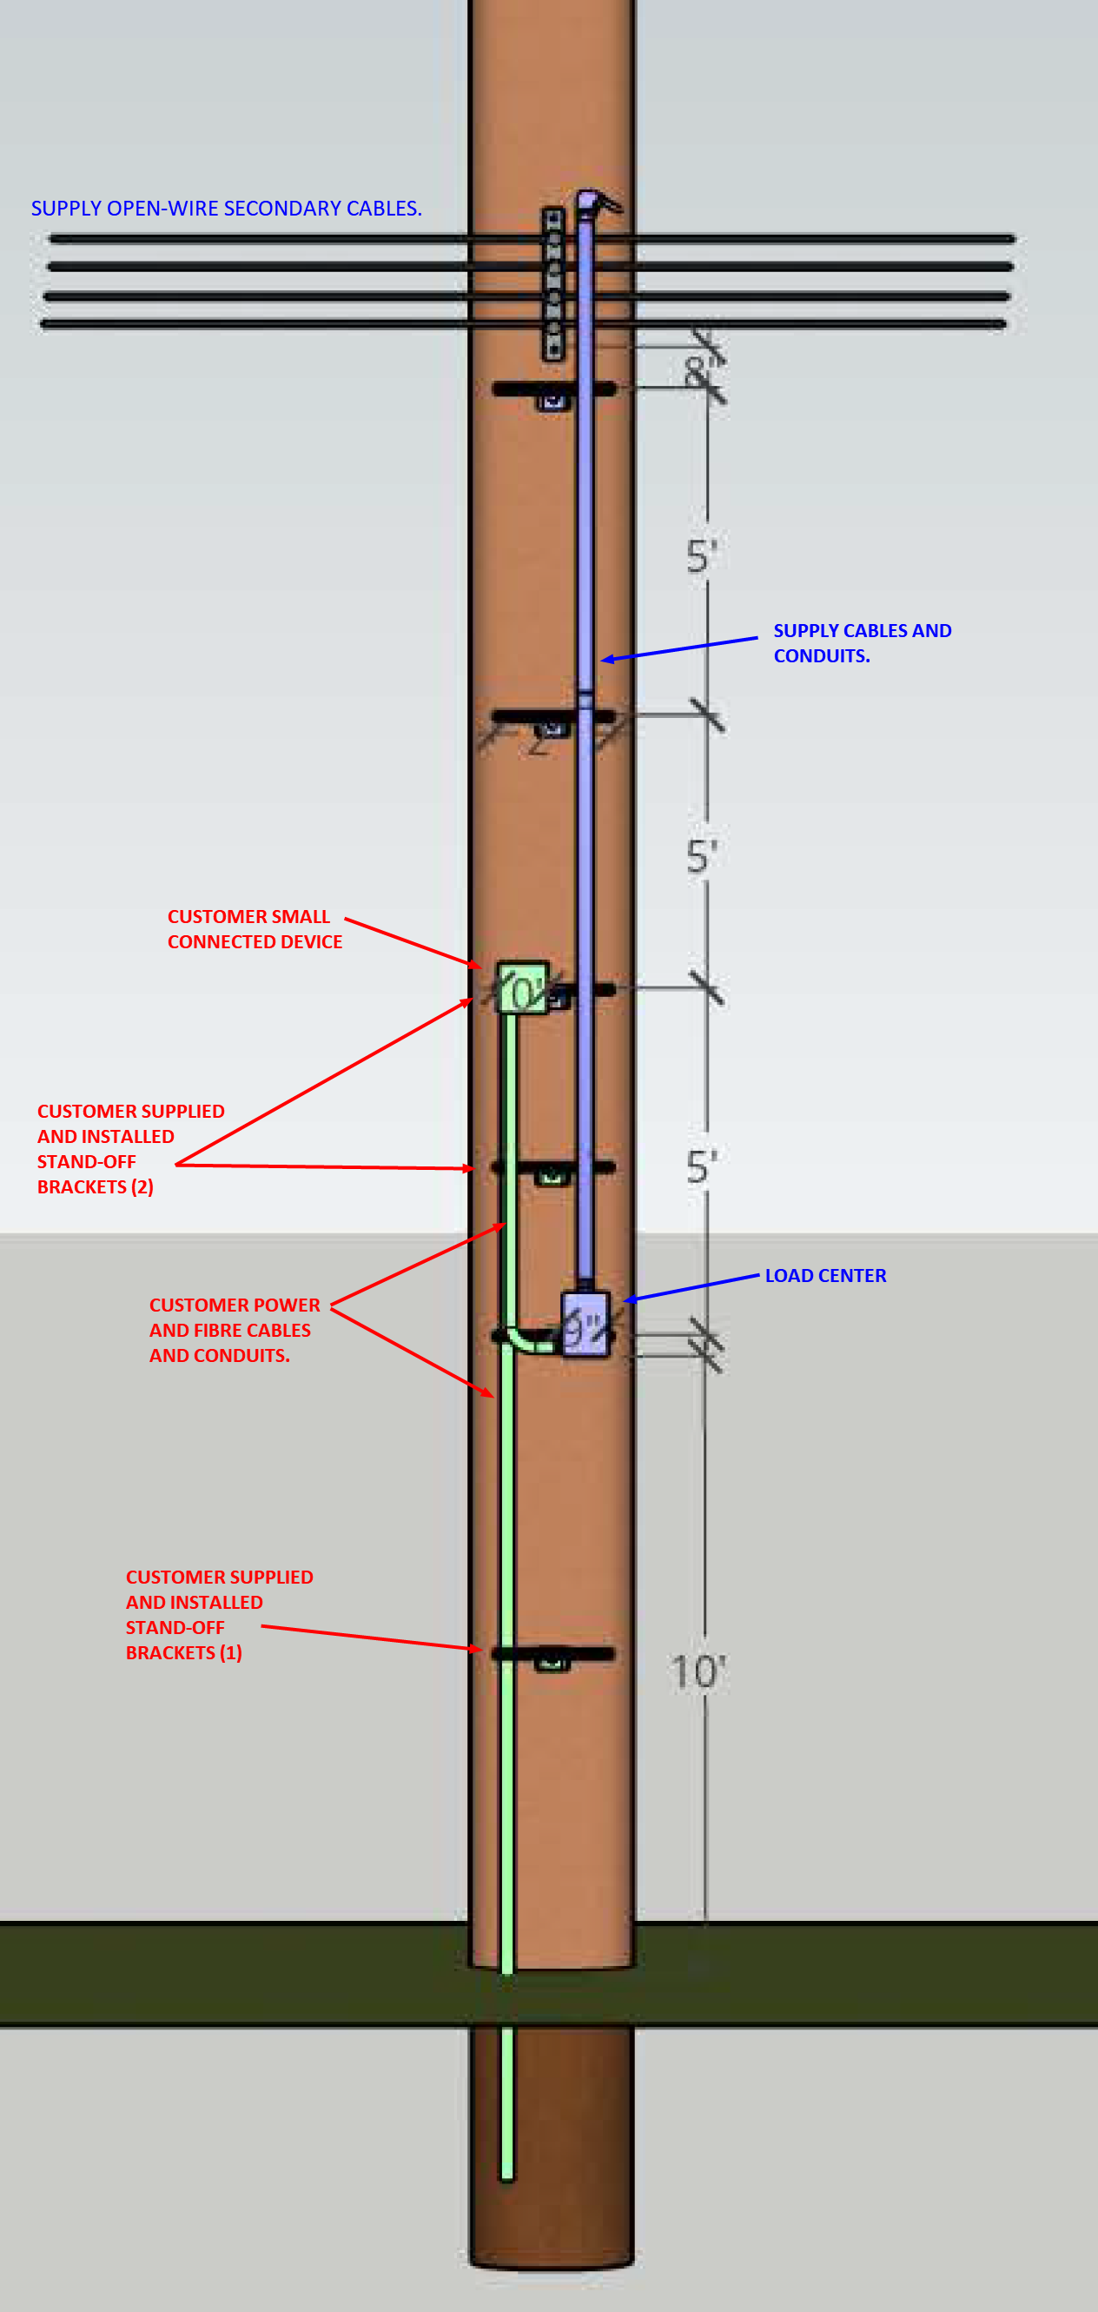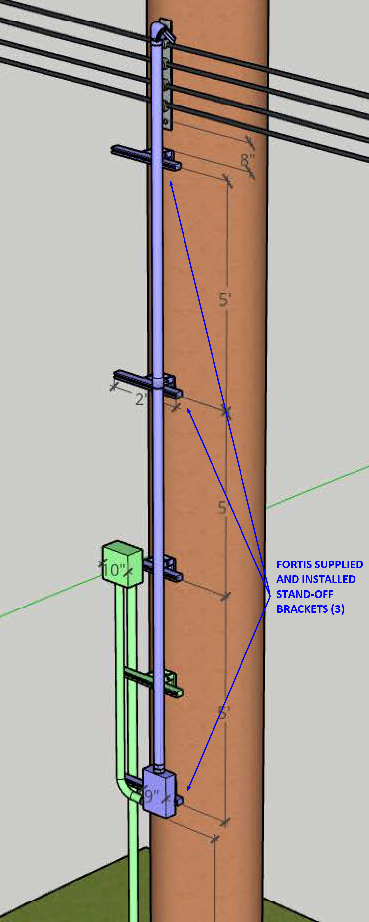

Figure 7: Load center, supply conduits, licensed occupant devices attached on stand-off brackets.
- Attachments of any small connected devices are not allowed on a streetlight steel bracket on a wood pole (i.e., FortisAlberta structure 1440). See Figure 8. The vertical separations between small connected devices and any portion of the lowest primary (e.g., switches, transformers, primary cables, etc.) and secondary (e.g., secondary cables, streetlight bracket, secondary rack, etc.) distribution system on a wood pole shall be as per Section 13.
NOTE: This is to avoid possible encroachment within the required minimum approach distance both to the primary and secondary facilities. This is also intended to avoid placement of licensed occupant facilities (such as running supply load conductors from the load center and up along the steel bracket and on to their device) which would encroach on the required vertical separations between supply and licensed occupant devices at the pole.
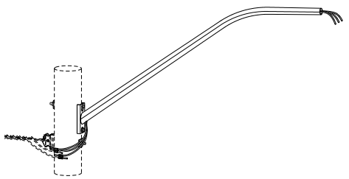

Figure 8: Small connected devices – not allowed to attach on streetlight steel brackets on wood poles.

Attachments on streetlight poles
- Pole straps must be used when attaching equipment and devices on streetlight poles.
- If there are municipal attachments (e.g., signs, banners and banner arms) on the streetlight pole, the municipal attachment shall be either relocated below the load center (disconnect switch) and or removed from the pole, of which will require a municipal approval. FortisAlberta will not start make-ready work until municipal attachment is relocated below the load center or removed from the pole.
- Streetlight poles with existing licensed occupancy attachments (including previously approved attachments) will require a re-evaluation of the integrity of the structure and a new approval from FortisAlberta.
NOTE: Streetlight pole structural analyses are usually completed by FortisAlberta’s streetlight pole manufacturer. Thus, details of new and existing licensed occupancy attachments on the streetlight pole shall be obtained and gathered for evaluation. Any additional cost of evaluations will be attributed to the licensed occupant.
- Drilling on Streetlight Poles
Drilling on streetlight poles should be avoided, where possible. Where streetlight poles do not have a provision of nipple (usually the older streetlight structures), drilling on streetlight poles may be allowed when providing an electric service or where the licensed occupant may require running cables from their device to go inside the pole. When drilling the streetlight pole, use a 7/8” steel step drill bit and paint the hole with a galvanized paint.
NOTE: FortisAlberta will complete the required drilling on the streetlight pole.
Where streetlight poles have a nipple, the nipple should be used where practicable and avoid further making holes on the pole.
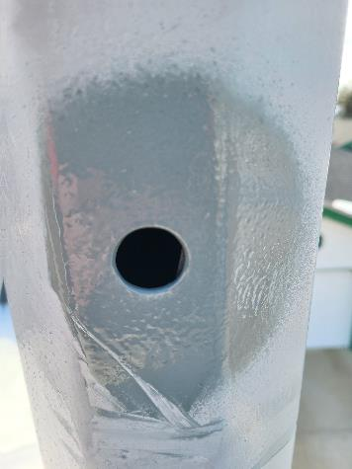

Figure 9: Drilled hole on a streetlight pole and painted with a galvanized paint.

(document continues next page)

Licensed Occupancy Poles and Vertical Separations at the Pole

The typical Space Allocation for services on FortisAlberta Wood Structures.
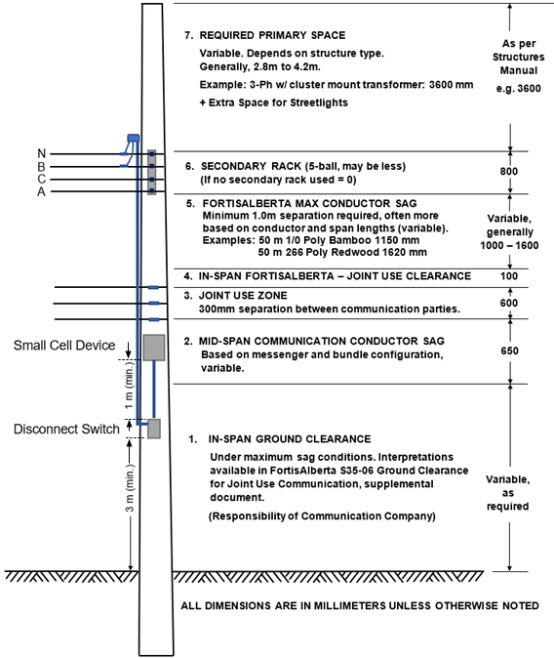

Figure 10 – Typical Space Allocation for Services on FortisAlberta Wood Structures

The required separations between the lowest primary supply facilities and the highest small connected device facility shall be a minimum of 3.6m.

The required separations between the lowest secondary supply facilities and the highest small connected device facility shall be a minimum of 1.6m.
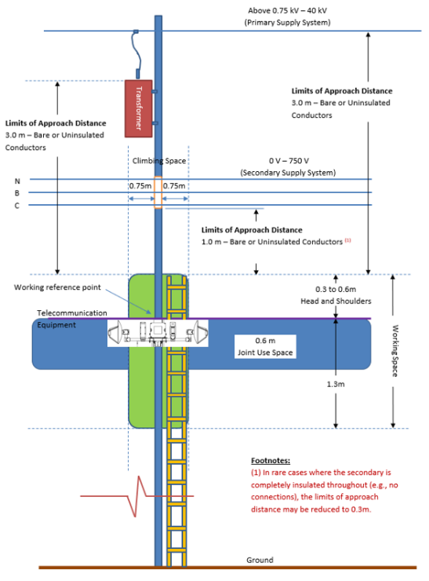

Figure 11: Diagram showing telecommunication equipment and a 3.6m safe limits of approach (includes minimum 3.0m limits of approach distance + 0.6m head and shoulders).

The required vertical separations will help ensure the minimum limits of approach to the nearest primary and secondary supply facilities are maintained by the Telecommunication worker on the pole.

Small Connected Device on FortisAlberta Pad-mounted Equipment

Small connected devices on FortisAlberta pad-mounted equipment are not allowed. This is to facilitate operations and maintenance of FortisAlberta equipment without obstruction and to avoid 3rd party facilities being damaged on this process.
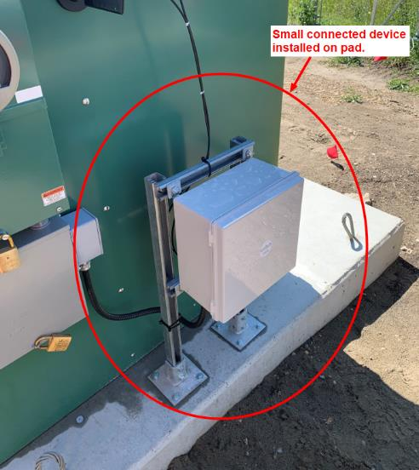

Figure 12: (NOT ALLOWED) Small connected device attached on pad-mounted equipment.

Connections, Shutdown, and Notifications for Equipment & Devices

Electric Service Connections

Licensed occupancy requests for equipment and devices mostly require an electric service. Electric service requests for licensed occupancy equipment and devices will be delivered as a commercial service and not metered.

Electric supply connections must be completed as follows:
- For devices which emits non-ionizing frequencies (such as small cell radios) – such devices shall be serviced using a load center (disconnect switch).
- Devices not emitting non-ionizing frequencies (such as security cameras, etc.) – such devices could be serviced with a load center, a weatherproof receptacle, or an ancillary tap (connected at the photo eye of the luminaire on a steel streetlight pole).

FortisAlberta will supply and install the power supply devices (load center, weatherproof receptacle, ancillary tap).

The costs of supplying and installing the power supply devices would be attributable to the licensed occupant.

A Local Authority Electrical Permit / Connection Authorization Form and Site IDs are required for each point of service prior to connection of any licensed occupancy device and equipment to the FortisAlberta’s electric distribution system. NOTE: Site IDs are to be utilized to set up account with the retailer of choice prior to construction completion. Licensed occupant to contact retailer to request service connection after FortisAlberta inspection of installed devices.
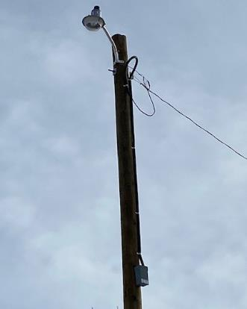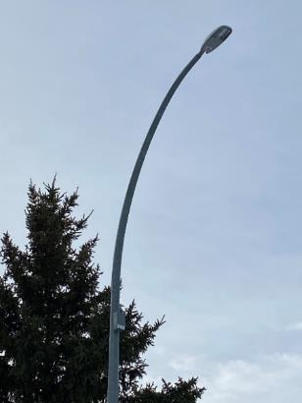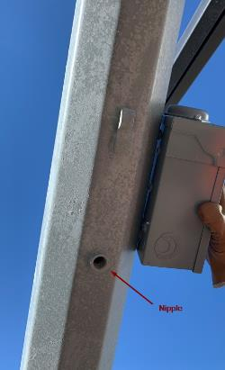

Figure 13 – Load Center on Wood (Left); Load Center on Streetlight (Middle); streetlight with a nipple.

Servicing and Demarcation Points

The demarcation point of electric service shall be at the FortisAlberta supplied and installed power supply devices.

The customer shall be responsible to supply and connect the load side service conductors at the load side of the load center.

On wood poles, the load side service conductors shall be installed in rigid PVC or liquid tight flexible conduits (i.e., mechanical protection), placed on stand-off brackets, and shall be continuous from the load center up to the customer’s device.

On streetlight poles, the load side service conductors shall be installed in rigid PVC or liquid tight flexible conduits (i.e., mechanical protection), and shall be continuous from the load center up to the customer’s device.

The distribution system shall be designed and built to meet cable ampacity and voltage drop requirements. Where these requirements are not met, modifications or upgrades may be needed before connecting these loads in the system. All needed upgrades will be attributed to the customer.

Shutdown Procedures for small connected devices attached on wood and streetlight poles.
- Emergency Situations (unplanned work)
- For emergency situations (i.e., line down, pole hit, etc.) and where work needs to be done on a pole with small connected devices, the safety of workers and the public are to be paramount.
- Locate the load center (disconnect switch) on the pole and switch it to the “OFF” position. NOTE: This is intended for safety of workers and to avoid exposure from non-ionizing frequencies in case the device is emitting these hazardous frequencies.
- After emergency work is completed, check and look for any field labeling of the device on the pole. Call the telephone number indicated in the field label and notify the licensed occupant representative of the emergency work performed and if the device needs attention (removed from the pole, or damaged, etc.) for the licensed occupant to take the needed action.
- In case the small connected device is still in good condition and attached to the pole, switch the load center to the “ON” position and call the licensed occupant representative and notify them that the device has been put back into service.
- In case the small connected device is removed from the pole, advise the licensed occupant to pick up the device in the local service area (provide FortisAlberta address and contact information).
- Pre-Planned Outages (PPO)
- Prior to performing work on the pole, check and look for any field labeling of the small connected device on the pole. Call the telephone number indicated in the field label and provide details of the of the work that needs to be done. NOTE: This is to show courtesy to our customer prior to disconnecting their services from our system.
- After an arrangement has been made with the licensed occupant representative, locate the load center (disconnect switch) on the pole and switch it to the “OFF” position. NOTE: This is intended (for safety of workers) to avoid exposure from non-ionizing frequencies in case the device is emitting these hazardous frequencies.
- After pre-planned outage work is completed and in case the device is still in good condition and attached to the pole, switch the load center to the “ON” position and call back the licensed occupant representative and notify them that the device has been put back into service.
- In case the device is removed from the pole, advise the licensed occupant to pick up the device in the local service area (provide FortisAlberta address and contact information).

Back-up power devices
Customer devices and equipment attached on Poles are not allowed to have back-up power (e.g., battery). Note: A downed pole may not stop a device with back up power from operating, of which may cause hazards to utility workers and public.

Use of 3 kVA transformer servicing SCDs

A 3 kVA transformer may be used to supply service to small connected devices that meets the following conditions:
- Cross-country, rural, and hard to reach areas (e.g., not accessible by vehicle trucks); and
- Unlikely to serve future customers (i.e., residential).
NOTE: 3 kVA transformers are to be attached at the same height of attachments for typical single-phase transformers (i.e., 1800mm for single-phase structure or 2350mm for three-phase structure).

Mapping of FortisAlberta Electrical Facilities

FortisAlberta electrical facilities mapping information may be obtained as follows:
- Through Altalis.com website. Annex A provides information in obtaining mapping information of FortisAlberta electrical facilities through Altalis.com.
- Through FortisAlberta. Please send a request to FortisAlberta Licensed Occupancy Team (licensedoccupancy@fortisalberta.com).

FortisAlberta’s Facilities through Altalis.com (Informative)
FortisAlberta’s mapping of electrical facilities are available through the www.altalis.com. The customer requesting for mapping information of FortisAlberta’s existing electrical facilities within an area should be directed to the www.altalis.com website.
The following steps will guide the customer to gather FortisAlberta’s mapping information:
- Click on the link www.altalis.com

- Click “Infrastructure”


- Click on “Electrical”
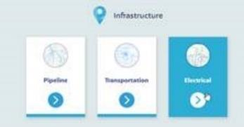

- Click on “Fortis Facility Data”
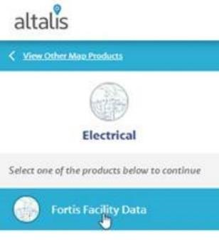
- Select the area of interest by clicking on “Select” and “Rectangle” or “Polygon.”
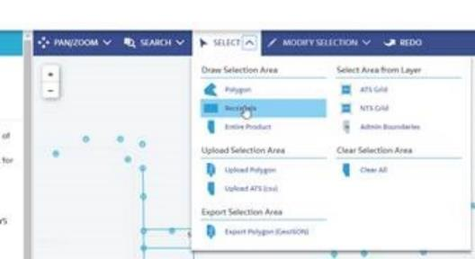

- Click and drag the cursor to identify the area of interest.

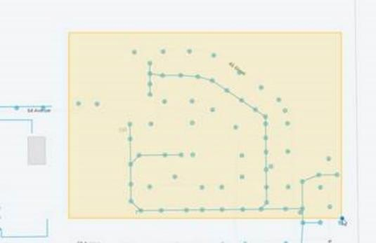

- Click “Add to Cart” located at the bottom right corner of the screen.



Alberta Electrical Utility Code (AEUC), 6th Edition (Normative)
This annex contains some applicable code clauses. Refer to the full AEUC for more details.
2-012 Interference with Systems
(1) No person shall interfere with, tamper with, or willfully damage electrical utility systems covered by this Code.
(2) Electrical utility system poles and structures shall be kept free of all materials and equipment not required for the system, unless permitted by the operator of the utility system.
(3) No person shall make attachments to electrical utility system poles and structures unless authorization has been received from the operator of the utility system.
(4) No person shall climb electrical utility system poles or structures or make connections or disconnections to electrical utility system equipment unless the person has been authorized to do so by the operator of the utility system.
(5) No person shall enter an electrical utility system generating station, substation, subsurface chamber, equipment room, or similar location unless that person is authorized to enter by the operator of the utility system.
2-014 Activities near Overhead Power Lines (See Appendix B.)
(1) This Rule applies to activities near overhead powerlines and not the movement of persons, equipment, buildings, vehicles, or objects under overhead powerlines.
(2) A person must contact the operator of the utility system before activities other than those in Subrule (1) are undertaken or equipment is operated within 7.0 meters of an energized overhead line to:
(a) determine the voltage of the power line; and
(b) establish the appropriate safe limit of approach distance listed in Table 1.
(3) Except as provided for in Subrule (4), a person must ensure that the safe limit of approach distance, as established in Subrule (2), is maintained and that no activities are undertaken, and no equipment is operated at distances less than the established safe limit of approach distance.
(4) A person must notify the operator of the utility system before activities are undertaken or equipment is operated in the vicinity of the power line at distances less than the safe limit of approach distances listed in Table 1 and obtain the operator’s assistance in protecting persons involved.
(5) Notwithstanding Subrules (1) through (4), Table 1 does not apply to utility workers falling under the OH&S Code, Part 40 Utility Workers – Electrical.
(6) A person must ensure that earth or other materials are not placed under or beside an overhead power line if doing so reduces the safe clearance to less than the Minimum Vertical Design Clearances above Ground or Rails as defined in Table 5 of this Code and the safe limit of approach distances listed in Table 1.
(7) A person must follow the direction of the operator of the utility system in maintaining the appropriate safe clearance when conducting activities near an overhead power line.
(8) If an activity is being carried out near the safe limits of approach distances specified in Table 1, the person completing the activity shall assign a competent person to act as an observer whose only responsibility is to ensure that the safe limit of approach distances will be maintained.
(9) A person shall not excavate or perform similar operations in the vicinity of an overhead or underground power line if it reduces the electrical and structural integrity of the power line including associated grounding equipment.

Connection Authorization Form (Normative)
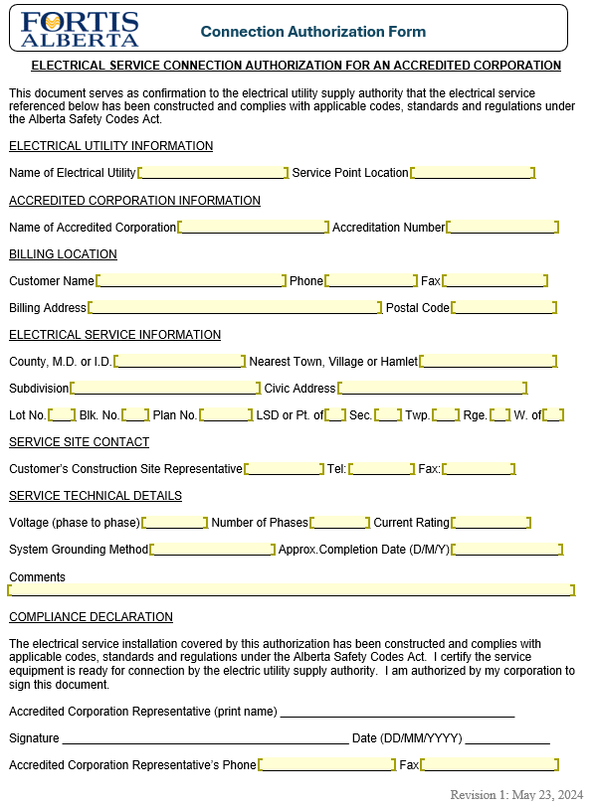

Transformer and Voltage Drop Calculations (Normative)
Applications of small connected devices connecting in FortisAlberta’s existing distribution system and meeting the criteria below will not require an evaluation of transformer loading or voltage drop calculations:
          - Total additional load of up to 1% of the transformer’s rating added to the existing secondary distribution system.
For example: Existing 1-ph transformer is 10 kVA, the maximum allowable load that can be added without the need to check for transformer loading and voltage drop is 90W.
10 kVA * 1% = 0.1 kVA
kVA * 0.9 (power factor) = 0.09kW or 90W
          - The customer’s “typical load” shall be used for the calculations above.
Where an existing secondary distribution system (includes secondary cables and transformer) are found to be overloaded, these projects should be discussed with Asset Maintenance representative for evaluation prior to any additional loads to the system.

Bibliography (Informative)
[B1] FortisAlberta, D08-08.1 through D08-08.4, Licensed occupancy related standards. Available for external third-party licensed occupancy communication parties.
[B2] FortisAlberta Licensed Occupancy processes and Limits of approach for telecommunication workers as posted in the FortisAlberta.com website.
[B3] Alberta Electrical Utility Code (AEUC), 6th Edition, Summer 2022
[B4] Alberta Occupational Health and Safety Code, March 31, 2023
[B5] Canadian Standards Association (CSA) C22.3 No.1-20, Overhead Systems
[B6] FortisAlberta’s Service and Metering Guide. Available in the FortisAlberta external website.
[B7] Licensed Occupancy Agreement
[B8] Canadian Electrical Code C22.1
[B9] Safety Code 6
[B10] Electric Distribution System Franchise Agreements
[B11] APEGA, Professional Practice Standard, Authenticating Professional Work Products
[B12] CEA Guidelines on Joint Use Poles with Wireless Attachers
[B13] APEGA Professional Practice Bulletin – Authentication Requirements for As-Built, Record, and As-Acquired Drawings (February 2023 version latest at publication date).

FortisAlberta Standards can be found from The Wire by choosing ‘Our Company’, ‘Safety’, then ‘Standards Database’, or by selecting ‘Applications’, then ‘Standards Database’. The search function can be used to find Standards Documents. Select ‘Standards Documents’ on the left menu to view all available Standards Documents. Standards made available to contractors can be found using FortisAlberta’s Contractor Portal at https://workingwith.fortisalberta.com/.

Revision Tracking Table
Rev | Date | Summary of Changes
0 | March 3, 2022 | Document created.
1.0 | July 27, 2023 | Additional Code requirements captured and updated. General housekeeping - moved process related information to the Licensed Occupancy Small Connected Devices Attachment process document.
1.1 | December 12, 2023 | Section 5.1 and 5.2 – added clarification on minimum separations between SCD and electric distribution facilities.  Section 8.2 – updated licensed occupancy contact information.  Section 8.3.2 – clarification requirement between electrical inspection permit vs. connection authorization form.  Section 8.3.4 – provided new SCD application form.  Section 8.4 – applicable fees are now referenced to the published schedule of fees.  Figure 2 – updated.  Figure 3 – updated.  Section 11.2 – Updated requirements on restricted wood pole structures. Removed underground services and added hot line primary jumpers.  Section 12: Removed limit of maximum number of SCD services allowed.  Section 13: Drilling on streetlight poles.  Figure 7: Updated.  Section 14: added clarification on minimum separations between SCD and electric distribution facilities.  Section 15: SCD on padmount equipment not allowed.  Section 16: Electric service connections and demarcation points updated.  Section 18: Mapping of FortisAlberta facilities updated.
1.2 | September 10, 2024 | Section 4, Glossary: added Primary, secondary, and telecommunication risers.  Section 7.2.Updated requirements.  Section 8.2.3 – licensed occupant to call 310-WIRE prior to any activities on the poles.  Section 8.3.2 – clarification on submissions of electrical permit and connection authorization form.  Section 8.3.4 – review of attachment process prior to making an application.  Section 8.4 – Added Safety Code 6 Report requirement.  Section 8.5 – Added As-Built Drawing requirement.  Section 8.6 – Added number of small connected device licensed occupant and small connected devices attachment on poles.  Section 11 – Updates on recommended and restricted poles for licensed occupant attachments on poles.  Section 12.1 licensed occupant to install field labels on their small connected devices on the pole.  Section 12.2 small connected devices attached on wood poles. Details updated. Load center, licensed occupant devices, and all conduits are to be placed on stand-off brackets. Small connected devices not allowed to attach on structure 1404 streetlight.  Section 12.3 small connected devices attached on streetlight poles. Details updated.  Section 15.3, updated shutdown procedures for small connected devices during emergency and pre-planned outages.  Annex C – updated and attached a fillable Connection Authorization Form.  Annex D – Added Transformer and voltage drop calculation requirements on small connected device loads.

⁽⁾ Conductors must be insulated or covered throughout their entire length to comply with these groups.
⁽⁾ Conductors must be manufactured to rated and tested insulation levels.
⁽⁾ Conductors must be insulated or covered throughout their entire length to comply with these groups.
⁽⁾ Conductors must be manufactured to rated and tested insulation levels.
⁽⁾ Table 23, Minimum Vertical Separations at a Joint Use Structure, CSA C22.3 No. 1-20.

